Department of Sociology
Report 2021-2022
The Department of Sociology, taking into consideration the pandemic situation, has continued conducting online workshops and webinars in the current academic year. The details of the online guest lectures conducted are as follows:

9 September 2021: Guest lecture on PCOD and PCOS
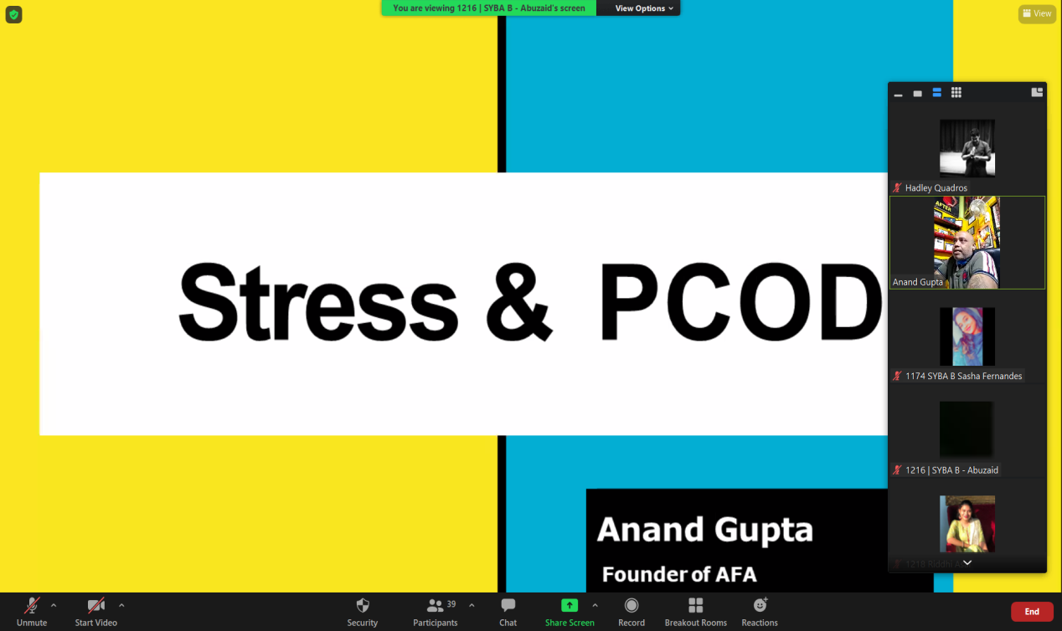
September 2021 is recognized as World PCOS awareness month. The Department invited, Mr. Anand Gupta, a nutritionist to speak on health issues related to thyroid and PCOD and stress management among the youth on 9 September 2021. The interactive session was organized to remove the myth associated with PCOD as a disease. The speaker emphasized on topics related to how to manage stress and live a healthy lifestyle especially during the time of pandemic

17 December 2021: Guest lecture on ‘Reading Gandhi's Questions and Experiments with Food Today’
A talk on food culture through the lens of Mahatma Gandhi was oragnised for the students on 17 December 2021. The lecture was titled as ‘Reading Gandhi's Questions and Experiments with Food Today’.The guest speaker, Dr. Anjali Bhatia emphasized on the values of self-discipline, an integral part of Mahatma Gandhi’s life. The speaker derided gluttony as a social evil. The lecture stressed on how food in contemporary times is syncing more with the privileged ideology of consumption of selected preparations rather than satiation of hunger. The students gained an edge on understanding the knowledge of consumption through this interactive session that relied on the message of self-discipline and self-sustenance as promoted by Mahatma Gandhi
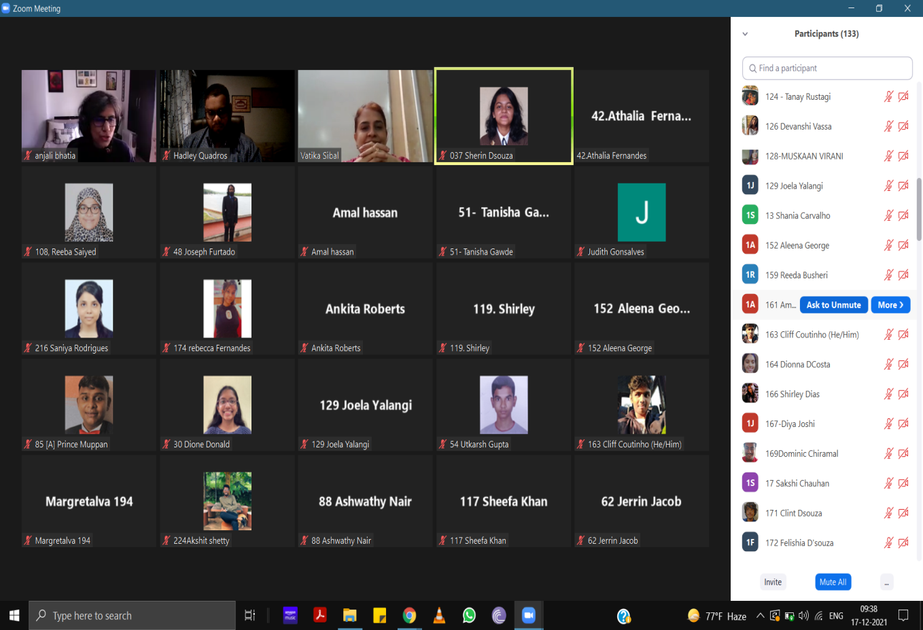

5 February 2022: One- Day International Webinar titled ‘The Paradoxical Lens: Education during the Pandemic’ as part of Crossroad Identity Series.
As part of the Crossroad Identity Series initiated by the Department of Sociology in 2021, an international webinar was oragnised as Volume II titled ‘The Paradoxical Lens: Education during the Pandemic’. The key note address was given Dr. Roy Pereira S.J ( Special Assistant to the Senior Vice President, Loyola Marymount University, USA). Dr. Roy engaged the crowd with holistic techniques to deal with stress especially during the pandemic. The techniques relied on meditation and music which separates negativity and boosts self- morale. The second session of the webinar stressed upon the challenges and learnings of rural and urban teachers in Maharashtra during Covid 19 pandemic. This session was taken by Dr. Manasi Bawdekar (Vice President- Research and M&E Salaam Bombay Foundation, Mumbai). Dr. Manasi highlighted the plight of teachers and students in rural areas during the pandemic and chalked out steps to bridge the gap between rural-urban educational dichotomies through inclusiveness.
The webinar concluded with a panel discussion. The panelist comprised of Ms. Girija Gupte (Professor. Sathaye College Mumbai), Ms. Linda Dhakul (Professor. St. Xavier’s College Mumbai), Dr. Swati Moitra (Professor. Gurudas College, Calcutta) and Ms. Ashmi Sheth ( Alumnus and Art Therapist). Themes such as accessibility, inclusiveness, communication barriers, emotional and mental fatigue, and the uncertainty of the future were explored during the phase of the webinar. The panel discussion was moderated by Fr. Nigel Barrett (Spokesperson for the Archdiocese of Bombay). The key highlights of the discussion was to highlight the loop holes in the education system and plan out a strategy to create a teaching learning environment that will help in the long run in the post pandemic era.
