Student Manual for Online Exam:

Step 1
Click on the below link.
Exam Link: https://asfc.edflyexam.com/

Step 2

You will be redirected to Exam login page

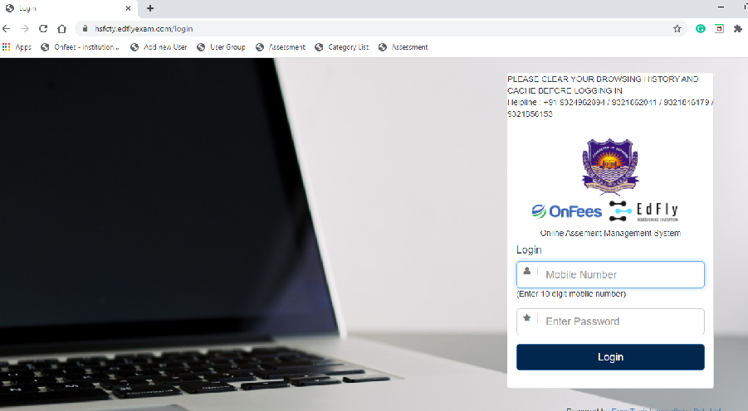

Step 3

Login with your registered Mobile number and Password as 123456 (This is one time Password)
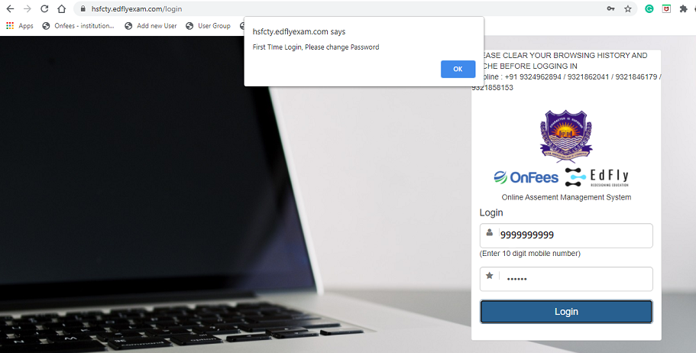

Step 4

You are required to change the password and set the new password which you will be using for all the exams.

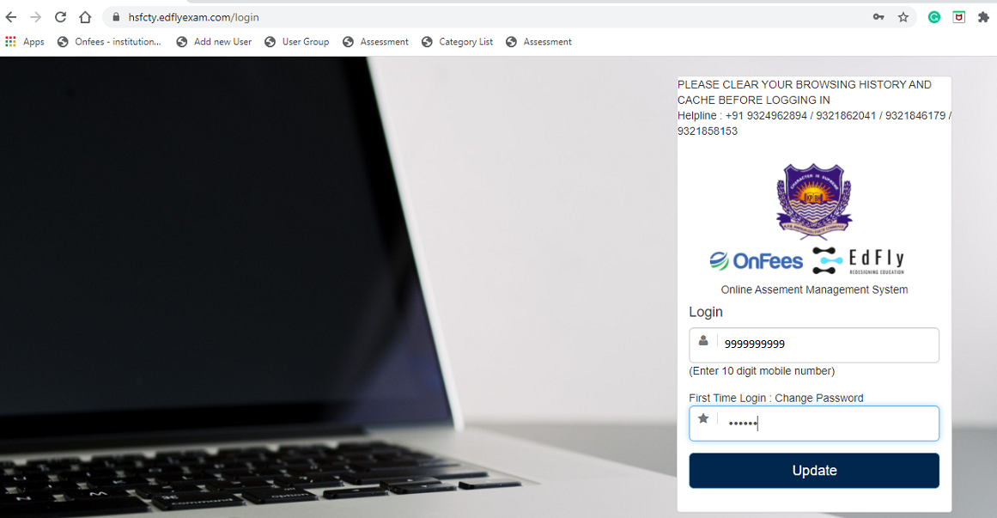

Step 5

Once you have set your new password, you are required to login again with that new password which is set by you as mentioned in step3

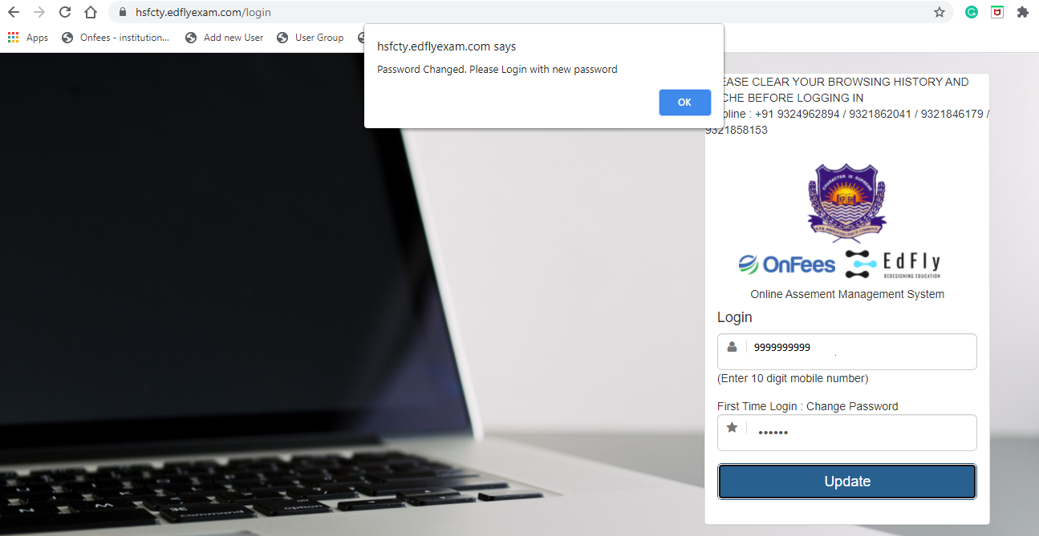

Step 6

After you have logged in to the exam portal you will have the access to give your respective exams. Click on Attempt to start with the exam.

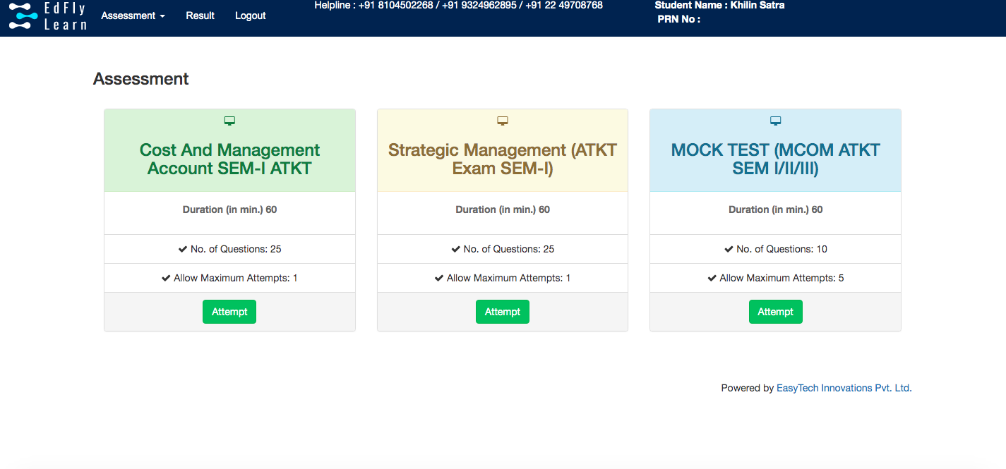
Step 7
New window will open and you will see instructions before your exam starts and at the end of instructions you will see start assessment link. It will get activated only at the time of your exam. For e.g. if your exam is between 11am-12pm then this link will be get activated at 11am onwards. Click on start Assessment and your exam will start.

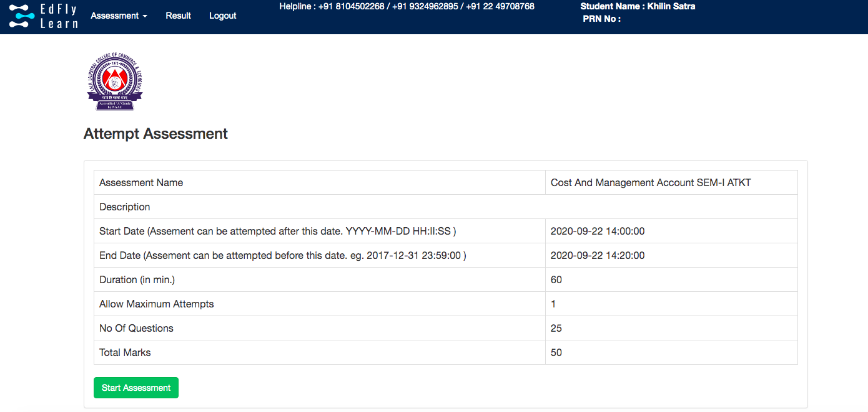

Step 8

After you click on Start assessment your exam & Timer will start.
As you see once you start answering boxes on your right starts changing colours.
You can give answers and CLICK ON SAVE & NEXT. You can go back to any question during exam time and edit your previous answer. You can mark your question if you want to review later.

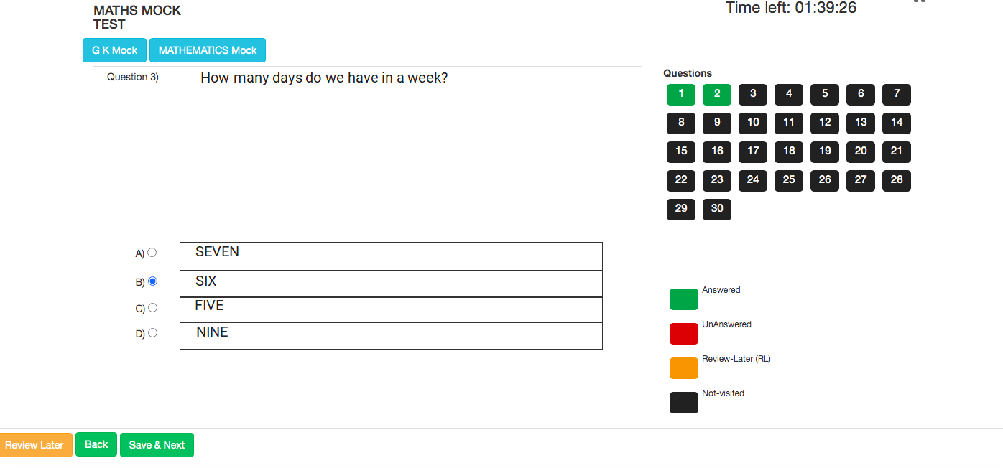

And on last question you will see SUBMIT EXAM tab.

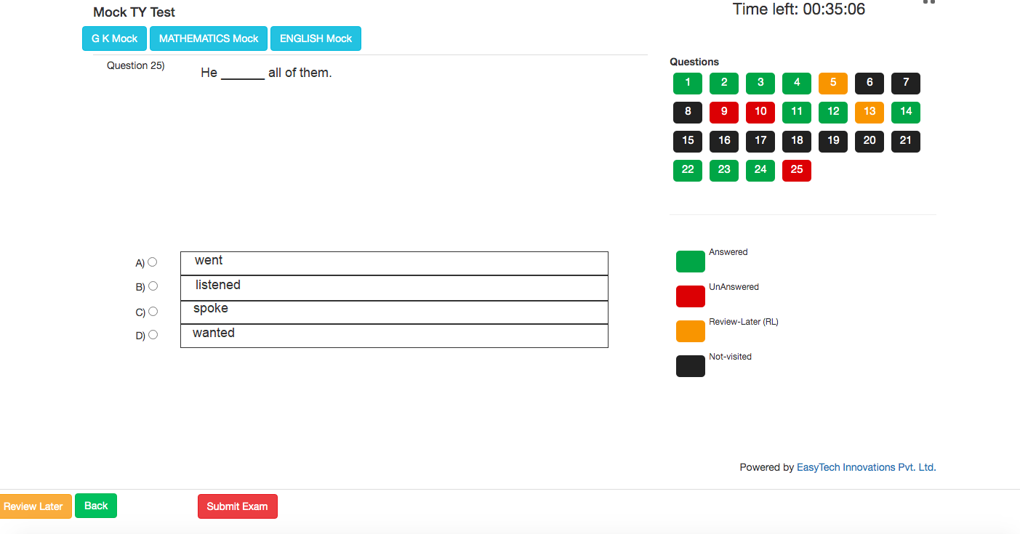

Once you click on submit tab it will ask you again to reconfirm.

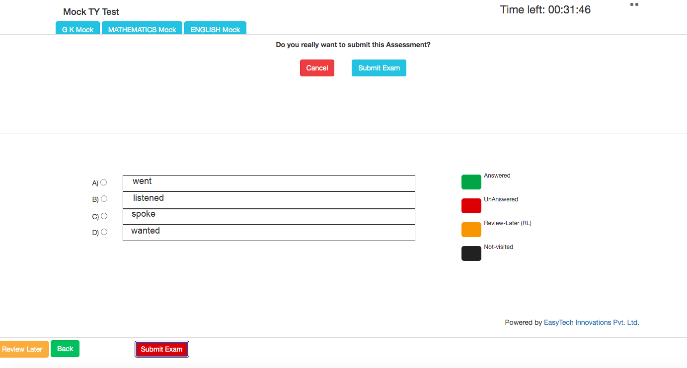

Click on Submit Exam and your exam will get submitted.

ALL THE BEST!

