ST. ANDREW’S COLLEGE OF ARTS, SCIENCE & COMMERCE
BANDRA (W), MUMBAI 400.050

F.Y.J.C. ORIENTATION DAY: 6 OCTOBER 2021

STUDENT’S NOTICE October 5, 2021

There will be a compulsory ONLINE ORIENTATION PROGRAMME for Students of Std. XI (Arts, Science & Commerce) on Wednesday, 6 October 2021 as per the Schedule given below:

Std./ Division | Stream | Time | Log-in Time
11 A & B | ARTS | 3.30 pm to 4.15 pm | 3.25 pm
11 A & B | SCIENCE | 4.30 pm to 5.15 pm | 4.25 pm
11 A & B | COMMERCE | 5.30 pm to 6.15 pm | 5.25 pm
11 C | COMMERCE | 6.15 pm to 7 pm | 6.10 pm

PROCEDURE TO LOG-IN FOR THE ORIENTATION:
Step 1: Type Edflylearn in Google Chrome, Click Enter and then Click on Home.
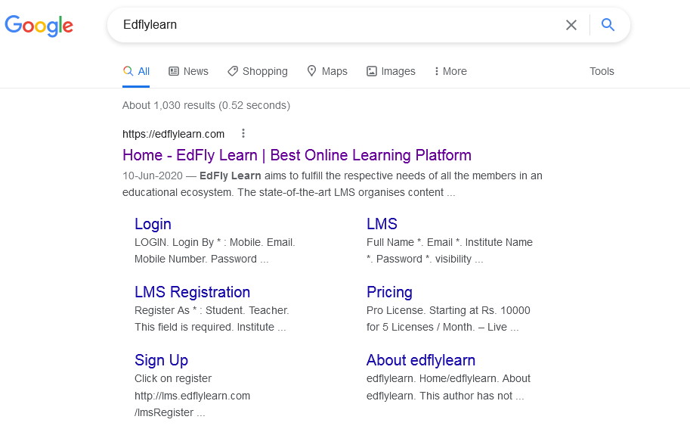

Step 2: Click on Login.

Step 3: Fill in your Mobile Number (which is registered with Edfly) and Password (which has been sent by SMS to you).
Login as: Student and Click on SIGN IN
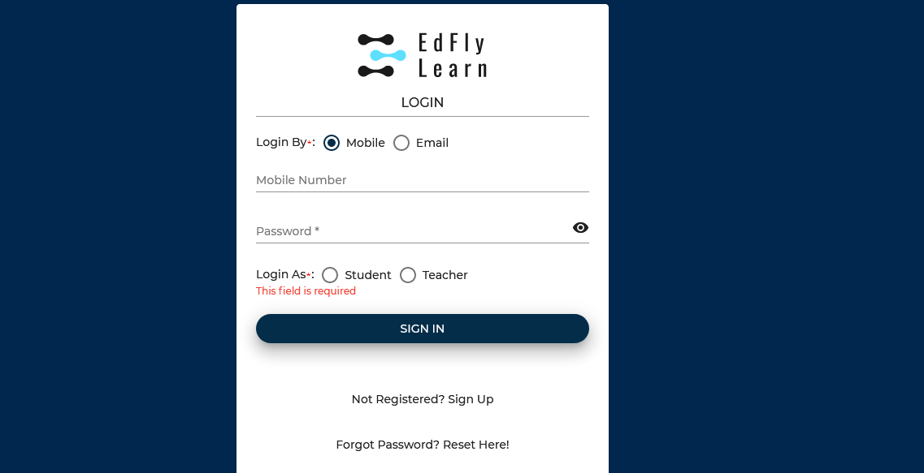
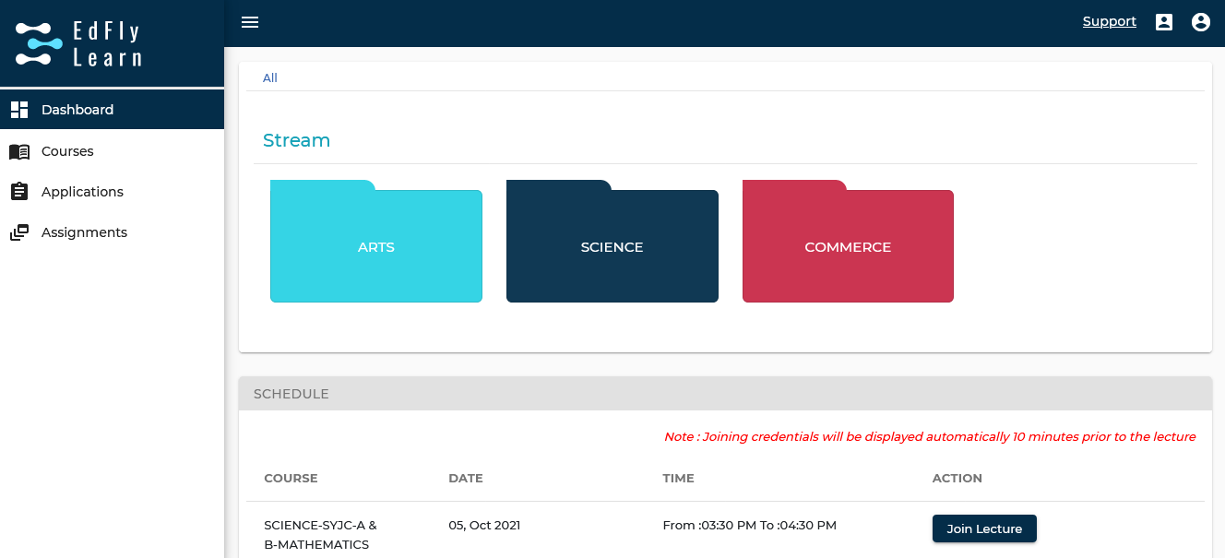
Step 4: You will be led to the following page; Click on ‘JOIN LECTURE’ button.
Step 5: After getting into the Zoom meeting;
Please Ensure: Your Microphone is SWITCHED OFF & Your Camera is SWITCHED ON.

V. Important:
1) Students who have not received their Login ID and Password can directly join in with the Zoom Link which will be posted on the College Website 10 minutes before the commencement of the Orientation Session.
2) Students should be neatly dressed with their Cameras switched ON for the Orientation programme.
3) The Orientation programme is FOR STUDENTS only.

‘All the Very Best’, for the Academic year 2021-22.

Vice-Principal,
Prof. Frederick Arland
October 5, 2021

