ST.ANDREWS COLLEGE OF ARTS, SCIENCE AND COMMERCE
NAME OF THE DEPARTMENT :
THE ANDREAN ENTREPRENEURSHIP CELL AND THE INCUBATION CELL
NAME OF PROFESSORS IN-CHARGE :
- DR. HARMEET KAUR BHASIN
- PROF. SAVINA SHENOY
NAME OF STUDENT IN-CHARGE(Term Over and handover given to new current students)
- SWEDAL PATEL
- REUBEN FERNANDES
Name of Students in-charge (New appointees)
- SAYAN SAMANTHA
- CHAITANYA
- _{CALVIN FERNANDES}

LIST OF EVENTS CONDUCTED BY THE ANDREAN ENTREPRENEURSHIP CELL AND THE INCUBATION CELL, 2020-2021
SR NO. | NAME OF THE EVENT | DATE | DURATION | SPEAKER / JUDGE | NO. OF STUDENTS ATTENDED | LEARNING OBJECTIVES
1. | Webinar : Entrepreneurship – Idea to Execution | 30th May, 2020 | 11:00 AM to 12:40 PM | Mr. Harshit Shah  Co – Founder, LeapUpEdutech | 700 live views - As of Live Streamed on YouTube | Students learnt the ideas and ways to execute their plans or targets in entrepreneurship.
2. | Webinar : Decode Design | 13th October, 2020 | 9:00 to 10:30 AM | Prof. Bulbul Choudhury,  Professor at ISDI | 13 | Advices, tricks and tips by the Expert from the Designing Area, helped students to know the significance of designing in many aspects like Brands, Logos, Products, etc.
3. | Webinar : Careers in Fashion | 13th October, 2020 | 3:00 to 5:00 PM | Prof. Poonam Mishra,  Professor at ISDI | 110 | Fashion and Non – Fashion fanatic – students had a wonderful exploration of the Fashion World, be it pricing, bespoke or bulk designing and crafting, marketing, etc. Students also were made aware about the Careers in and related to Fashion and how one can get into it.
4. | Webinar : Failure is the building block to Success | 28th November, 2020 | 1:30 to 3:30 PM | Mr. Sharad Sharma,  TedEx Speaker & Co – Founder at IAM Human Capital Consulting | 150 | Students were made realised about the importance of failure, reasons to it, prioritising the right activity as per its need and significance and most importantly, a clearer view of what exactly, entrepreneurship is.
5. | Webinar : How to suit up before a Venture Capitalist? | 25th February, 2021 | 4:30 to 7:00 PM | Dr. Karishma Desai,  Associate Professor @ NMIMS School of Law | 152 | For all the budding entrepreneurs who wish to have Venture Capitalists investing their time, money and energy into their start – ups, the session gives them the know – how of pitching and convincing the capitalists.
6. | Workshop: DIY Websites and Blogs. | 8th& 9th March, 2021 | 5:00 to 7:00 PM  (both days) | : Ms. Jenecia Rodrigues,  Java and Python Programmer & IT Trainer. | Day 1 – 115  Day 2 - 92 | Students who wish to create their own Websites and/or Blogs, had a live – first-hand experience of learning and creating one so, in future they wouldn’t have to rely on anyone else for the same. In addition, they were also made aware about the pros and cons of website and blogs.
7. | Webinar : How to Promote yourself on LinkedIn & build a pitching profile? | 12th March, 2021 | 4:30 to 7:00 PM | Prof. Jinal Shah, Associate Professor @ NMIMS | 99 | LinkedIn is a major social media platform for all the professionals. This session helped the students to understand the importance of having a LinkedIn Account, improvising professional and personal skills, and carefulness while using LinkedIn.
8. | Quiz Event : BizWhizz | 13th March, 2021 | 2:00 to 4:00 PM | - | Participants - 20 | The event helped students to familiarize themselves with the various aspects of business world such as CSR, Marketing, Startups, trends, etc
9. | Poster Making Event : Use of Artificial Intelligence in Business | 15th March, 2021 | - | Dr. HarmeetKaurBhasin,  Associate Professor, Dept. of Commerce, SACB | Participants - 8 | Students poured out their creativity and imagination in making a poster on the given topic. Also, they made sure to spread knowledge, awareness and significance of the given topic.
10. | CSR Activity : Promotion of Roadside Vendors (small businesses) | 15th March, 2021 | - | - | Participants - 22 | Students got exposure to interview someone, which would help them develop their communication skills. They also learnt about experiences and the difficulties faced by the vendors in their business.
11. | Webinar : Practical Analysis of Factory Business | 17th March, 2021 | 4:30 to 6:00 PM | Mr. Joseph D’souza, Entrepreneur. | 120 | The event helped students know practically what it takes to start a business and encouraged them for doing a Startup and taking the risk
12. | Event : Analysis and Presentation of Case Studies of the Business World | 19th March, 2021 | 2:00 to 4:00 PM | Ms. AshwiniShejwal,  Trainer and Coach | Participants - 14 | Students learned how to analyse various case studies and present different solutions to these case studies
13. | Presentation Event : Tips on investing in Lister Companies or Crypto-Currency | 23rd March, 2021 | 2:30 to 3:30 PM | Ms. AshwiniShejwal,  Trainer and Coach | Participants - 13 | Students presented their views, opinions and tips on Investing in Companies, while at the same time, were made aware about more knowledge and experiences from their fellow participants.
14. | Event : Business Ideas (Pitch Up Round) | 8th April, 2021 | 5:00 to 7:00 PM | Ms. AshwiniShejwal,  Trainer and Coach.  Prof. RiteishSheth,  Faculty @ St. Andrew’s College, Bandra | Participants - 18 | Similar to Shark Tank, students have to present their start – up ideas, explain and convince the judges as to why should they invest their time, money and energy.

THE ANDREAN ENTREPRENEURSHIP CELL & THE INCUBATION CELL -Details
Established in 2016 with a view to bring out the Entrepreneurship skills of students and encouraging them to transform their skills into businesses. Initially, the ECell wasn't known to many until 2019. The events and activities conducted by the ECell created a huge, fantastic impression in St. Andrew's. But, due to the pandemic, all the events were conductedvirtually. Here are the list of activities conducted by the ECell for the academic year 2020-21
Webinar : Entrepreneurship – Idea to Execution : Mr. Harshit Shah : 30th May, 2020
Harshit Shah, Co Founder of LeapUpEduTech, addressed students from different colleges on how to execute the Entrepreneurial ideas one has. While it usually seen, people with Entrepreneurial ideas just plan and fail to execute, here's him explaining as to how you can flawless execute ideas. This webinar was live streamed on YouTube Channel of Team LeapUpEduTech. This event was in collaboration with the Public Relations Team & the Certified Courses Cell of our college.
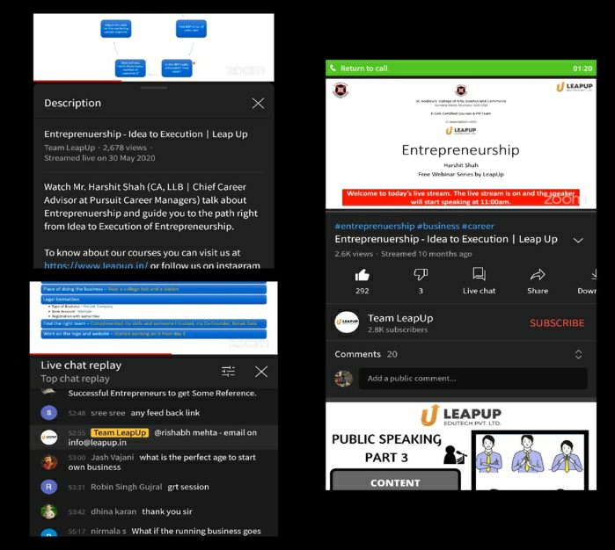
Workshop :Deocde Design : Prof. Bulbul Choudhry : 13th October, 2020
ISDI brought 2 exciting workshops for the students. The first one was ‘Decode Design’, which was all about the Significance of ‘Design’ in Products, Brands, Marketing, Sales, etc., which Students understood and were mind blown with the real time examples, the resource person shared. This workshop was in collaboration with the PR Team.

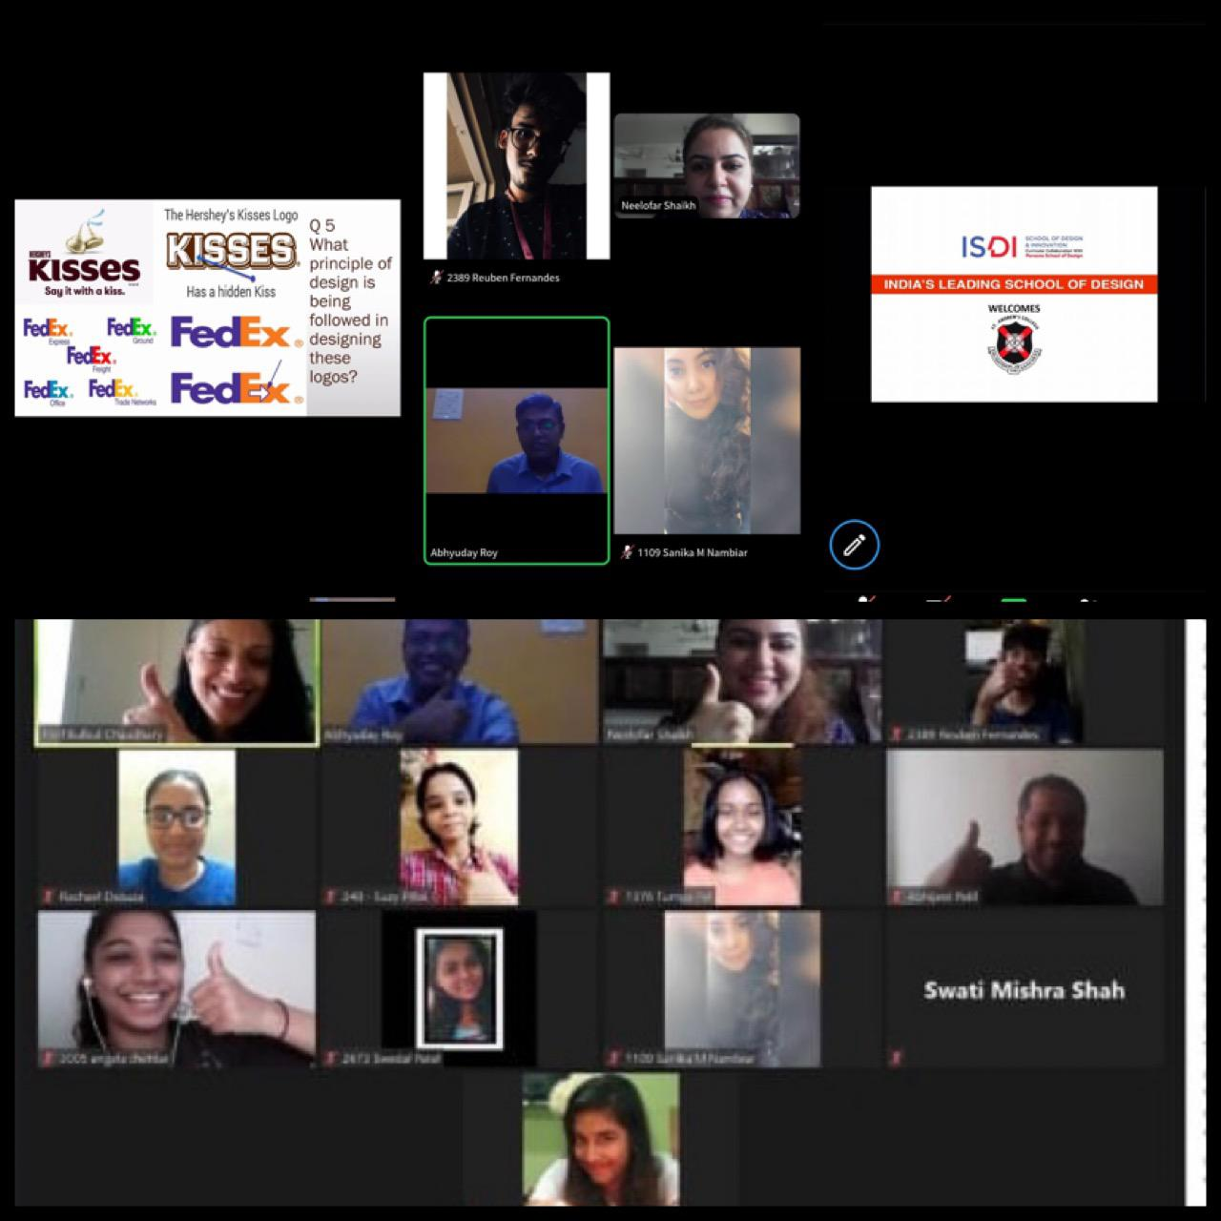

Webinar : Careers in Fashion : Prof. Poonam Mishra : 13th October, 2020
ISDI’s second one workshop on the same day, was all about the World of Fashion, students were shared with real time examples, how one can get into it, how one should go about when having an own label, and much more. ISDI, which is an institute for Designing and Fashion, too promoted about their Curriculum of Parsons (which they follow) and the Institute overall. This webinar was in collaboration with the PR Team as well.

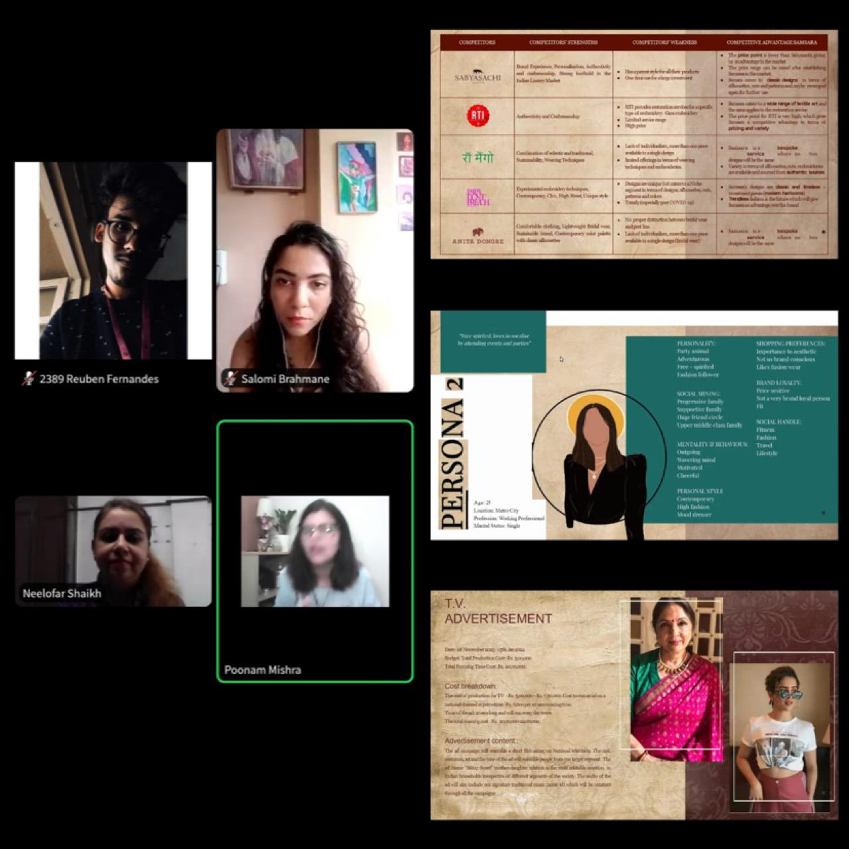

Webinar : Failure is the building block of Success : Sharat Sharma : 28th November 2020
Sharat Sharma is a TedEx Speaker and Co Founder of IAM Human Capital Consulting. He spoke about how one should understand the importance of Failure and how should it be a natural process and not a deliberate one. In addition, how to prioritise things at the right time and place, what entrepreneurship is exactly all about, and much more.He’s the author of ‘One Invisible Code’, which teaches to break the barriers of Mediocrity, rekindle the inner potential and deliver world – class results.

Host& Event Head–
Reuben Fernandes (TYBCOM - A)

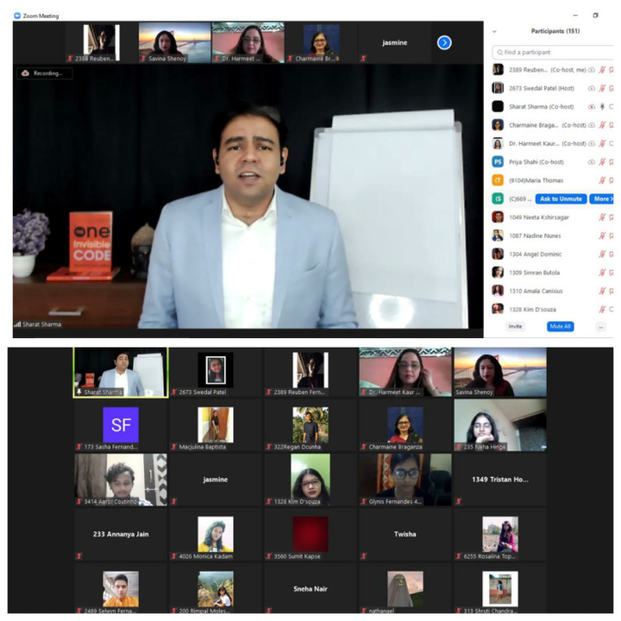

Webinar :How to suit up before venture Capitalists? : Dr. KarishmaDesai :25th February, 2021
Dr. Karishma Desai is a Associate Professor @ NMIMS School of Law. She guided the students as to how one should convince the Venture Capitalists to invest their time and money into its Start Up, by ensuring the planning, presentation, execution, returns, etc. are done well. In addition, she too shared guidance on Communication Skills and Relationships of Employers and Employees in the Firm.

Event Head :

Reuben Fernandes (TYBCOM – A)
Ridge Ribeiro (FYBMS – B)

Host :
Selwyn Fernandes (TYBCOM – A)
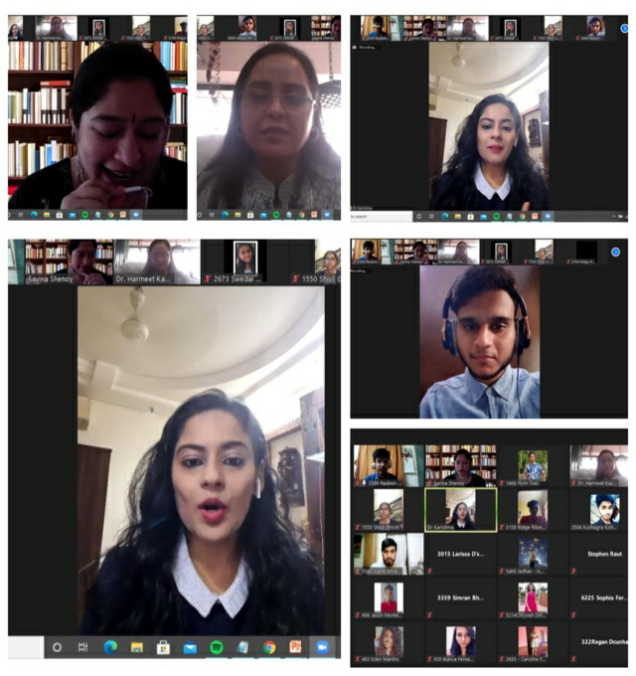

Workshop : DIY Websites & Blogs : Ms. Jenecia Rodrigues : 8th to 9th March, 2021
Ms. Jenecia Rodrigues is a Java and Python programmer & IT Trainer. Students who wish to create their own Websites and/or Blogs, had a live – first-hand experience of learning and creating one so, in future they wouldn’t have to rely on anyone else for the same. In addition, they were also made aware about the pros and cons of website and blogs.

Event Head(s) :
BraydenCastelino (TYBCOM – C)
Larissa D’souza (FYBMS – A)

Host :
Reuben Fernandes (TYBCOM – A)

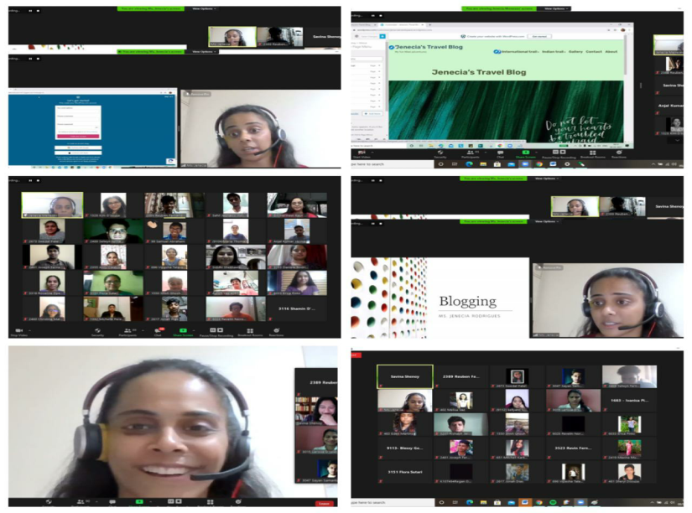

Webinar :How to Promote yourself on LinkedIn & build a pitching profile? : Prof. JinalShah : 12th March, 2021
Prof. Jinal Shah is an associate professor at NMIMS College. LinkedIn is a major social media platform for all the professionals. This session helped the students to understand the importance of having a LinkedIn Account, improvising professional and personal skills, and carefulness while using LinkedIn. Prof. Jinal Shah gave guidance on how to create an effective Linkedin profile for a successful career.

Event Head :
Sneha Nair (TYBCOM - C)

Host :
SayanSamanta (FYBMS – A)

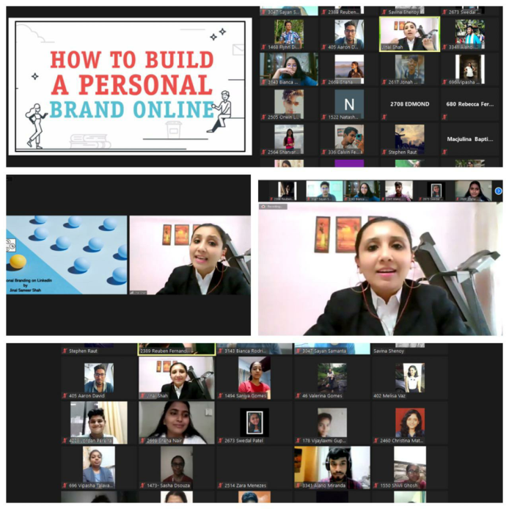

Quiz :BizWhizz : 13th March, 2021
With the use of Kahoot, an online Quiz creation & play platform, about 20 students participated in the Business Quiz that was held, to test their knowledge & familiarize on the following aspects – Business, CSR and Current Affairs.

Event Head :
Bianca Rodrigues (FYBMS – B)

Host(s) :
IshitaPrabhu (TYBMS)
Ridge Ribeiro (FYBMS – B)

Winners of ‘BIZWHIZZ’ :
1st prize: Saikrishna Naidu -SYBMS A
2nd prize: Brenelsa Pereira – SYBMS A
3rd prize: Reema Maryanne D’souza – FYBCOM B

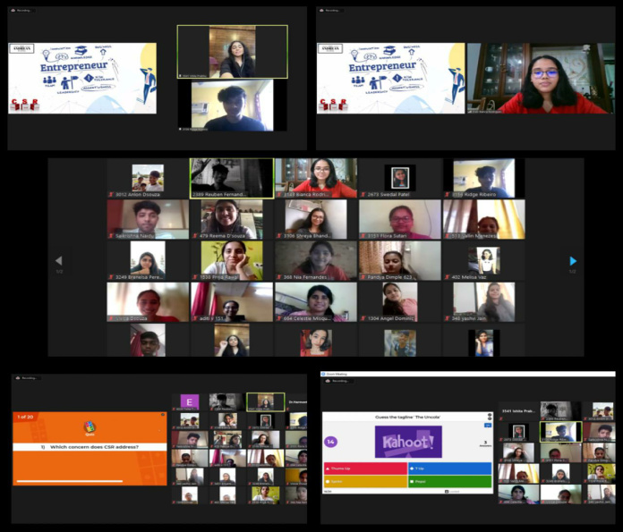

CSR : Promotion of Roadside Vendors & Small Businesses
It was an activity where Students got exposure to interview someone, which would help them develop their communication skills. They also learnt about experiences and the difficulties faced by the vendors in their business. The following collage representation is an overview of few activities.

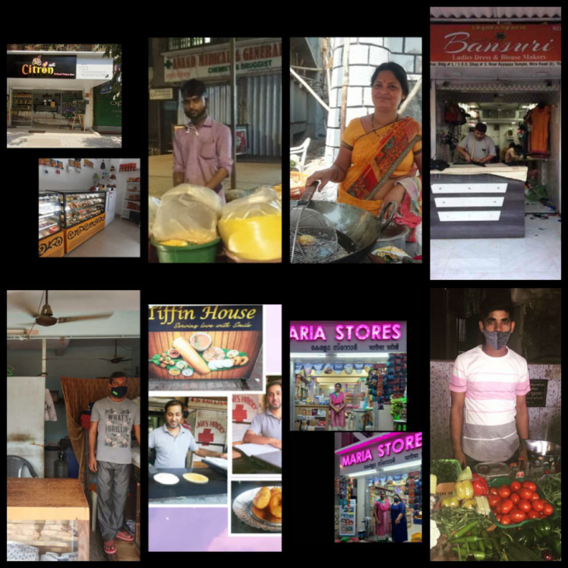

Event : Use of Artificial Intelligence in Business : Poster Making Competition
Students with vivid imagination, creativity and talent created posters on the given topic and shared their views and ideas pertaining to the topic.

Event Head :
ShivliGhosh (SYBCOM – B)

Winners :
1st Place – Simran Milton Dabre – FYBCOM C
2nd Place – Flora Felix Sutari –FYBMS B
3rd Place – Shawn Noronha – FYBAF

Webinar : Practical Analysis of Factory Business : Mr. Joseph D’souza : 17th March, 2021
The event helped students know practically what it takes to start a business and encouraged them for doing a Startup and taking the risk. There were 120 students who attended the webinar. The webinar was effective for students for starting their own business .

Event Head :
Chaitanya (FYBCOM – A)

Host :
Selwyn Fernandes (TYBCOM – B)

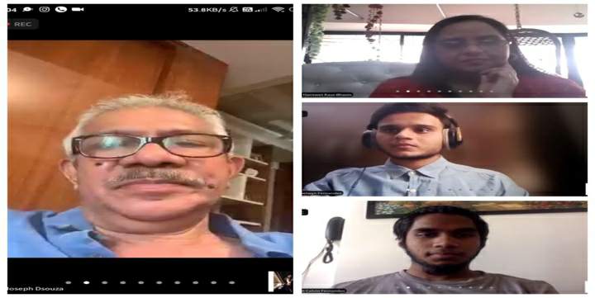

Event : Analysis and Presentation of Case Studies of the Business World : 19th March, 2021
There were 6 participants in this competition. Round 1 was an individual participation round, where each participant was given 2 case studies to analyze. Round 2 was a group participation round where each team was divided into 2 groups of three members each. These case studies were purely related to the Bsusiness World in Real Time. They learnt how to analyze various case studies and present different solutions to these case studies.

Event Head :
Alano Miranda (SYBMS)

Host :
Anlon D’souza

Winners of the case study event:-
Zenia D'souza - SYBMS A
Vivica D'souza- TYBMM/BAMMC
Aashish Jain - FYBAF
Judge :
Ms. AshwiniShejwal

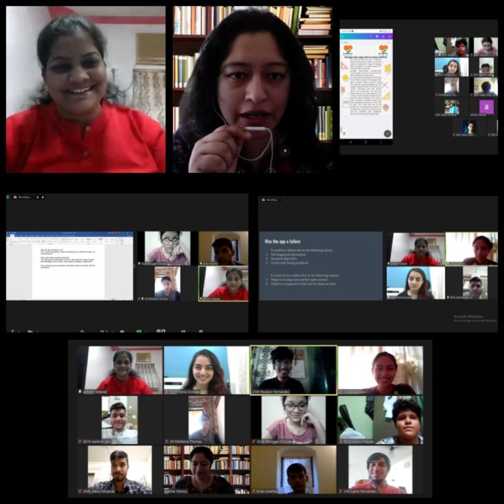

Presentation Event : Tips on investing in Lister Companies or Crypto-Currency : 23rd March 2021
Students presented their views, opinions and tips on Investing in Companies, while at the same time, were made aware about more knowledge and experiences from their fellow participants. There were in total 3 participants.

Host & Event Head :
Supriya Purohit

Winner of the Presentation event:-
Aashish Jain - FYBAF A

Judge :
Ms. AshwiniShejwal

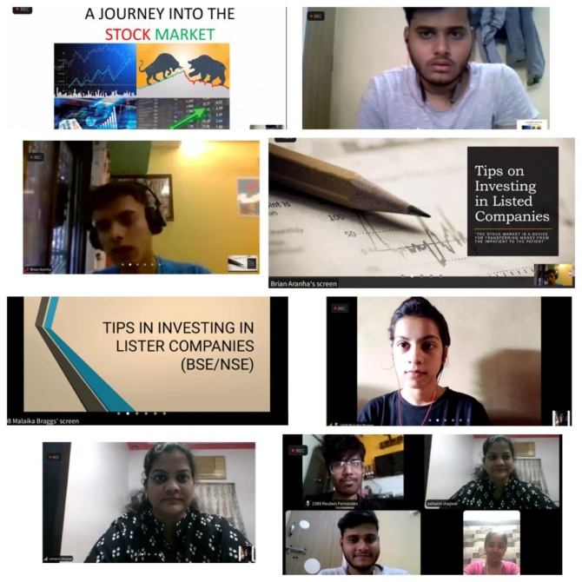
Event : Business Ideas (Pitch Up Round) : 8th April 2021
Students pitched up the business idea in front of the judges , they were given 10 minutes each for presenting their business idea. There were in total 4 participants who participated for the event.

SayanSamanta (FYBMS – A)

Host :
ShivliGhosh (SYBCOM - B)

Winners of Pitch Up Round event:
1st prize :Rohan Ashok Thorat - SYMCom A
Consolation Prize :ArmaanRizvi - SYMCom A

Judge(s) :
Ms. AshwiniShejwal
Prof. RitieshSheth

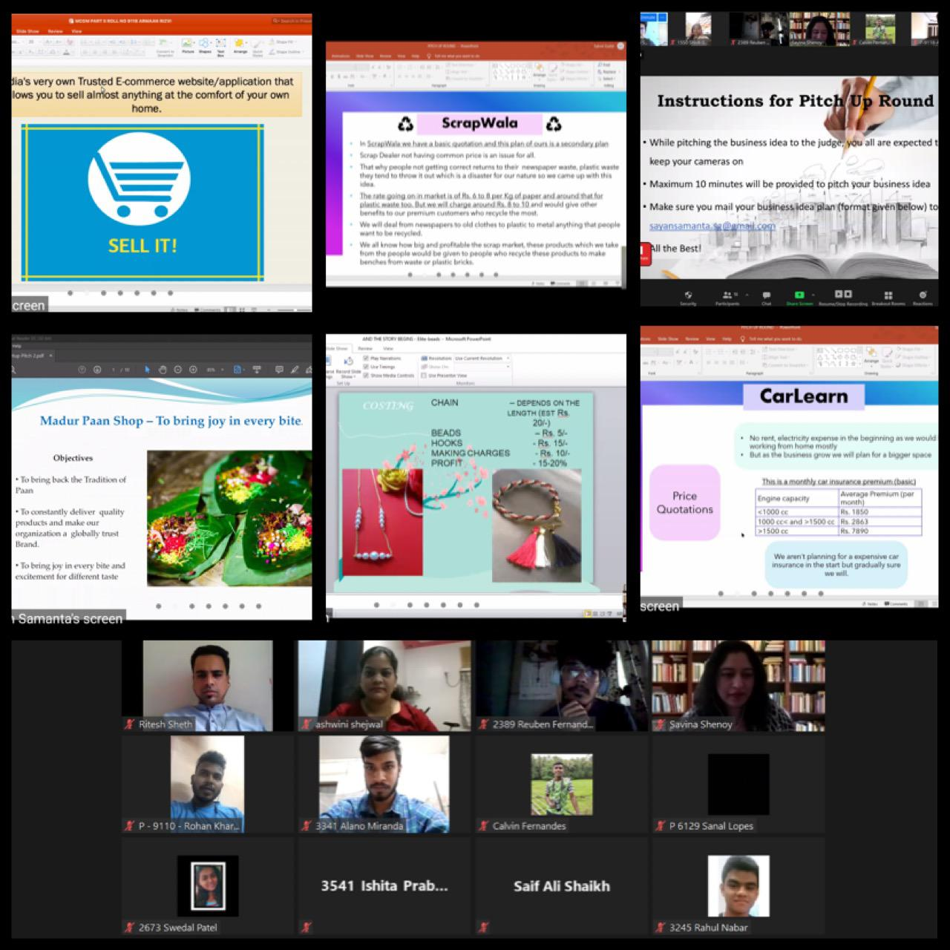

Incubation Cell – Official Andrean Merchandise and Andraprenuers
Official Andrean Merchandise
The Official Andrean Merchandise of St. Andrew's College, Bandra, was inaugurated on 11th December, 2019. The Merchandise is the Venture - Segment by The Andrean Entrepreneurship –Incubation cell , Immense love and support was received from the College Management and Professors, Current and Former Andreans. The main aim of launching the Merchandise, was –
1. To promote "Brand Andrew's", as in to promote our College as a Brand of its own to create an image and goodwill of the College
2. To bring out the nostalgia of our former students and the love for its college, through the souvenirs, the current students feeling a sense of belonging and love for the College
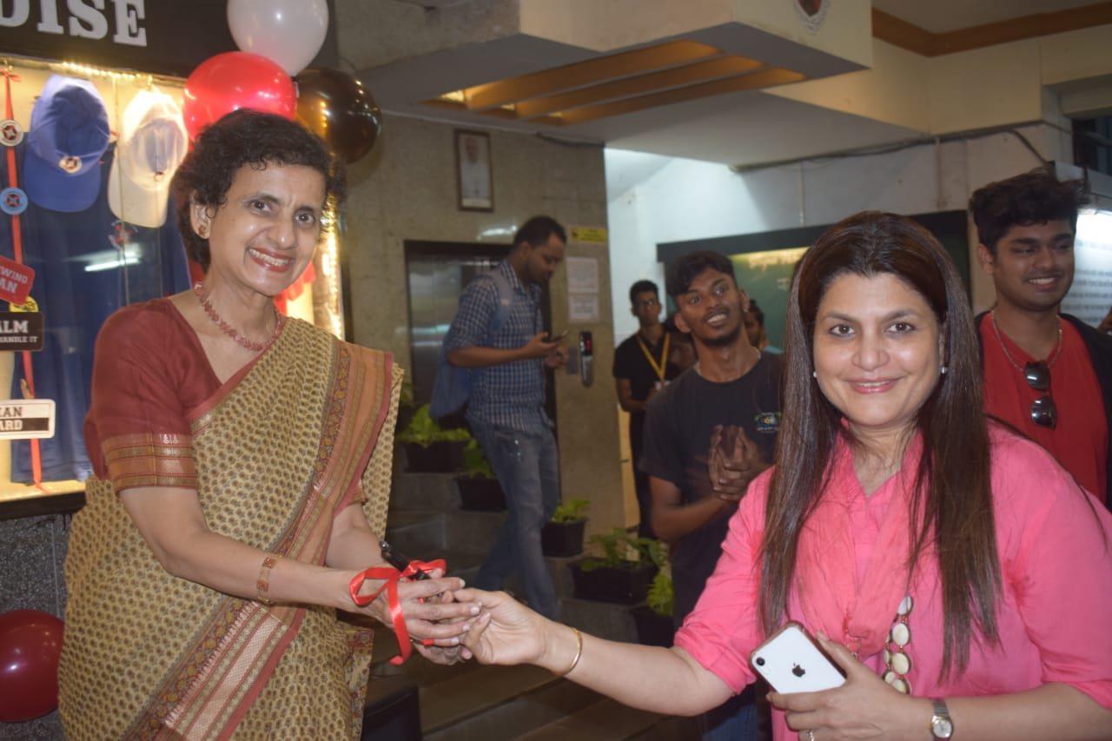 | 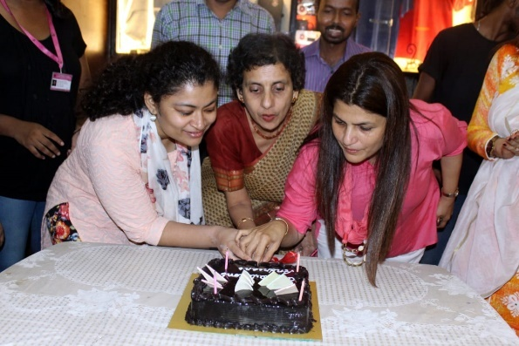

Current In-charge of E-cell – Events and Incubation – Official Merchandise and ANDREPRENEURS
Dr. Harmeet Kaur Bhasin | Ms Savina Shenoy
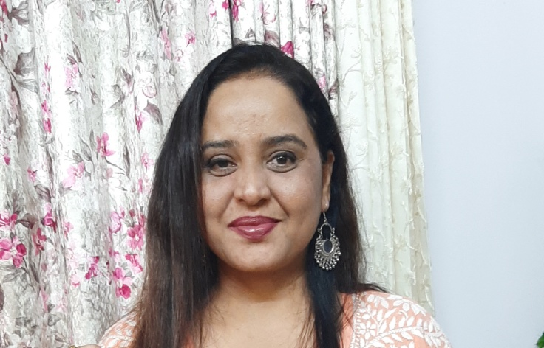

The souvenirs offered by Incubation Cell –Official Merchandise section are as follows :

Official Merchandise | Photo
- Hoodies - Zip and Non Zip (5 colour options available) | 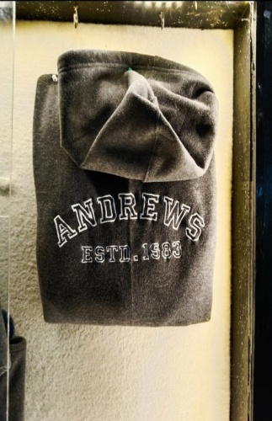
- T - Shirts - Polo Neck and Round Neck (5 colour options available)

- Caps - in 6 different Colours | 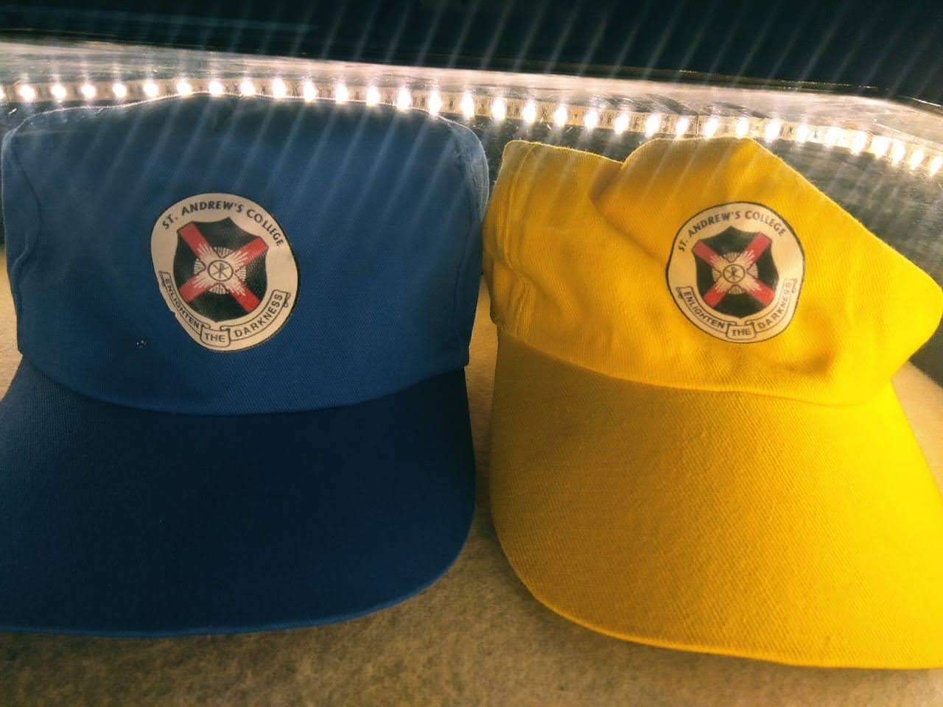
- Badges - Classic and Design (2 different types).  - The classic design are (available in 2 colours) which bears the College logo.  - While the design badges depict the everyday life of an Andrean. | 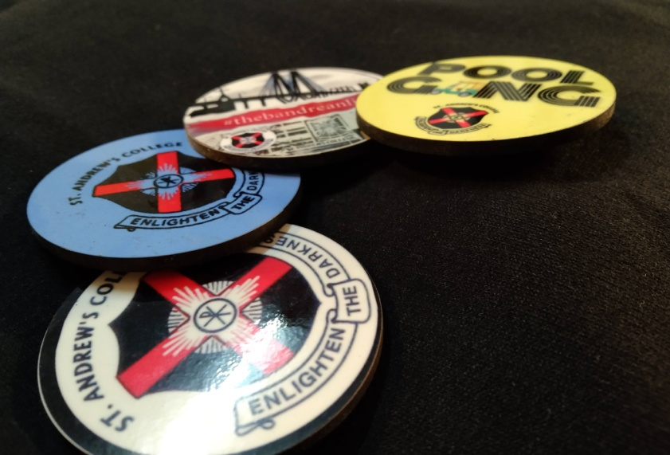
- Diaries - A simple black diary (100 pages) | 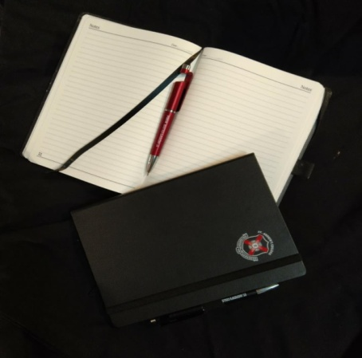
- Pens - A Multipurpose Pen, which serves to - write, holder for smartphones / tablets, and a stylus for smartphones/tablets - (available in 2 colours - Red and Black) | 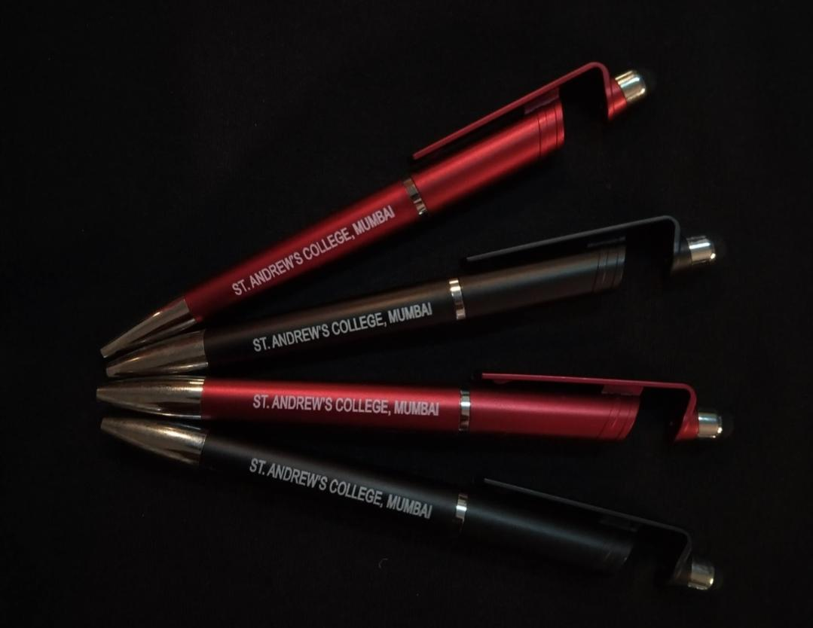
- Mugs –(Available in 2 different colours - Black and White) | 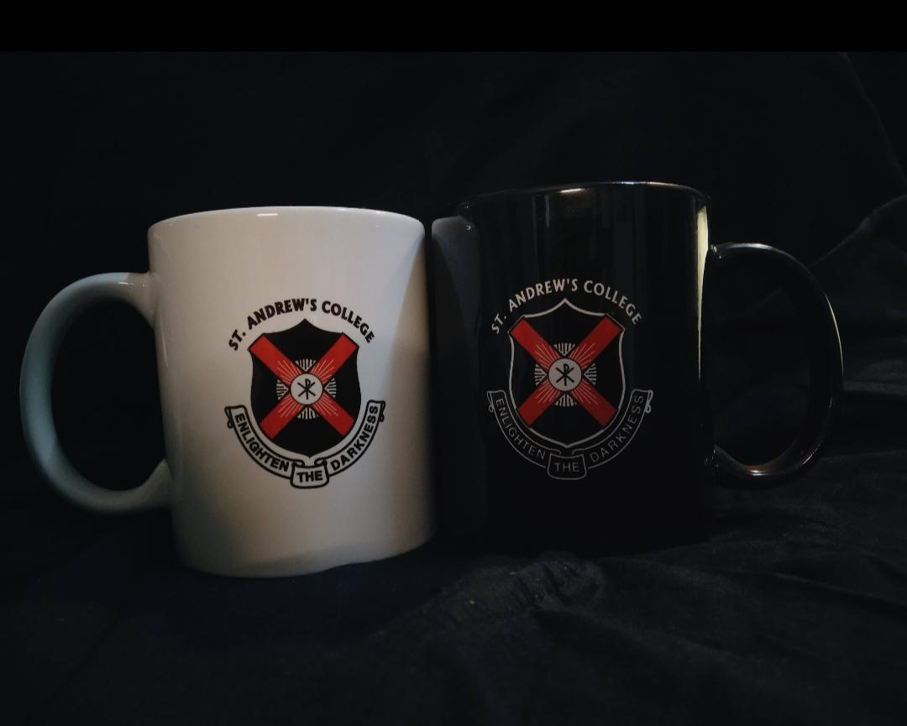
- Flasks - A steel flask (Black), capacity- 750 ml | 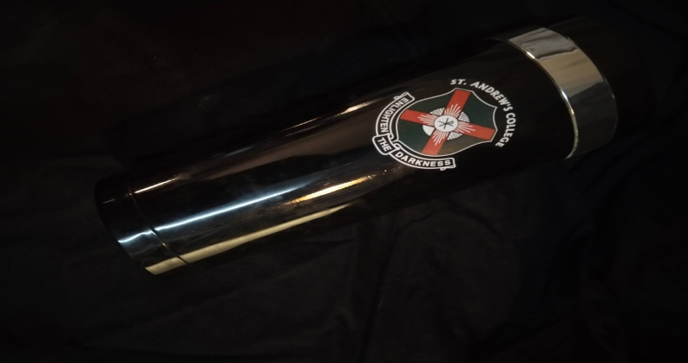
- Bag Tags - Bag Tags (Black), with Quotes on one side, and writing part on the other side.

- Vehicle Stickers - Stickers with Funky messages related to travelling (available in black, red and white)

Incubation cell – Official Merchandise Desk | 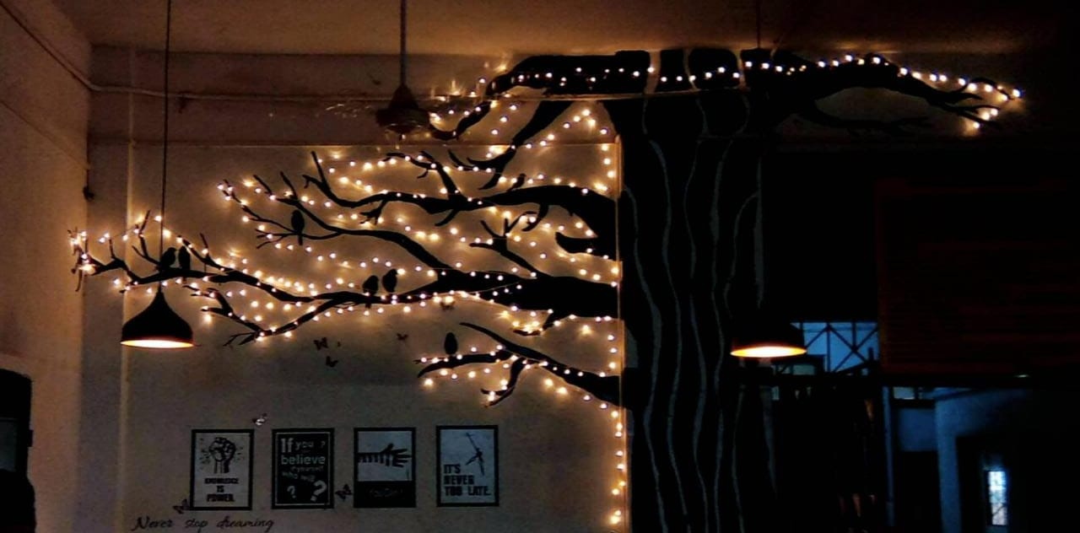
Incubation – Official Merchandise display board

A desk was provided outside the G1 room for enquiries, placing and receiving of orders and payments for the same. The launch and functioning of the same, was started in December, 2019.
During the month of March 2019, the exams for the First and Second Year Aided students had almost came to an end, meanwhile COVID 19 Pandemic strike the country. Due to which, considering safety and precautions of the citizens, all the colleges were shut, which also means, the merchandise functioning was halted till situations were clear and good. But as the cases arose, there was no way that the merchandise segment would function as it were the students who closely worked on this segment. Constant updates were made to everyone regarding the merchandise through WhatsApp and the Official Instagram.
As October approached, and situation was partially safe, the Team decided to have a check on the Merchandise Desk to ensure the products are safe. By November, 2020, placing and delivering of orders were started. As a precautionary measure, most of those who wished to collect orders wouldn't make it to college, the home delivery system was started. The team implemented green packaging i.e. recycling old newspapers into paper bags/wrapper, use of environmental friendly materials for packaging.
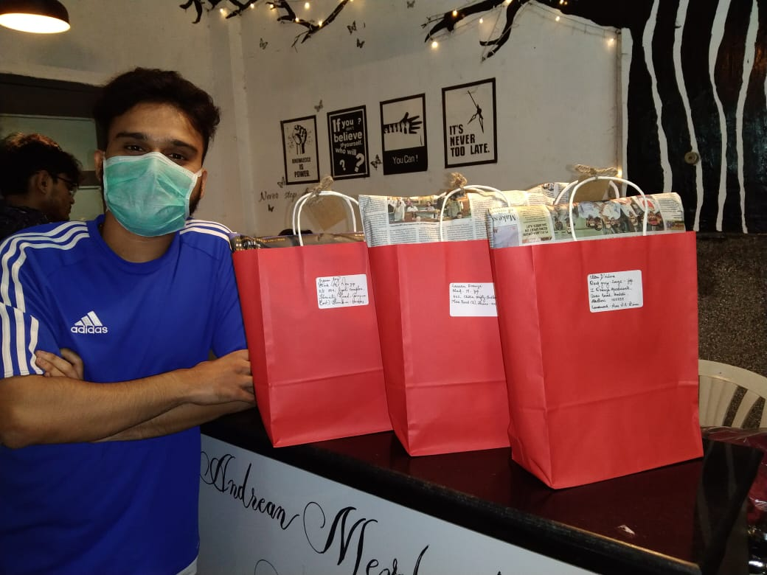

However, at the same time, the team realised the problem of customers who wished to place orders, as usually, one had to reach to the merchandise desk to place orders (which is possible when it is feasible for one who is visiting college). Thus, the Online Order Services was started. It was a Google Form that was provided to everyone, WhatsApp messages was passed on through sources and means, while on Instagram Handle of E-Cell.
A catalogue too was added to the form Incase one would want to refer and place orders and make payments for the same. The payments were done, once the order was confirmed, through UPI Platforms - Paytm and Google Pay. Accordingly, the advance sales made through these services amounted to a good sum too. It was noted that, due to the ongoing situation, the processing, completion and delivery of products would take time and it was an acceptable condition for the ones who placed orders.
However, as the cases started rising sky rocket, the orders were unable to be processed by the merchandise making vendors, and eventually, the customers were refunded. And again, a few notices were sent across Instagram and WhatsApp, notifying about the halt, and that it would be restarted only when the situations are safe.
ANDREPRENEURS

SR.NO. | Stories of the Andraprenuers and their Business
 | CURRENT STUDENTS
1. | Name: Ian Almeida  Business Name: Jinxed Network,  Class: TYBMS
Jinxed Network-Ian Almedia
Hey! I'm Ian Almeida, a twenty-year-old design entrepreneur based in Mumbai. I founded Jinxed Network, a small start-up that helps businesses conceptualise their vision through design, technology, and innovative marketing solutions.

I founded this company in college (during FYJC) with a group of friends in 2018, and it has expanded from a five-person team to an eighteen-person team in three years.

A little about myself: I've always been fascinated by design and technology, and as a child I was constantly curious about how technology has aided in our advancement in this world. I've been a freelance designer for around five years and have worked with over 75 clients in India and around the world, ranging from small business owners to large corporations. I stumbled into design by installing a design program called "Photoshop" in order to create a banner for my YouTube channel. Additionally, I assist in the management and marketing of my family's company by managing and marketing our filming site.

My Freelance Portfolio is available at http://www.ianalmeida.com

I've discovered that I'm passionate about teaching creatives, designers, and entrepreneurs about design, technology, and innovative marketing, and it's through Jinxed Network that I power my vision and mission as Founder & CEO.

- What motivated you to start the business.
One of the primary reasons we started this was because – We recognised that everybody is capable and capable of something in life; the only issue or concern we had was how to monetize our abilities? How do we earn money doing what we love? We took on numerous challenges and responsibilities in pursuit of this response. The solution was straightforward and straightforward, and our primary objective now is to assist those who are still on the lookout for this solution.

Jinxed began as a platform for us to share our talents, gain learning experiences, and market our abilities. We began with a variety of ideas and obstacles that placed us in a variety of circumstances and sometimes forced us to face failure. However, these activities allowed us to develop a variety of skills and expertise. Today, we've discovered that we can do more as a Team, as an organisation of mature entrepreneurs capable of disrupting an economy and slashing through the competition in today's sector.
- What is your business about.

JINXED™ is a community-basedcreative branding studio powered by a collective of like-minded individuals. “Jinx” is also a phrase used to describe when two people say the same thing at the same time. Similarly, we enjoy networking and partnering with individuals who share our vision and ability to execute.
We assist businesses in conceptualizing their vision through design, technology, and innovative marketing solutions such as graphic design, content creation, website design and development, video production, and blogging.
Jinxed's central philosophy is to collaborate with like-minded individuals who are actively generating ideas, sharing their perspectives, and assisting us in achieving shared goals and objectives by using the tools available to us today.
Learn more at www.jinxed.in | www.jinxednetwork.com

- What stage is the business in
We are now in the growth stage, which means we are simultaneously building our clientele and team. Each year, we update our strategic plan, which outlines our year's objectives. This year, we plan to double the size of our team of entrepreneurs, designers, and creatives by the third quarter.

- Important details about product and strategy
Our Objectives at Jinxed Network are as follows:-
• To help businesses reach the right customers using principles of design and branding along with a marketing mix.
• To Transform businesses into brands using the right tools and expertise with a dignified workforce.
• To help businesses create a sustainable growth by visually communicating their vision and brand values to their target audience.

As a Community based Creative Branding studio – We provide the following services: -
1. Social Media Marketing – Designing Creatives, Handling Accounts, Providing Consultation to our clients with regards to growth on social media platforms. Ad Management and Placements.
2. Branded Video Content – Video Production, Content Creation, Directing, Producing and Editing Videos. Shooting Footage and essentially branding it for the client.
3. Web Design & Development – Building a Website from A to Z for a client, Designing and Developing the website according to the client’s needs and preferences. Maintaining the website monthly.
4. Branding & Brand Identity – Crafting a Brand Strategy, Designing a Brand Identity (Logo) and extensions, ensuring overall communication of Brand values.
5. Augmented Reality for SMM (New) – Designing Face filters for Brands and other AR Collaterals for Instagram and Facebook.

As an entrepreneur, one will face a variety of challenges and obligations. Working in a start-up is extremely educational and enlightening because you gain hands-on experience working with a team while constantly developing operations to support the goods and services that solve problems.

Entrepreneurs are problem solvers. There are a thousand different ways to solve a single problem; the only constraint is that you must invest the necessary time, effort, and commitment. To carry them out.

Numerous times, I've encountered difficulties with team management, dispute resolution, and client service. Aligning yourself with your colleagues and with your team's goals takes time.

There are challenges with teaching other people – sometimes there are collaborators that don’t have the willpower to learn or lose the momentum to learn. Hence, there are various measures that have to be taken to solve these internal problems.

As an entrepreneur, you are compensated in proportion to the problems you solve; hence, my position at Jinxed Network entails no fixed income. However, I continue to enjoy contributing to Jinxed Network's mission and vision. I've gained a great deal of knowledge and discovered many resources as a result of these challenges.

I want to work harder and continue learning about my job and the start-up I am establishing. Jinxed Network will continue to assist businesses in Mumbai and throughout the world with design, technology, and innovative marketing solutions.

The critical point to note is that awareness has the ability to alter the course of events. We can reliably predict that the world will be a better place if we make effective use of learning and knowledge development.

This planet desperately needs more entrepreneurs, career creators, and problem solvers, and we are just doing our part.

2 | 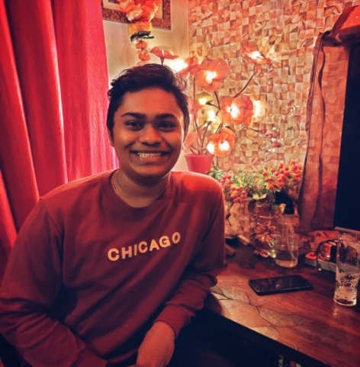  Name: Denver Nazareth  Business Name: Craft Buzz  Class: FYBSCIT
 | I always loved creating new things and trying different stuff, and this made me think why not try to sell the things I love creating. This thinking motivated me to start by resin business. So today I would like to talk about my Small business and the questions I am commonly asked as a small business owner. I started selling resin Keychains/pendants/earrings and scrunchies and I'm always adding new products to my business. Resin products are hard/durable and can withstand any condition without loosing their beauty and that's what I showcase people. My business strategy is that I try to learn what my customers want and adapt myself accordingly. Owning a small business has its challenges, some days you will be packed with orders, some days you won't have any. But it's the thrill and excitement to make new products that keeps me going.
3. | Name: Raelle Daniels  Business Name: Little Lili  Class: FYBA B
Little lili -Raelle Daniels
Staying at home during the lock down, watching Netflix , listening to music, playing indoor games wasn’t enough so I decided to try a different DIY everyday. After scrolling a lot on Pinterest the idea of making jewellery plates was stuck in my head but I knew I wanted to make something different and I did.
I posted my idea of making jewellery plates on Instagram and all my friends asked if they could buy it from me . That’s
how Little lili started on 26th September 2020. The main goal-of my business is to provide cute, trendy stuff at really affordable prices . From making jewellery plates-to making crop tops it’s been quite a journey. I try to make sure I post regularly, interact with my followers ,etc it may not be a big page but I enjoy what I do to while away time.

4 | 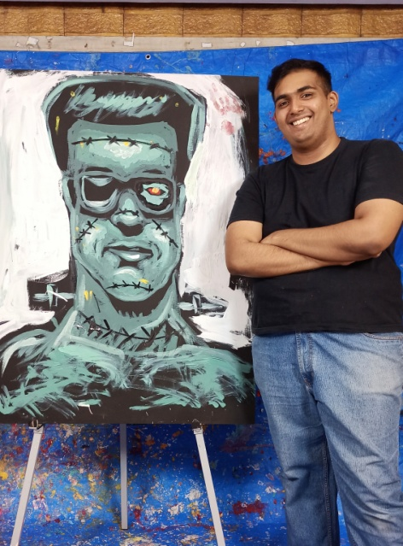  Name: Vishal Gohil  Business Name: Artomization  Class: TYBMM Advertising
Vishal Gohil -Artomization (Speed Painting, Painting, Sketching, Digital Art and more..)

Before I had started my own freelance work/small business, I had initially made as many Artworks as I could, ranging from Sketches, doodles to Paintings which at first I was a bit hesitant to share with others but I finally did. After much deliberation I had starting posting my work online on Instagram and Facebook. That became a reference point for many of my clients who were looking for Artworks. Initially much of my orders started from good old word of mouth after which my Artworks online were used as a reference to my work and to see if my vibe and skills matched what my respective client was looking for. From then on it was and still is a journey of ups and downs but definitely full of bliss and satisfaction which I thoroughly enjoyed.
The idea to start my freelance/small business journey had come to me after I had received good feedback a few years ago regarding my Art from my peers, friends and family. After receiving an order for three Paintings from a good friend in my first year in BMM, I realised that I really enjoyed it while I had also made some pocket money as well. I had wanted to start a business for a long while but didn't know what I wanted to sell, after the above mentioned instance and after much encouragement from friends and family for my Paintings, Sketches and Craft work I decided to take regular commissions for Paintings Sketches, Digital Artworks and Speed Painting Performances. Following these events, I had rediscovered a love for Speed Painting (Painting live in minutes to music) after which I decided to make it an integral part of my Art journey and prior to the pandemic my main focus.
While being a college student it definitely gets a bit hectic managing college life with a Freelancing / Small business but nonetheless is extremely fulfilling. It was definitely a little more hectic prior to the pandemic but due to restrictions imposed by the lockdown things have slowed down significantly (especially Speed Painting Performances due to venues being closed)
Nevertheless we learn to move with the times and make the best we have regardless of the situation. I keep posting as much content as possible on my socially media handles such as Instagram, Facebook and YouTube while also networking with friends and associates in order to identify a need for my product by staying as active as possible.

Due to the pandemic and it's outcomes we need to stay indoors as much as possible while remaining connected for our businesses or with our friends, family and loved ones. For me Social Media has been very handy not just as a reference point for people approaching me through known channels but also for new clients who have randomly come across my page and who have expressed an interest in purchasing an Artwork. I try to be as active as possible on social media trying out new trends, revamping old ones, posting videos (Time-lapse, showcase, or tutorials) in order to engage with as many people as possible.
Some of the things I wish I knew or was advised of when I was starting out would be staying true to your own style and vibe regardless of what is going on, be it trends, influences or demands. There will always be someone who requires something that you are providing regardless of how niche or rare your product or service is, you don't ever have to change your style because it doesn't appeal to others. Trust the process and you will find the right audience if you yourself believe in your work.
Also be as active as possible when it comes to producing content or products, whether it's posting on social media or just engagement. Even if you're not active that's alright, just keep building a portfolio and keep it handy because you never know when they opportunity arises.
Sometimes you may feel low or under the weather, demotivated or mentally burnt out. One must always remember it's okay to take a break, reorient yourself and get back. (this will happen often while working on detailed products) Forcing or pushing yourself will burn you out further making it harder for you to bounce back. Just remember stick to deadlines.
Also as artists we must remember that we all are unique and possess different abilities at different skill levels and we must try to avoid comparing our work and skills with others which would only put one further into a slump instead of continuous improvement. I made that mistake in the past but I try my best to improve my current skill set and knowledge to the best of my abilities because life isn't a race but a beautiful detour along the road with a scenic view along the way.

5 | 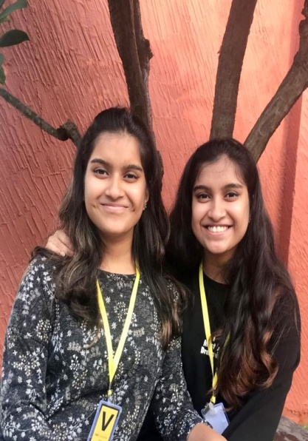  Name: Alethea Alphanso and Alexis Alphanso  Business Name: Twingredients  Class: FYBA A
Twingredients -Alethea Alphanso and Alexis Alphanso

Hi everyone we’re home bakers, teenage twins who have learned baking from our Mum and through trying out our family favourite recipes and recipes from the Internet. Our baking business is in its youth and will need a lot of hardwork from us and support and encouragement from everyone to blossom into its full potential.

Twingredients was born out of our sheer love & passion for baking and our love for strays. Not only do we get to bake, create & share some amazing designs & goodies for our clients, but our profits go towards feeding, neutering and medical expenses of the strays on our streets and in shelters.

All our products are made to order and with the best ingredients. They are also customisable as per the client’s requirements. We mostly promote our products through our Instagram page and through word of mouth. Our business strategy is to be up to date with all the trends and constantly updating our skills.

6 | Name: David Jayaprakash  Business Name: Character and Colour  Class: SYBA - A
Character and Colour-David Jayaprakash

My journey started as a hobby. I enjoyed drawing, painting and sketching and eventually it motivated to produce more work. People started taking interest in it and soon I was selling my work to people and doing small commissions for different projects. It gradually grew into what it is today.
I sell artwork and do art commissions along with my mother who has also contributed greatly to this endeavour. Both of us are passionate about this profession and we hope to bring mutual appreciation and unity through our work. We work with several materials and mediums and there's always room to grow and learn more.
The business is still in its initial stages, it is still mainly our passion that keeps running it. We have a community that appreciates our artwork and it has only grown from there since we started very recently. You can find us on Instagram under @character_and_colour who works in partnership with @liz_latalentodedios.
We work with our strengths in particular mediums and themes but we are open to finding out new styles and methods of creation. All of our products are originals, and we ship our products within Maharashtra and occasionally out of the state. We assure our clients of premium quality in every piece. Our strategy is to maintain clarity and transparency between our clients to avoid miscommunication. We always have happy satisfied customers which motivates us to put our best in every artwork.

7 | Name:Haile Henriques (SYBMS B) and Titus D'souza (TYBMM- Jounalism)  Business Name: The Social Stamp
The Social Stamp’- A little about us(Haile H)

Hello there! We’re The Social Stamp and we’re really glad to have the opportunity to show you who we are, what we do and what our goals for the future are. So without further ado, we’d like to invite you to hop with us onto our wonderful journey.
Our motivation
‘The Social Stamp’ was founded by Haile Henriques and Titus D’souza in August 2020. The intention to begin our very own social media management start-up for small businesses was ignited by Haile’s vision to help the several budding businesses that began during the months of the pandemic navigate through the complex and often-intimidating world of social media.
Our motivation has always been to provide organic solutions to the media needs of those running small businesses at prices that are affordable, while also making sure there is no dearth in the quality of work we put in.
What ‘The Social Stamp’ is all about?
As we already mentioned earlier, The Social Stamp is a social media management start-up that aims at helping small business make their mark and find their niche through the complexities of social media platforms. As our focus is on helping small businesses grow, we generally aim to provide organic social media solutions to our clients, as this helps them achieve their target audiences without having to shell out huge sums of money.
Along with the already-mentioned social media management services, we also provide a host of other services that include content creation, poster design, photography, video production and general consultancy.
The Social Stamp has helped several businesses-ranging from handicraft start-ups to baking businesses to educational ventures-express themselves to their target audiences on social media platforms with the help of catchy captions, attractive high-quality photography as well as enticing and informative posters and banners.
Our start-up’s current stage
Currently, The Social Stamp is in its growing stages. As young entrepreneurs ourselves, our start-up has taught us some valuable and helpful lessons, while also helping us make a difference to the dreams and aspirations of several budding entrepreneurs, all while also honing our own skills and crafts.
We are constantly on the look-out for opportunities to work with businesses, understand their needs, and study their visions, helping them to achieve their goals without having to spend absurd amounts of money.
What makes The Social Stamp so different?
We believe one of our biggest USP’s is our dynamism that stems from us being young. Being youngsters, we are able to better understand the current climate on social media platforms with regards to trends and what works and what doesn’t. This enables us to provide a unique, dynamic and relevant outlook to the way we plan and strategize for our clients’ needs.
Our modern approach helps reduce the burden that small businesses have to shoulder when they implement the use of social media platforms to market their products or services.
Additionally, the fact that we offer multiple services under one banner at reasonable prices sets us apart from the rest. The value and importance of photography, video-making, content creation and poster designing cannot be stressed enough in a world that is increasingly moving towards the digital sphere in these unforeseen circumstances.
So then, that was all about us at The Social Stamp. As we grow with time, we hope to keep learning and keep evolving in our approach to fulfilling our goals of making social media much more approachable and user-friendly, especially for those who are unfamiliar with the latest happenings across social media platforms.

8 | Name: Ashbelle Rozario  Business Name: ArtisticBlueRoz  Class: SYBA A
ArtisticBlueRoz by Ashbelle Rozario
“You want to be Unique, Reach out to the ABR Boutique!” This creative art Small Business is run by me, Ashbelle Rozario. Art, Craft, sewing, designing has been a blessing to me throughout life and the creativity kept flowing throughout my academic years. Initially, converting an obvious and appreciated talent into a small business seemed daunting but now, with the positive response from friends and family, the encouragement and support from buyers and the experience I have gained along the way made an idea a reality. In a fledging stage, ArtisticBlueRoz is all about keeping art alive and be it on garments, earrings, masks, shoes or bags, the ultimate product speaks for itself. Notwithstanding the present scenario, I hope ArtisticBlueRoz will continue to grow and be an inspiration to others. Thank you!
Current students in the Business pitching stage to venture capitalist and other investors
1 | 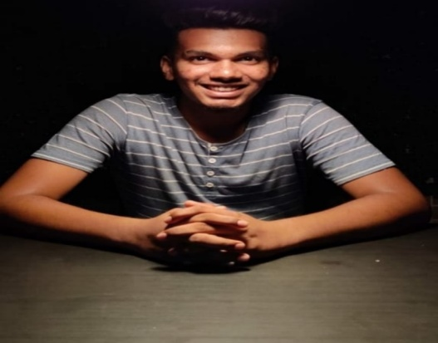  Anthony Fernandes & Vivek Yadav – Sy BSc IT
Idea/Strategy: (pitching to different venture capitalist)
“ Hi I am Anthony Fernandes. I and my colleague Vivek Yadav we are planning to start an E-commerce business related to fashion mainly focus on Shoes,
Our vision is to create a online platform where our customers can buy a hand painted customized shoes, And also they have liberty to elaborate their idea by sharing their idea on customized their own shoes and accordingly we will design and reach to their expectations and provide the shoes at reasonable price.
Also we are planning to engage designer (Students) as an intern who are willing to contribute in creative designing and if their designs are liked by our customers then we will also provide the interns with a stipend and more.
As for advertisement we are planning to initially start with social media as a platform for marketing and as the business grow will start our own website and with more further plans.”

2 | Supriya Purohit - SY BSc IT
Idea/Strategy: (Pitching stage)
“ Hi I am Supriya Purohit. My idea is to do a service based Startup in IT. Where I’ll Team up and approach many young minds in their specialization of field in IT (Branding in IT, Android developers, Web developers ) where will deal with clients and try to solve their real world problems by providing best of our services.
So first my strategy would be to help students in their projects which would indirectly help us to solve the real life projects problem and in that way slowly and gradually would like to expand my business by making a website and by hiring peoples for marketing which will lead many clients and so on.
At the end I would like to say that ‘Team work makes the Dream work’ ! “

3 | Aldrin Periera - SY BSc IT
Idea/Strategy:(start up)
“ Hii I am Aldrin Periera. So recently my mom started baking just as a hobby (whatever she bakes it tastes so yummy ! ) I have started this as a small scale business which could help my mom to continue with her hobby also my strategy would be including many more Housewives in this business which could help them to kickstart in their interest and their career too. Also my next strategy would be to market it to the highest level where I’ll use many social media platform to expand our business. All we need is determination and patience to start any business and I have a strong faith that one day it going to be very successful just because of our consistency and determination!

4 | 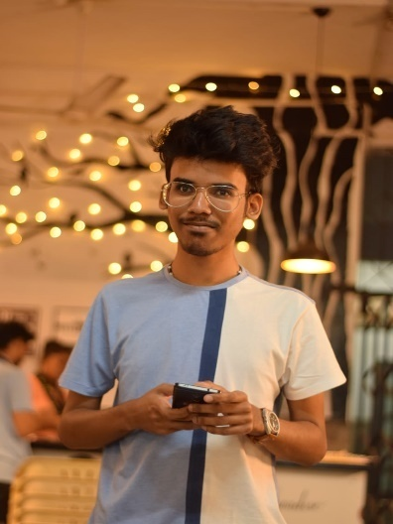  Name of the Startup: - paininpainting  By:- Reuben Fernandes TY.BCOM
Not really a start-up cause I've to yet register, but yes, I do digital artworks, illustrations and paintings. Illustrations are the cartoonist versions while paintings are like actual detailed artworks I do digitally. As of now I sell soft copies, post when situation is normal or safe, will give hard copies too.
it’s mostly social media. But otherwise, the only strategy I can rely on is how well and uniquely I create artworks. Just being out of the box
As of now my short term goals are to reach targets that I aim for. Definitely it will be a slow process but yes, will go longer for sure.
In a lot of ways ECell has helped me. Cause I just have not one, but many plans to start different businesses

5 | Name of the Startup: - Chocolicious  By:- Calvin Fernandes FY.BCOM
what motivated me to start a business was that during the pandemic I was jobless doing nothing, so I came up with the idea of Chocolate business.
so basically I make Chocolates of different varieties, flavours, chocolates for a particular festival as such. Also by my business I help one of my friend who is dealing with financial crises by giving him the chocolates to deliver to the specific location as ordered.
Attract more customers by the way of more WhatsApp groups, contacts Instagram page.
Invest less & earn more, so that you earn profit rather than recovering cost in the longer run.
E-cell helped me to get an exposure of how to go about & handle a business, also where my interest really likes i.e. 'Business'. It made me confident in my approach to start my own business with little investment

EX- Students – Motivators and Andreprenuers
1 | Name: Brian Martins  Business Name: Fotomartin  Class:BCom (graduated 1993)
Fotomartin- Brian Martins
Fotomartin is a wedding photography business which began in Jan 2010. It' s a business that provides detailed services in documenting a wedding/prewedding ceremony. Products and services include:
- Candid photography
- Traditional photography
- Videography/Cinematography
- Wedding albums
- Online e-albums
Fotomartin is a 11year old business. It' s client base of 24-35 year olds over the years have witnessed through family and friends the services provided. It is also visible online via its website www.fotomartin.in and as fotomartin mumbai accross social media platforms.

Being in the corporate world for 10 years has motivated me to start my business on my own. The strategy for Fotomartin is providing a creative product that the client expects on the most important day of their lives that they will cherish forever.

2 | Name: Adriel Fernandes  Business Name: Resin customised jewellery  Class: JC (graduated 2019)
Adriel Fernandes
My name is Adriel and I am a small business owner. I'm good at art and doing all sorts of creative work. At first I created an account where I used to post stuff related to the things I drew. Slowly I started getting fascinated by seeing people doing resin art. And I was really curious to know more about it.
I spent a couple of months just researching about how epoxy resin is used to make different items. I thought I'd do something for myself but then people started appreciating me on how good I was at it and suggested me to start selling my products. So this is how I got motivated to start a small business of my own.
My business is about making small jewellery items like pendants, earrings also making customized frames that you can gift your loved ones, and many more items!
Well I've just started my business a few months ago and need more boosting for it to reach more people.
I'm doing this business just as a hobby because making creative stuff makes me happy!

3 | Name: Tahseen Shaikh  Business Name: ZehTah Masks  Class: SYJC B (graduated 2019)
ZehTah Masks-Tahseen Shaikh
My name is Tahseen Shaikh and I have started a small business of fashionable protective masks.In these times when the entire world is struck by the pandemic it is absolutely necessary for everyone to own a facemask.The need motivated me to start my business.I thought of contributing and executing my responsibility in these hard times,so I started my small business-ZehTah Masks with the sole intention of providing stylish masks which offer protection and at the same time, are affordable.The idea of designing my masks came from the fact that eventhough everyone wanted to match their masks with their outfits,not many options were availabe and even if they were,they werent too pocket friendly.
That's how ZehTah masks came into being.I buy good quality fabrics from our local shops and then think upon the design of the masks and stitch them with love.A lot of thought goes into coming up with new designs which are trendy and fashionable. ZehTah masks collection includes satin masks-much suited to prevent maskne,festive collection etc..
I just started ZehTah masks in December 2020 and it is still at the initial stage.I'm also planning on some new collections which will be releasing soon.

4 | Name: Ishan Rajput  Business Name: Indigo Rock  Class: BMS- Marketing Major (graduated 2016)
Indigo Rock -Ishan Rajput
Ishan Rajput is the founder of Indigo Rock, marketing and business consulting firm, and the co-founder of Hobnob, a funded tech-based social startup. Ishan is also an influencer marketer, writer, and food critic with expertise in content creation and personal brand development. He earned a Management degree from St. Andrews College in Bandra.
Ishan has been assisting brands in achieving their objectives for over 4 years. Ishan has a proven track record of assisting companies such as No filtr Group, At Social, and Xrbia Group with social media marketing and engagement. He is an avid reader and a public speaker having spoken at conferences like 'Shabd' in Malaysia and Bali.
Hobnob is a social media platform for this socially busy age where individuals meet and physically engage. It's like meeting friends, telling individuals of the same genre, and even putting ideas into events. The philosophy behind hobnob is that, while individuals have time and friends, they are lonely and do not have someone to go to them. Hobnob helps them empower and enable them to know who is available for them. It helps you to meet friendly individuals and appreciate the availability of individuals around you.
Ishan is also the founder of Indigo Rock. Indigo Rock started around 7-8 months ago during the lockdown. It is a marketing and business consultancy firm that mainly helps companies with marketing, branding and corporate consultancy.
He worked with the No Filtr organisation in Mumbai that addressed influencers and the development of content that exposed him to this business. Ishan has one of the finest profiles of St. Andrew's College finest profiles and got the best All Rounder Award among 4000 students. After his trip from the United States, he trusted enough to enter the corporate business, but he could not get there. This was an eye-opener lock-down. After ten days of supporting YouTube and TAI LOPEZ SMMA 2.0 online courses supported by a small number of mentors, he outlined his concept and came up with Indigo rock and with all the hard work he now earns 1 lakh a month.
Hobnob app is at its MVP stage which consists of a team of 15. It's still at the start of glorification. The Indigo Rock team comprises of five employees who still work at the start-up stage.
Ishan follows a mantra which is that education is just a little portion of what you dream of, but it's to know how everything works in the external world. You don't need to have an MBA to be who you are. You need to be street smart and have a go getter attitude, You should have the ability to accomplish every task assigned. Individuals should be encouraged to identify which models and inspirations their genuine role by the right sort of teachers. You don't always have to work 9 or 5 in your life to be happy. In this fast-moving world, Entrepreneurship must be encouraged.
The College of St. Andrew enabled him to see the other side of the world. St. Andrew's College was a godsend gift when he got his admission in the second list after missing the first list at another college. Ishan has a Sports Quota as a state-level badminton player. The first young president of Jhankar, one of the founders of Mosaic, Mentor at the Entrepreneurship cell helped him obtain today's exposure. St. Andrew was able to see who he is now, with the support of academics, the non teaching staff and everyone.

5 | Name: Natasha Pereira  Business Name: Ambrosias Sweettreats  Class: Arts Economics (graduated 2004)
Ambrosias Sweettreats – Natasha Pereira
This is Our Go to Statement at Ambrosias Sweettreats:
"Find something you are passionate about and keep tremndously interested in it" - Julia Child.
I began my passion in baking & cooking 7 years back. I had just baked a cake for a very close friend of mine and she insisted that you should do something in this line, since you have the passion, knack and talent for making things so tasty and delicious. I always had something in the back of mind, that I should, so I did. A hobby that turned into a business. It’s a lot of hard work, but the payoff is even sweeter when you see your customers face, just wowing at the cake you created or the food that was prepared. I'm at a very satisfied stage with what we have accomplished at the moment with the sweet treats and the small parties we cater too. There are no words to express how happy we are to have reached here. In January we also won a 1st place for a Baking Contest & 2nd place for Salad Dressing. We are at the place where we should and still work in progress.
We pray for things to get better and if we could bring a little happiness through our Food, we have accomplished it all. We, also would like to thank St. Andrews College, My Alma Mater for giving us a chance to show case my Bakery & Food Items for their Andrean Attic Flea Market. This is still home to me even today, as many of them at the college have sculpted me to be what I am today

5 | Name:Alria (Monteiro) Kharage  Business Name:Asude Foundation  Class: JC Arts (graduated 2014)
Asude Foundation is an NGO co founded by me with an aim to provide holistic education to children in India. I am passionate about working in the education space. We work with adolescents from underprivileged backgrounds on life skills education and career guidance. We are an early stage organisation.
-Alria Kharage

6 | Name: Sanya dsouza  Business Name: Curious appitite  Class: BA Sociology Major (graduated 2020)
My driven passion for the love of baking desserts, I was always adventurous when it came to try new things specially when it came to desserts. I have a huge sweet tooth.

What is your business about?
My business is about my love for desserts that I share with my audience.

What stage is the business in?
It's in the budding stage.

important details about product and strategy?
I'm focusing on presenting desserts from all around the world on a platter. word of mouth and social media is my biggest source of advertisement.
-Sanya Dsouza

Junior college student | 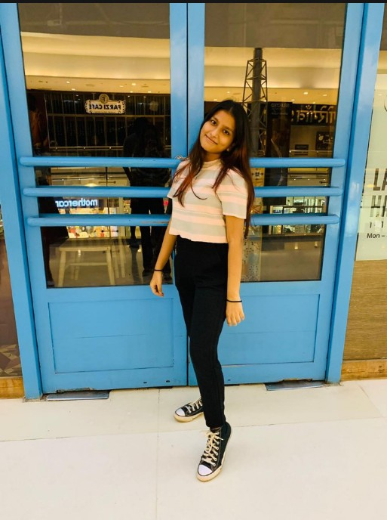  Name: Gloria D'silva  Business Name: Love by Glorissa  Class: FYJC A
The on going trend of starting a small business and wanting to do something with our own spice, motivated us to start our own business.
Our business is all about handmade hair accessories.
We’re still in the growing and learning stage of our business.
Our business is growth oriented. We target the right audience by implementing all sorts of strategies tailored exactly for our needs.
-Gloria D’Silva

