Department of Commerce Report

In October 2020, the Department of Commerce organised its very first session on ‘Create the perfect resume and nail the interview’ where the resource person was an alumna of the college- Ms. Brinelle Lobo, Asst. Vice President in Citi Bank. There were over 297 participants from T.Y.B.Com. Ms. Lobo began the webinar with a question leading to her presentation. Her presentation gave us tips and techniques with which we could be better interviewees. The techniques helped improve body posture, confidence, and communication skills during an interview. Along with the interview, the speaker focused on what needs to be included in an effective resume. She also was able to give us insightful information about small talks and a few exercises to have an effective interview. 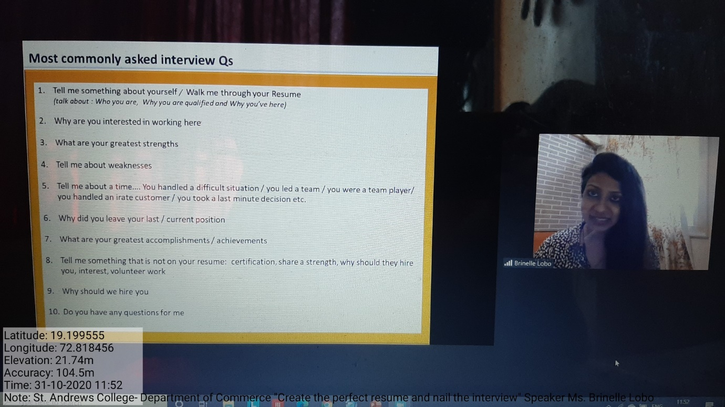
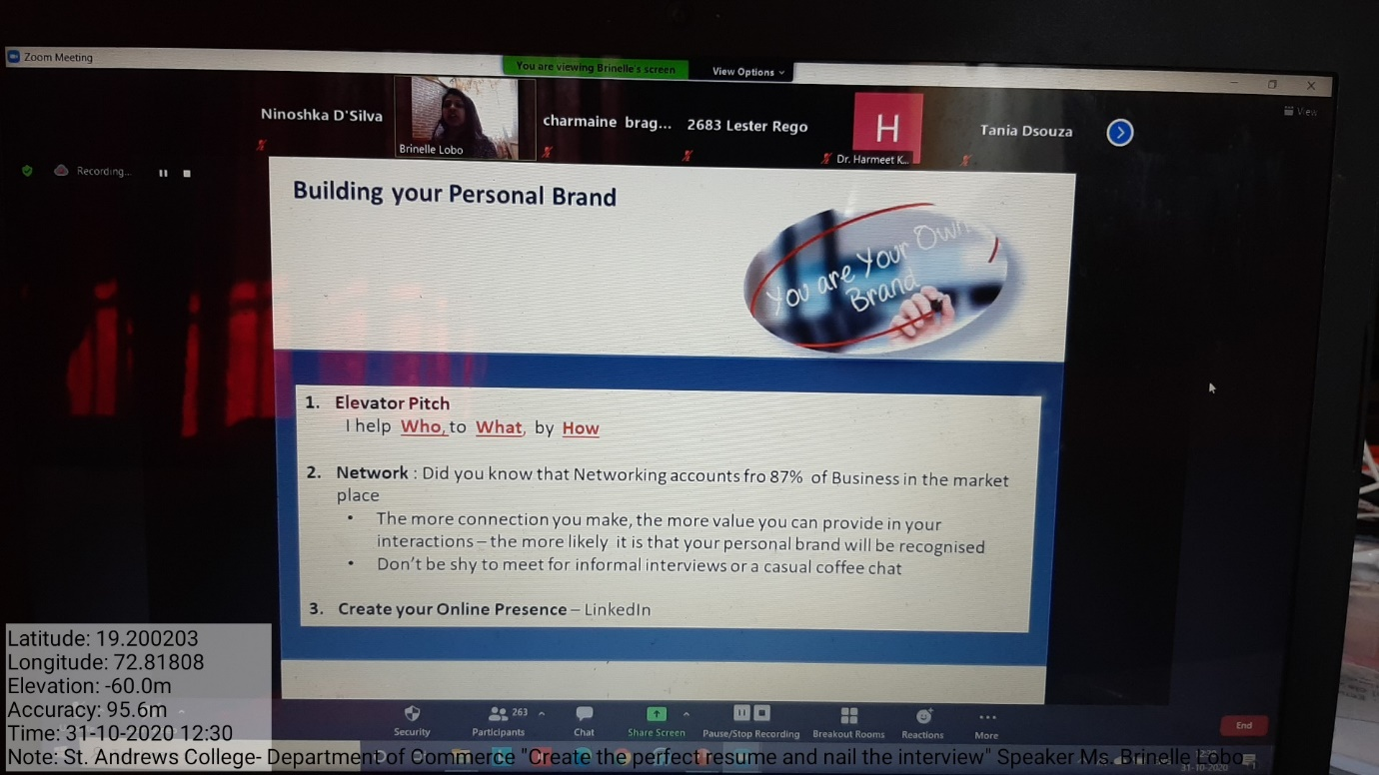

In January 2021, the Department of Commerce of the college in collaboration with BSE organised a webinar ‘Investors' Awareness Program’ where Mr. Amogh Gothoskar was the resource person. The session had 41 students attending from B. Com (F.Y.B. Com, S.Y.B.Com & T.Y.B.Com). The intend to quantify the Investors' Awareness Program was towards different sort of mutual funds. The pay winning and salary spending exercise is a piece of budgetary framework. He even highlighted upon the need to start investment early and made invoked sensitivity amongst participants on the value of money.
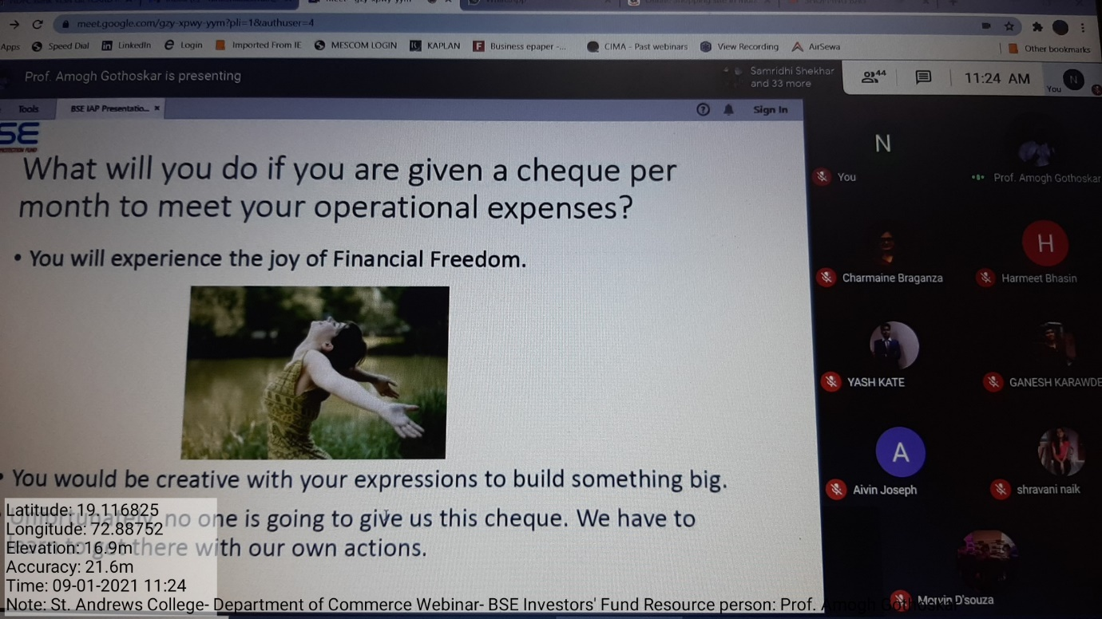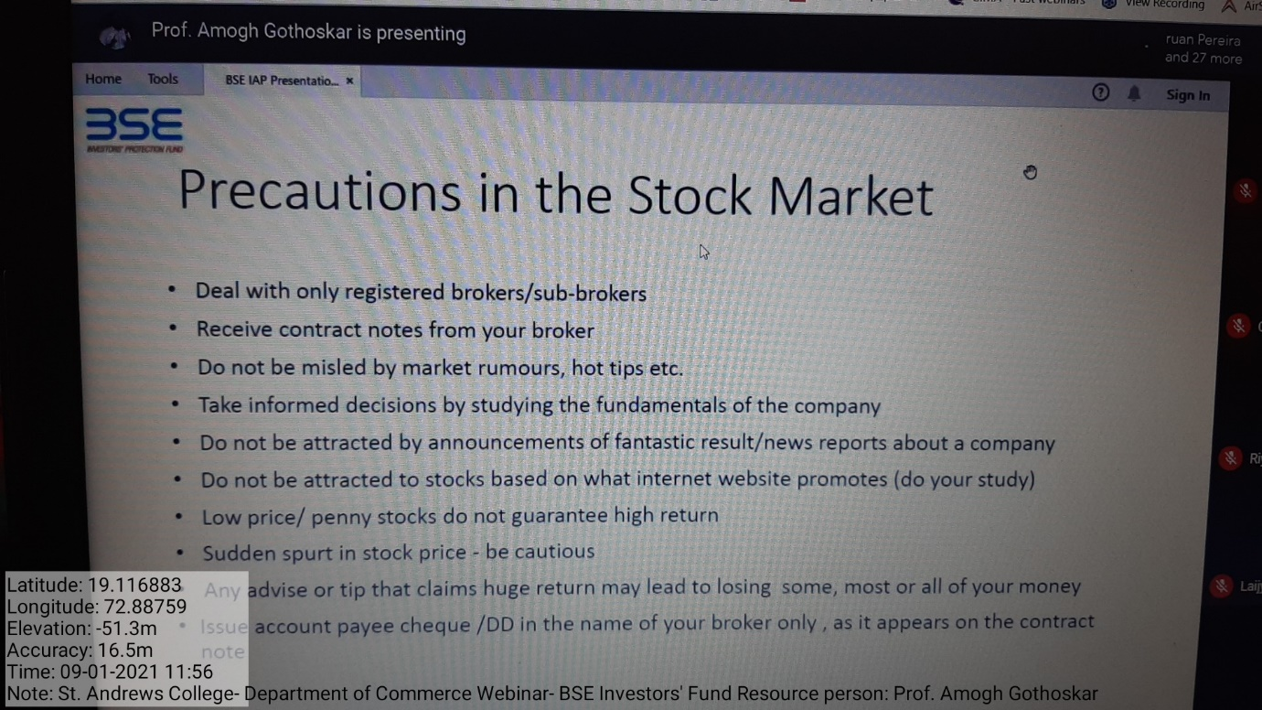

Skill Development Program- “Business Secrets to Accelerate Your Success”
These sessions were organised for the T.Y.B.Com students. The sessions were conducted by CA Rajesh Seshadri; Global CFO of DHL Global who is also a founder & creator of Nirmiti Nidra.

The first session on MAFA Syndrome was in January 2021, where Mr. Rajesh introduced the Eisenhower Matrix. Throughout the session, he helped students understand how to prioritise their workload, categorise them into doing it right now, scheduling it for later, delegating it to someone else and eliminating it depending on urgencies.
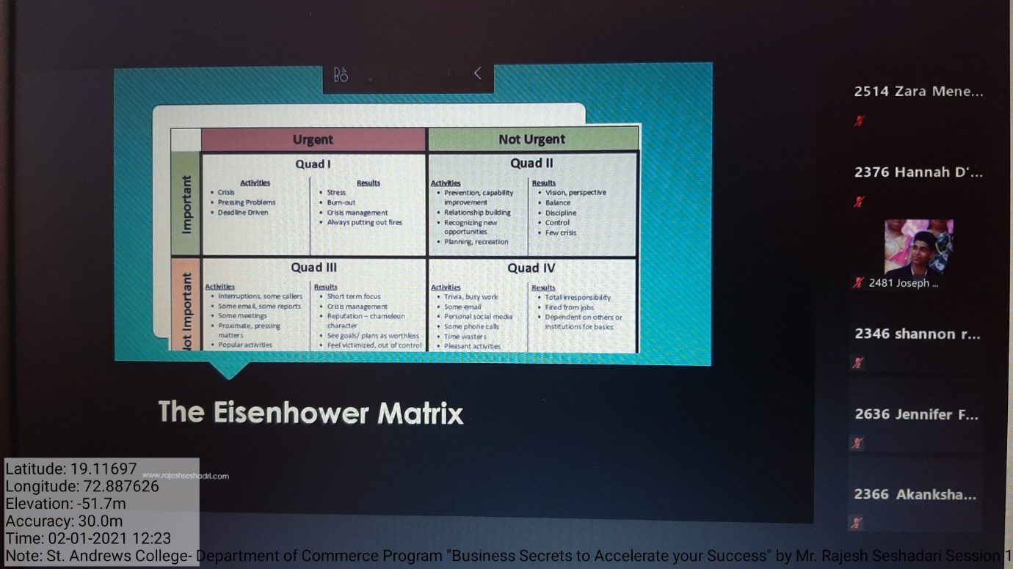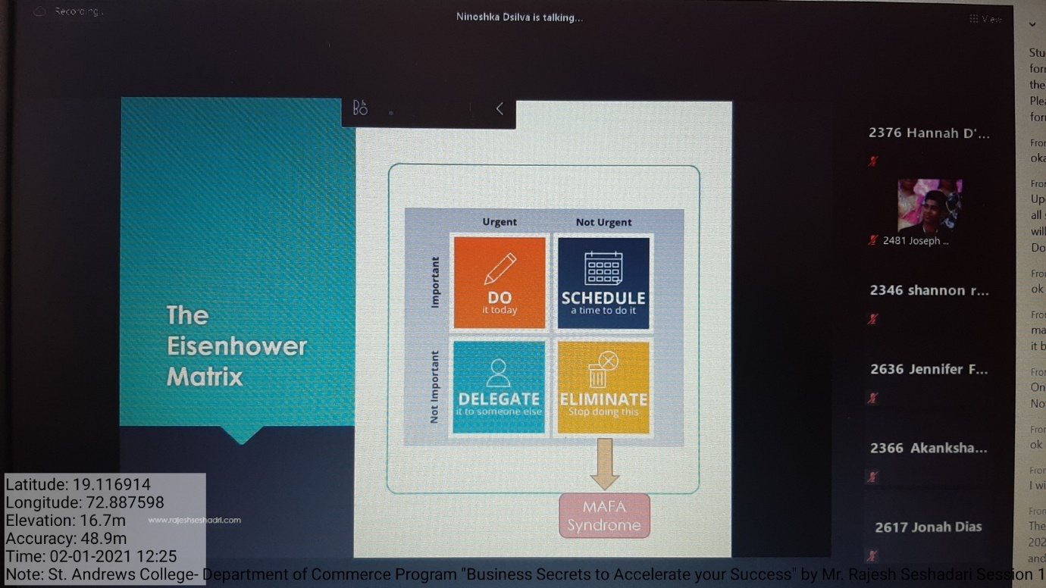

The second session on The Power of Focus & The Pain of Procrastination, SMART goals were discussed and so was procrastination and habits. Upon elaborating on SMART goals, the students were further explained on how to have goals. There were various other discussions on Habits & Distractions. Further, the causes of procrastination were highlighted and discussed upon. The students were enlightened on procrastination and laziness.
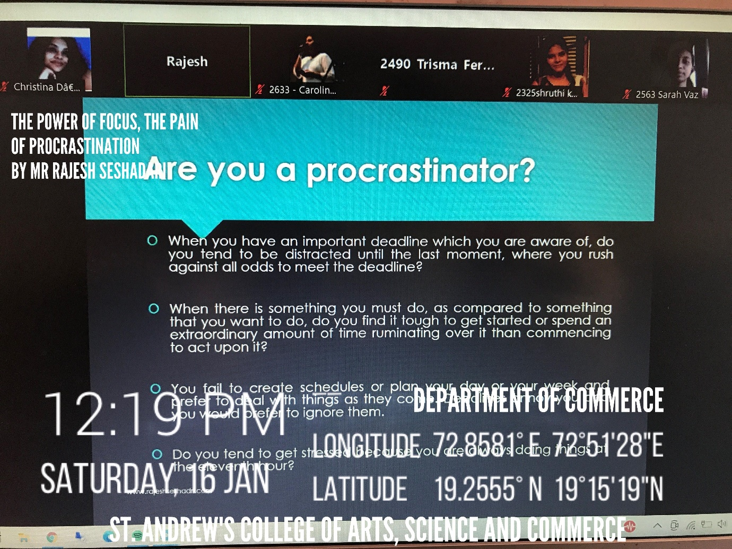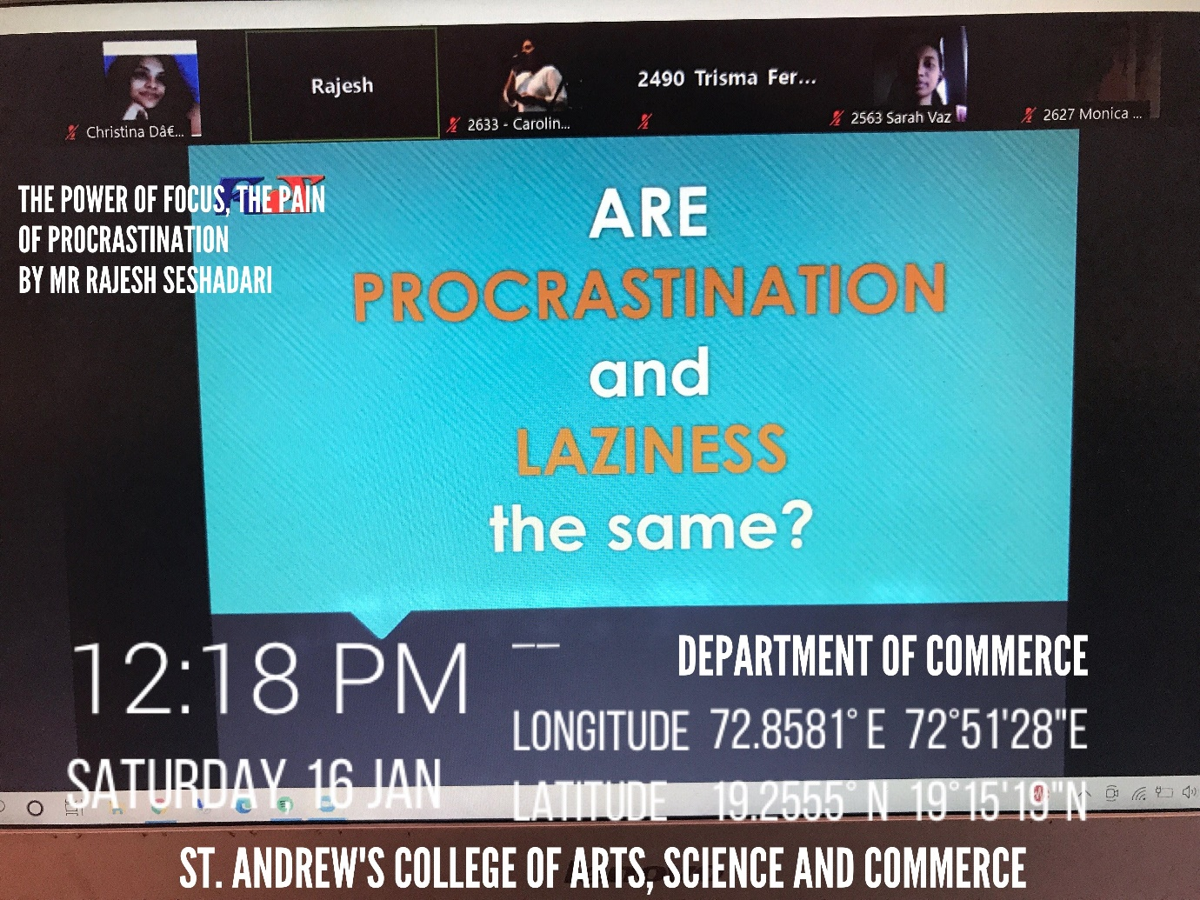
The third session on The Enchantment of Energy This helped the students to know how important energy is for Success. There was a quote related to it “Energy follows intention and flows with an attention”. The students were told about the physical health how important and necessary it is to be physically fit and was also given various suggestions of how one can be physically fit like Incline Sprints is one of them. Supplementary diet is also one of the crucial things one should have. There were various examples given on what one should include in one’s diet. Later, Mr. Rajesh spoke about the difference between the Mind and the Brain that further was taken by introducing to Conscious Mind which is 10% includes will power, long term memory etc and subconscious mind which is 90% includes beliefs, emotions, habits etc. All this was helpful to know because one needs to know all these in handling day-to-day’s stressful life. 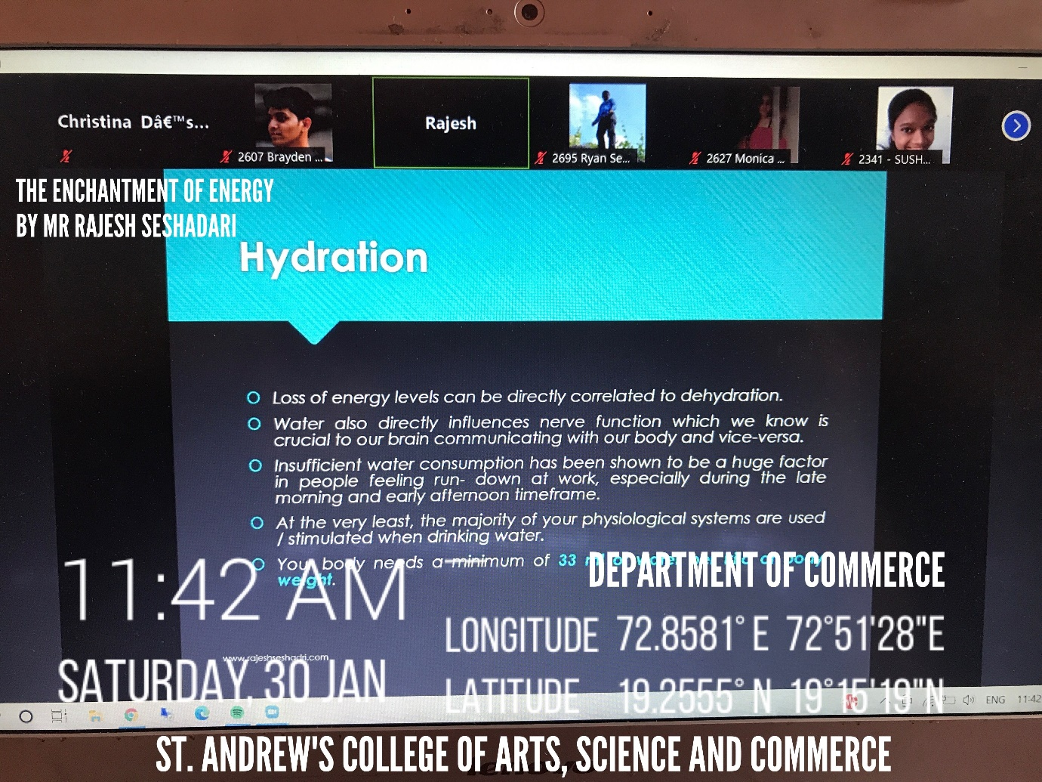
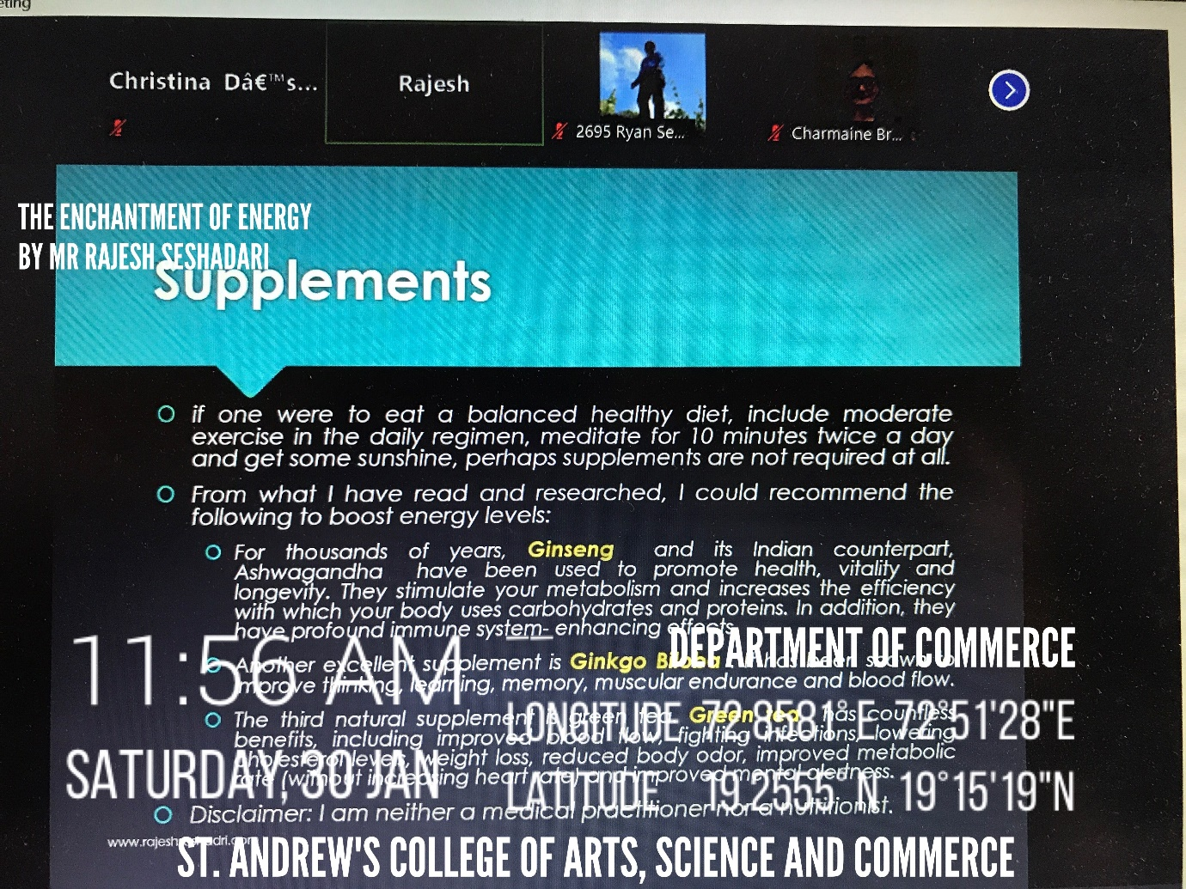

In February, the fourth session on Nirmiti Nidra and Stress Management was an extremely exciting session as Mr. Rajesh first explained about the theory of Mind, the Critical Area of it which was further followed by explaining on learning a skill which included Unconscious Incompetence, Conscious Incompetence, Conscious Competence and Unconscious Competence. Mr. Rajesh explained about neural pathways, the Autonomic Nervous System, Meditation & Myths. Then came the important part of the session i.e., Nirmiti Nidra which was practical example of how to manage stress. Students were given instructions on pre-requisite of session and then Nirmiti Nidra session started which helped one to be stress free and made the mind fresh.
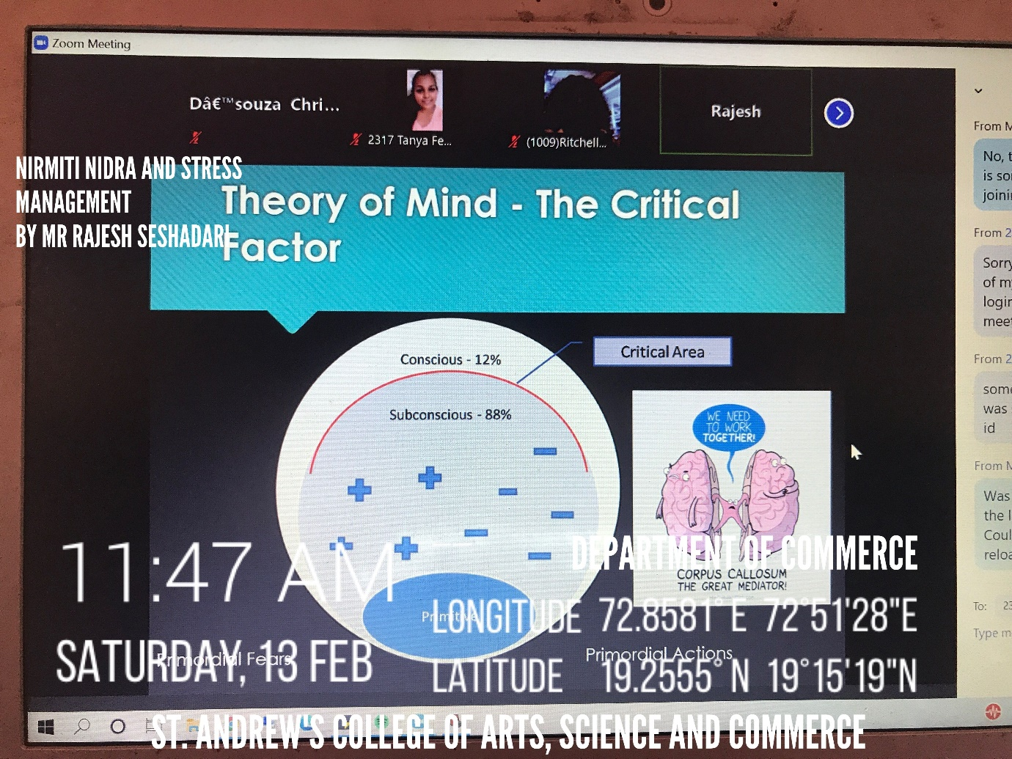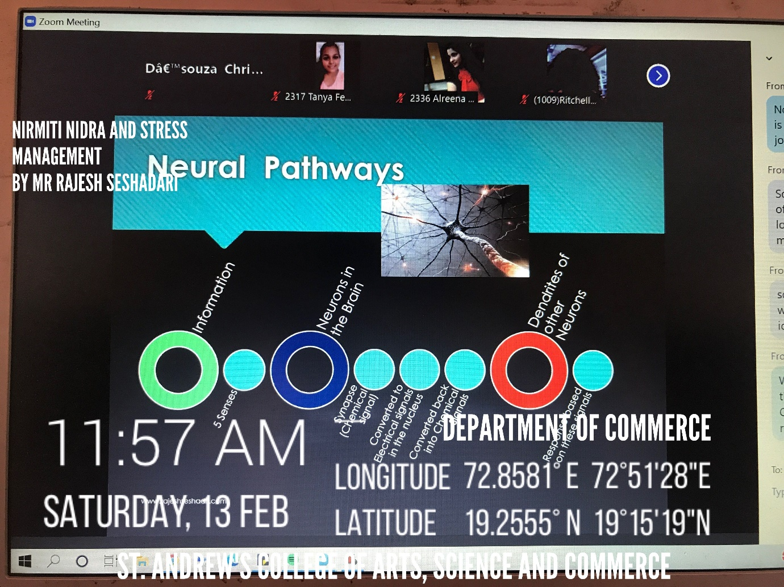
The fifth session on Personal Finance began with the introduction & explanation of Personal Finance Concept. Then it was further taken by explaining Personal Finance Management where 7 Golden Rules for successful Personal Finance Management was made known. The session also included topics like Finance Plan Components & the Thumb Rule to begin with Personal Finance. Students were told about savings, the difference between Savings and Investment. The session helped students in knowing how to manage one’s finance in this ever-growing world. 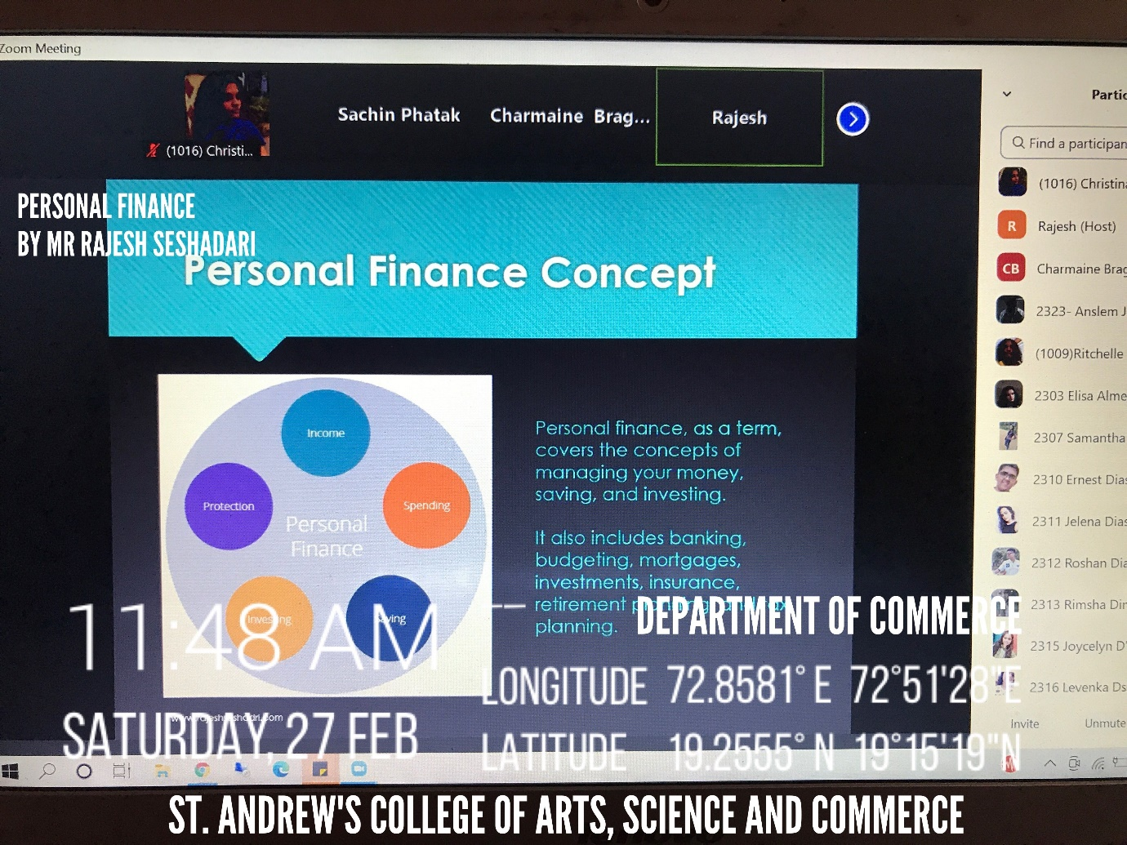
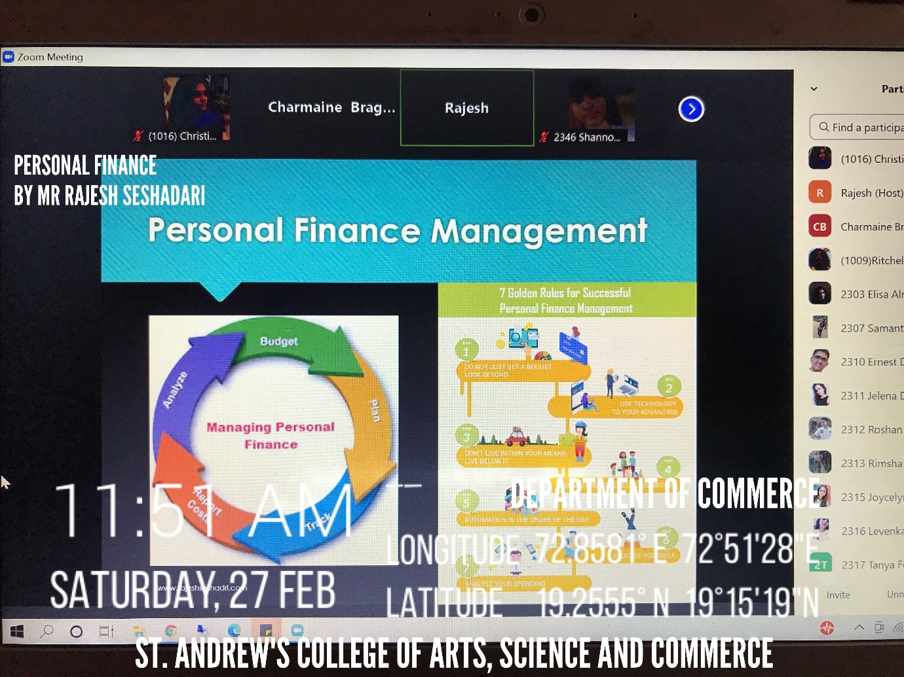

In March, the sixth session on, “The 7 Habits of Highly Effective People”. The session was inspired from the book “The 7 Habits of Highly Effective People” by Stephen R. Covey which spoke on the 7 habits- Be Proactive, begin with the End in Mind, Put first things first, Think Win-Win, Seek to first understand then be understood, Synergise and Sharpen the saw. Mr. Rajesh in the session explained the application of the 7 habits in real life situations and even emphasised on the need for one to make a list of activities that would help renew oneself.

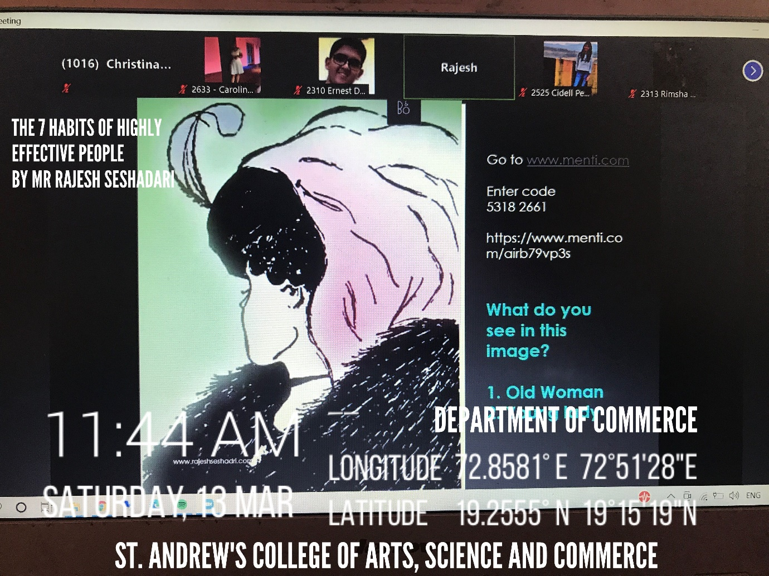
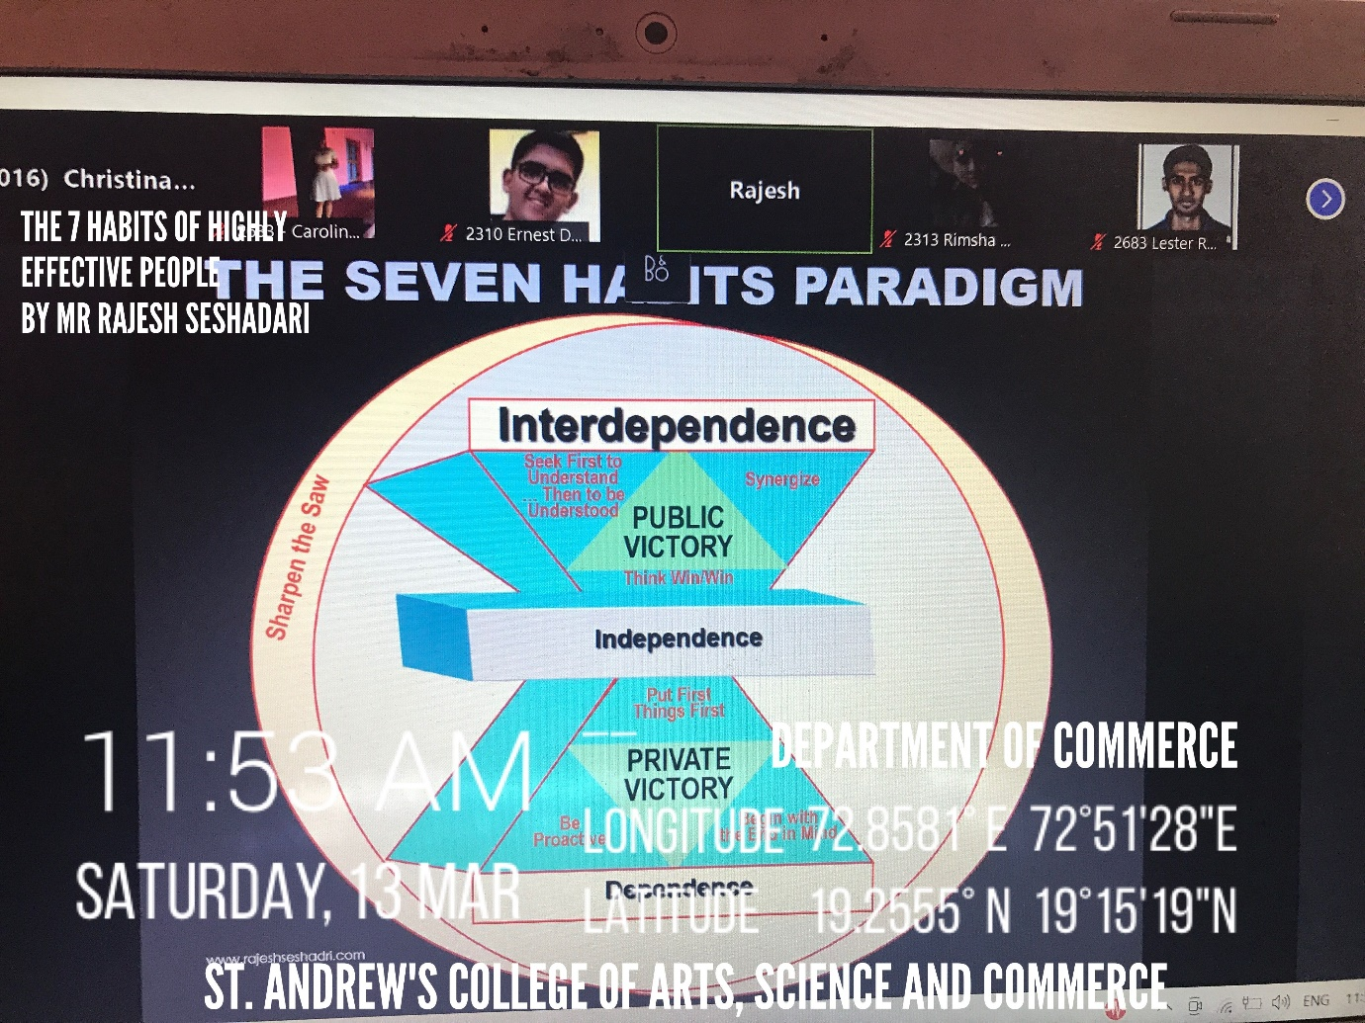

The seventh session on “The 7 Spiritual Laws of Success”. Mr. Rajesh spoke on the 7 Non-Religious Spiritual Laws which were namely- Law of Pure Potentiality, Law of Giving, Law of “Karma” or Cause and Effect, Law of Least Effort, Law of Intention and Desire, Law of Detachment and Law of “Dharma” or Purpose in Life. The students were explained on the powerful principles that would help to enable one to attain self-mastery. The speaker further mentioned that if one paid attention on the laws and practice it, one can manifest anything one would desire- affluence, money, success and so on. The students were also explained on how the application of the laws would make life more joyful and abundant in every way, making one’s life worthwhile.

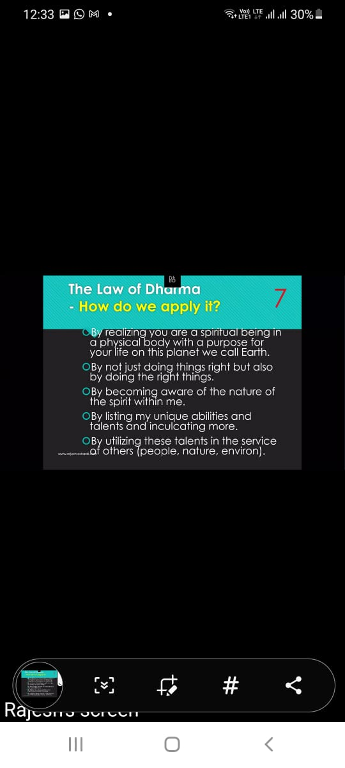

In April, the eighth session on “Enhanced Personal Productivity” where Mr. Rajesh explained the importance of productivity. He explained the concept of Total Leadership concept where he emphasised that leadership is no longer a position or a title but rather a process that every person at every level must practice. The Total Leadership concept encompassed of 4 sub-concepts- Personal productivity, personal leadership, motivational leadership and strategic leadership. Mr. Rajesh spoke the importance of having a life plan and reviewing one’s goals. He emphasised the need to write the one’s personal goals and explained the power of visualisation. He further went on to speak on optimising one’s personal productivity by giving insights on the productivity tools such as always having a planned day, ABC Analysis etc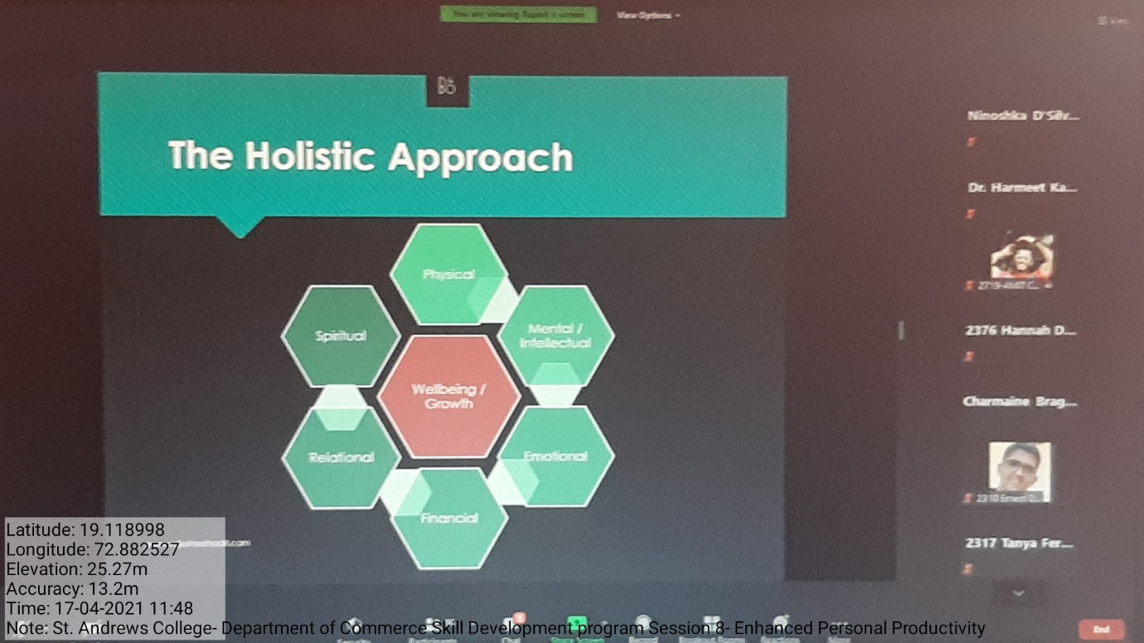.

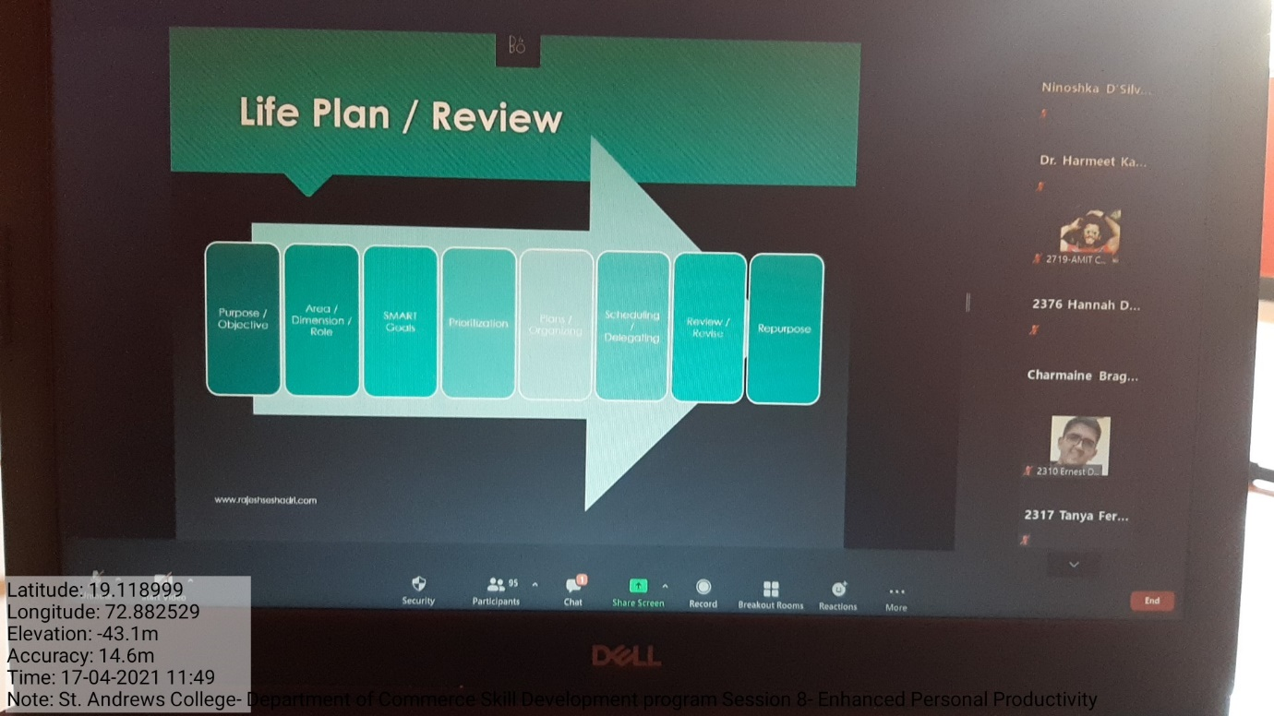

In May, the ninth session on “Personal Management Skills” where Mr. Rajesh spoke about the 12 management skills which include- communicating clearly, managing time, making decisions, delegating successfully, motivating people, managing teams, managing meetings, presenting successfully, negotiating successfully, interviewing people, managing change and minimising stress. He went on to explain the importance and application of each skills- both in personal and professional life. He went on to elaborate the 4A Stress Minimisation which includes- Avoid, Alter, Accept and Adopt and even demonstrated stress minimising tools. 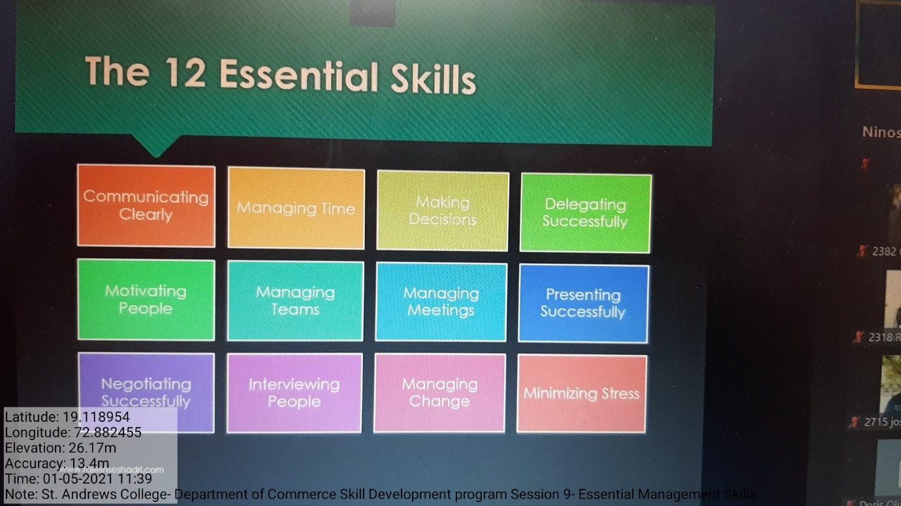

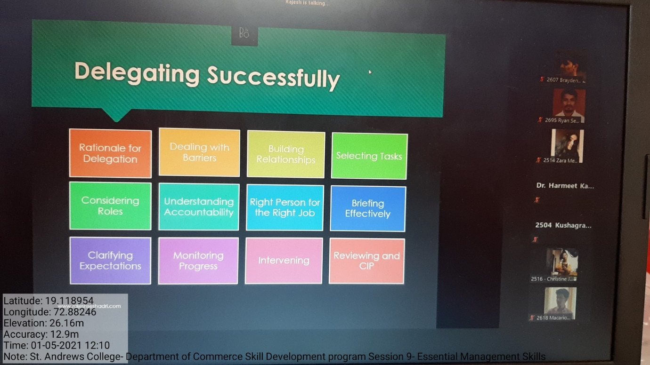

The tenth session on “Introduction to Neuro Linguistic Programming” where Mr. Rajesh briefed the audience about the birth and concept of NLP. He showed the visible eye accessing cues in NLP that helps one person to understand the behaviour of another person. He went on to elaborate on the Visual-Auditory and Kinaesthetic Representational Systems where he made the audience connect to oneself and explained ways of establishing rapport through the VAK Representational Systems. Further, he spoke about the VAK Sub-modalities in NLP wherein he showed how people can visualise, hear and feel the situations. He even demonstrated certain exercises that can help connect one to one’s subconscious mind and help to overcome any type of problem.
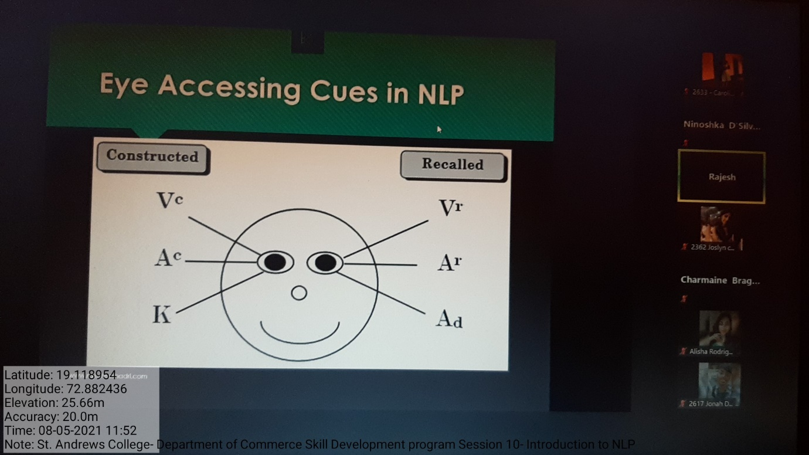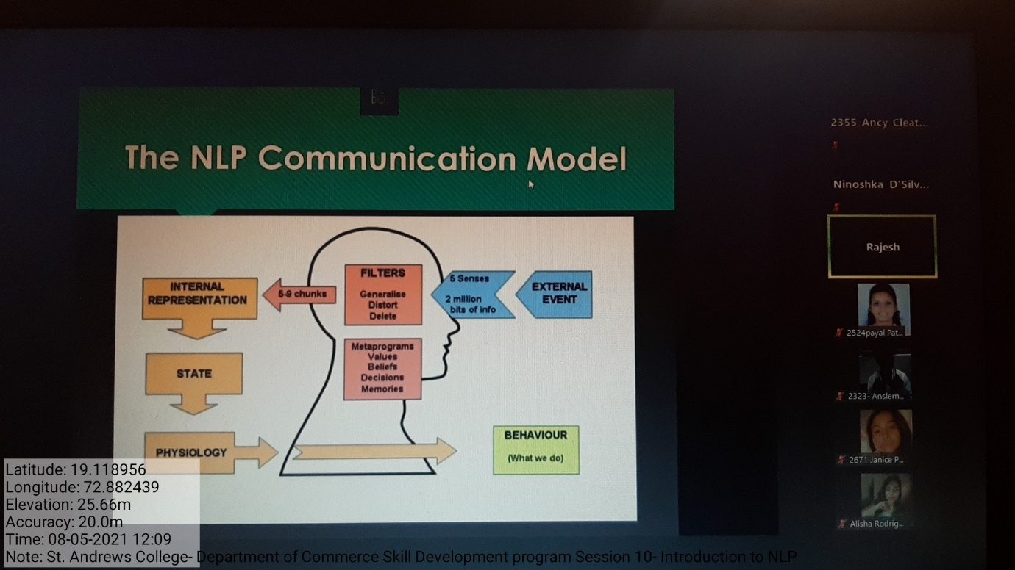

Students in-charge, Profs in-charge,
Christina D’Souza (SYBA) Dr. Charmaine Braganza (HOD & Vice-Principal),
Ritchelle Brahmane (SYBA) Dr. Harmeet Kaur Bhasin,
Ms. Ninoshka D’Silva,
Ms. Fiona D’Souza.

