College Women Development Cell (CWDC) (2020-2021)

The University of Mumbai set up the University Women Development Cell (UWDC) in 2001 in response to the Vishaka judgment passed by the supreme court in 1997. The main objective of this cell is to make the University gender sensitive. The College Women Development Cell (CWDC) of the college is constituted as per the directive of University of Mumbai. Its main objective is to sensitise students to the issues related to gender.
St. Andrew’s College Women Development Cell organised a series of programmes to conscientise students on concepts defining gender.

10 June 2020 Webinar ‘Gender Equity and COVID-19: 'Impact & Role of Religious Minorities’

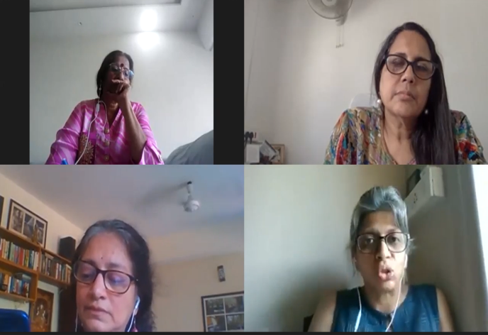 | A One-Day National webinar was oragnised in collaboration with the  University Women’s Development Cell on 10 June 2020 on ‘Impact and Role of Religious Minorities’ part of  a three-day National Webinar Series ‘Gender Equity and COVID-19’: Perspective from the Margins​. Dr.  Christine Nathan was invited as the resource person who shared her expertise on how the current pandemic  Covid-19 has disrupted the normalcy in the society while subtly exposing the inequalities faced by religious  minorities and women who are at the extreme end of protection.

28 Nov 2020 Workshop on Be A Cyber Saathi and avoid harassment

The CWDC in collaboration with the Red Dot Foundation conducted a workshop on ‘Be a Cyber Saathi’ on 28 November 2020. Ms Marissa Borges - Head (Red Dot Foundation) and Ms. NoelleAnn Park – Advocate Bombay High Court were invited as the resource persons. The objective of the workshop was to sensitise students to topics such as Gender Sensitivity, gender roles, biases and stereotypes and how they influence behaviour on the online space. The resource persons also addressed the various types of online cybercrimes affecting children and young adults as well as the remedies available to victims of cybercrimes. The workshop was an eye opener for the students as it helped them to understand the intensity of cybercrime and the legal implications that to protect the rights of victims of cybercrime.

28-29 January 2021 Two-Day National Webinar on Crossroad Identity Series- Demystifying Gender Praxis in Literature, Art and Media

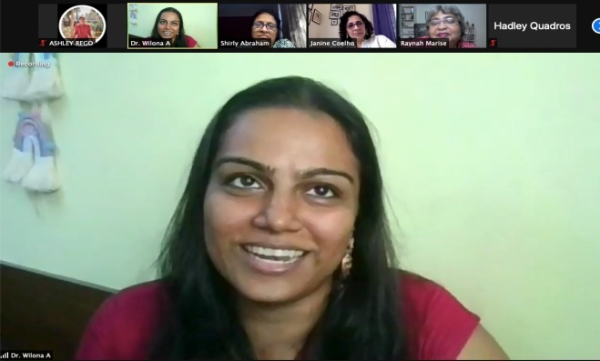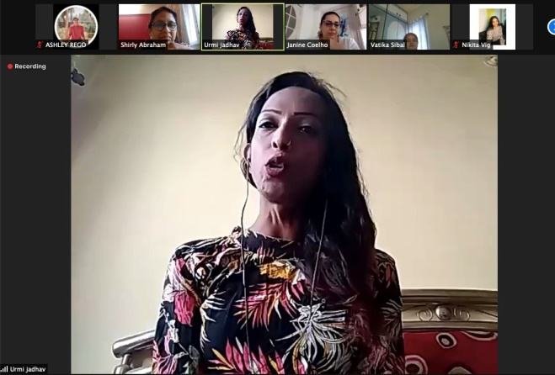 | A Two-Day National; Webinar in collaboration with the Department of Sociology was organised under the series ‘Crossroad Identity’ titled ‘Demystifying Identity Praxis’ on 28 &amp; 29 January 2021. Adv. Kamayani, a Human Rights lawyer and activist on the farmer’s protest was invited as the resource person who shared her  expertise on identity crisis of the marginalised and vulnerable groups, the violation of their basic human rights especially during the time of pandemic. The webinar also included student’s presentations on topics like Toxic Masculinity, Harassment against Men, Identity crisis among the Youth, and Marital Rape. The objective of the  presentation was to provide the students a platform to voice their opinion on the social evils of gender inequality and the various legal mechanisms to combat the social problem in the society.

