Department of Accountancy

Activities of Accountancy Association 2019-20

Training Programs:
- A 30 hours training program certificate course on Goods & Service Tax was organized from 20th August 2019 to 22nd January, 2020. The course trained students on registration and return filing of GST. 29 students undertook the training. The students were given certificates at the end of the programme. The Training was conducted by Edutech Centre by faculties CA Rupal Haria & CA Dipti Mody.

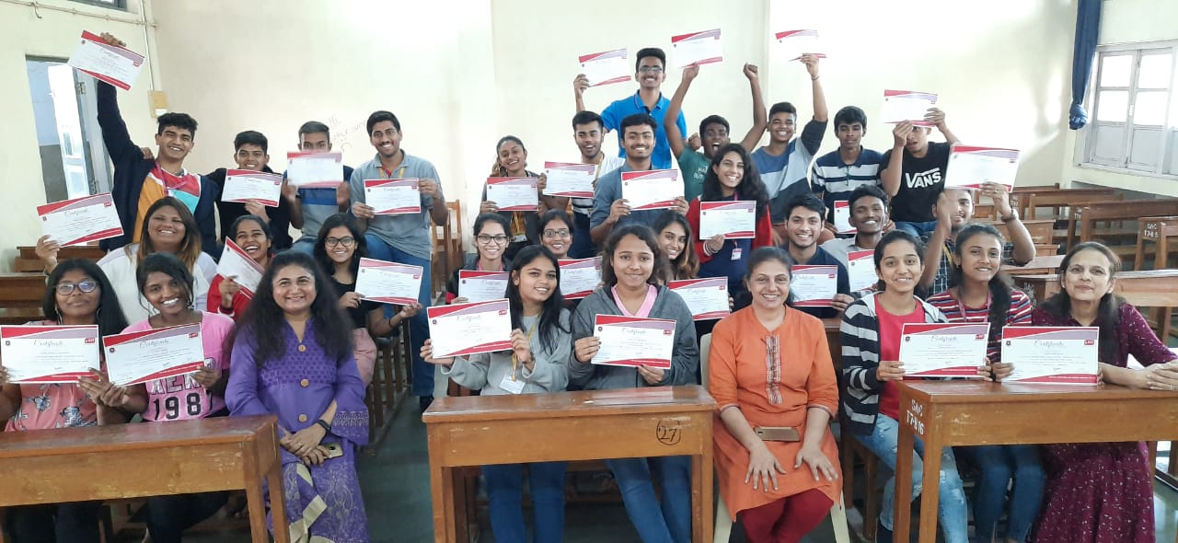

- 25 students visited MET Institute on February 27, 2020, for a workshop on Mock Management Aptitude test, group discussion and personal interview by Dr. Vijay Page, Director, MET and Prof. Arun Patil, Dean, MET. Through this workshop, students got hands on experience to crack MH-CET for MMS/MBA courses and appear for group discussions and personal interview.

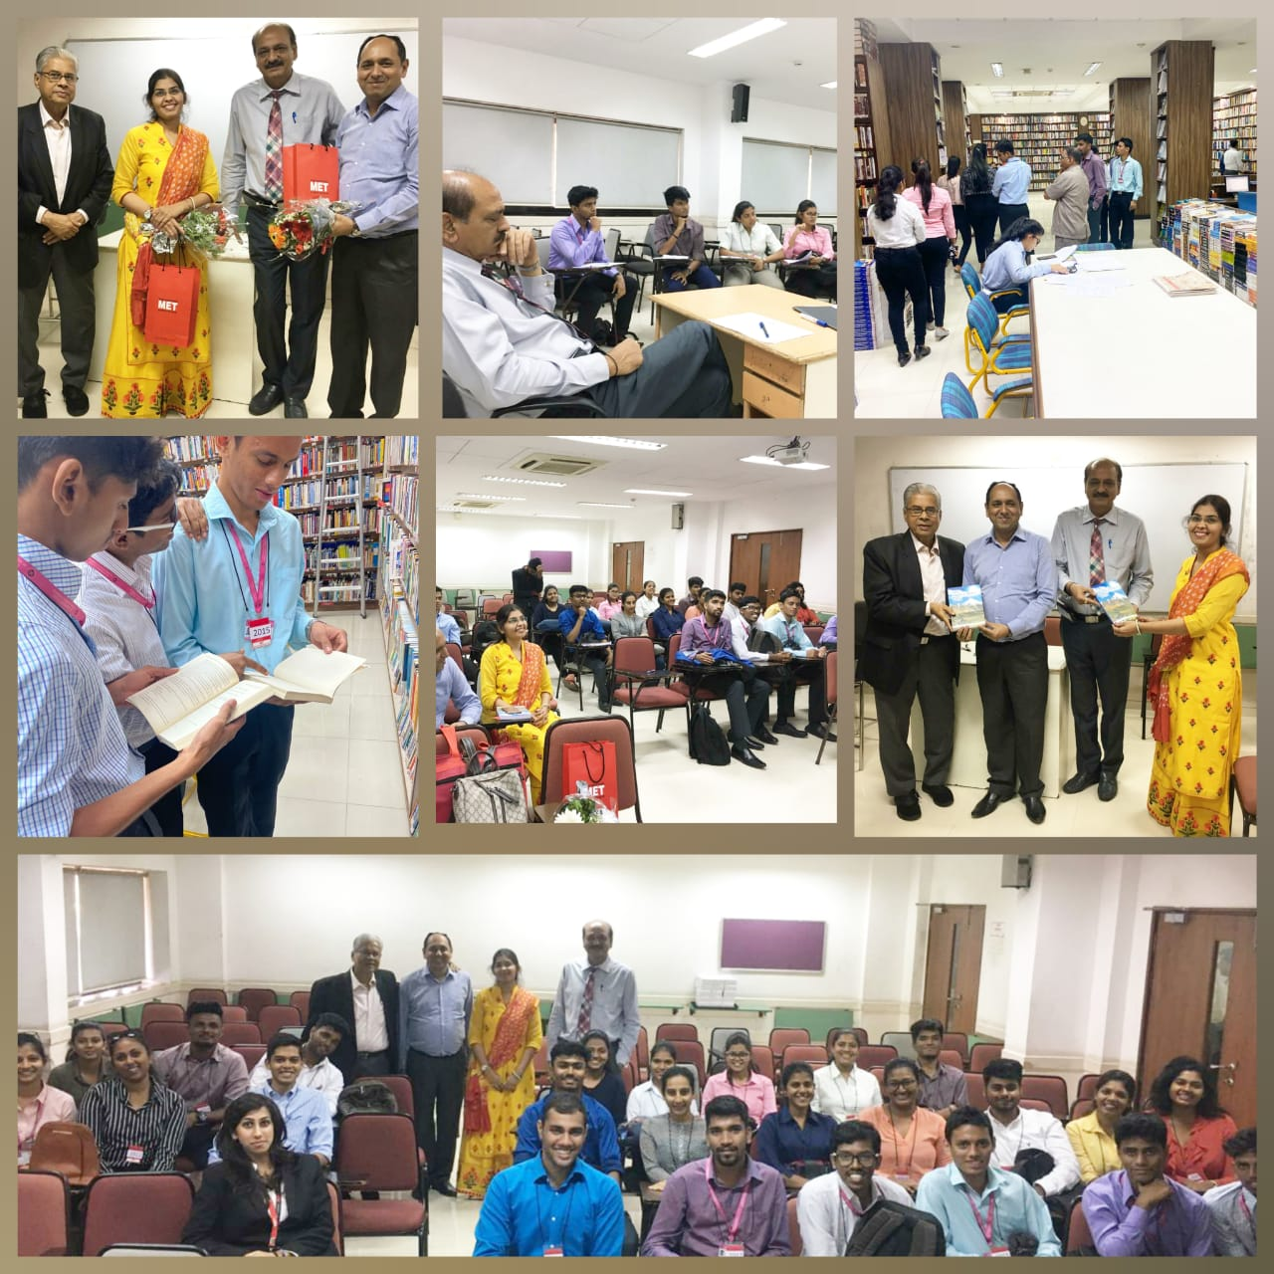

Guest Lecture:
- A lecture on International Career Opportunities in Finance was conducted for BCOM students by Dr. Nirmala Joshi, Research Guide, MET Institute on 6th February, 2020. The session included Career prospects in the field of Accountancy and Finance, courses available, examination schedule, and job opportunities at global level. 37 students attended the session.

- A Union Budget presentation was organized on February 3, 2020, to create awareness on budget. 38 BCom students participated and presented their views through charts and newspaper articles.

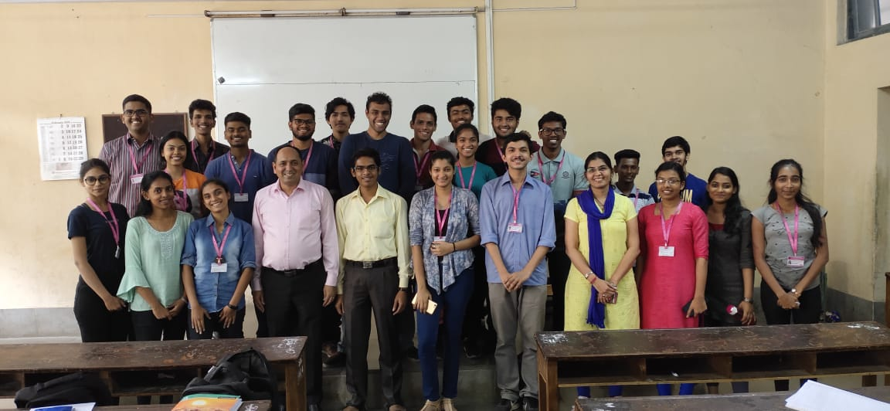

- On 13th February 2020, a session on Union Budget 2020 was organized. In this session, BCom students were provided an opportunity to reflect, analyse and express their critical evaluation on various areas covered under Union Budget 2020 through PPT and discussions involving questions and answers session.

Other Activities:
- On 1st July 2019, ICAI Foundation Day and GST Day was organized. On this day BCom students were encouraged and motivated to take up professional courses by providing information to them on these courses. 61 BCom students submitted charts and articles on CA course and GST which were displayed in the classrooms and accountancy notice boards.
- Throughout the year, 51 students contributed Newspaper & Magazine Articles along with their opinion on current issues relating to Accountancy, Finance & Taxation on a monthly basis

