THE RELEVANCE OF SOCIOECONOMIC BACKGROUND ON INTERPRETATIONS AND PURCHASE BEHAVIOUR OF LIFESTYLE AND LUXURY :
A STUDY OF APPARELS AND ACCESSORIES BRANDS AND MUMBAI’S GEN Y

Desiree Gonsalves
Associate Professor and Research Scholar, Department of Commerce, St. Andrew’s College, Mumbai

Ab s t r a c t :
India’s rapidly improving economy and growing affluence of the commercial capital city of Mumbai has brought in newer and younger buyers. Emerging markets are the new focus of lifestyle and luxury marketers, who have been watching these trends. In 2016, almost 40% of India’s population was aged less than 20 years, commonly referred to as the Millennials. A UN Report in 2014 stated that India had the world’s largest young population. This implied tremendous potential for economic and social progress, with youth determining the country’s future, Higher education levels, increasing incomes, greater family affluence and more frequent overseas travel are all indicative of the changing socioeconomic background of this target audience. The young buyer feels the need to dress well and spend his hard earned money. What is this consumer group’s interpretation of ‘luxury’ and a ‘luxury brand’? The research study covered an 18 to 30 year old, educated group of Gen Y from Greater Mumbai, and related their socioeconomic background to buying behaviour. This was measured by frequency of shopping and amount spent on lifestyle and luxury apparels and accessories.

Keywords: India, Mumbai, Millennials, lifestyle, luxury, apparels and accessories, socioeconomic, consumer behaviour

- Introduction:

In the ‘25 predictions for the Luxury Goods Industry in 2016’ Report, Rob Walker of Euromonitor International has categorically stated that India will be the “star of Asia” and the only major market in the world (Walker, 2016) to register double-digit year-on- year growth in US dollar terms. Added to that insight was another fact: “ luxury menswear and male accessories will outperform women’s wear and female accessories”. This was attributed to the global indicator that men’s annual disposable income is around 50% higher than women’s. A growing desire for the urban male to look good, in the major emerging markets of India and China, may trigger a significant shift in leading brand portfolios and marketing strategies. The changing levels of income, newer technology and higher levels of education are causing a shift in living styles and spending habits. ‘Lifestyle’, in Mumbai, which reflects interests, attitudes and opinions of a population, are in a state of flux. Lifestyle apparels and accessories continue their strong growth story in India and are the second biggest segment after jewellery and watches. (ASA & Associates LLP, 2015)

Socio-economic Factors:
Socio-economic factors are related to lifestyle, and measure the individual’s social standing and financial viability. “Socio-economic Factors” have been defined by the US National Library of Medicine as ‘social and economic factor’s that characterize the individual or group within the social structure”. (US National Library of Medicine). For the purpose of the study, the focus has been on the respondent’s income, occupation, parents occupation, family cars and international trips made in the past 2 years that would indicate their financial and social standing, and hence their lifestyle.

Gen Y:
The “Millennial Generation’ differs considerably from previous generations. Referred to by many terms, “Generation Y, Baby Boomers, Generation Next, Generation Me’ as well as “Millennial’ and being the subject of research, they are categorized by those born between 1981 and 1999 or there about and are one of the most studied generations. Also called millennials, echo boomers, iGen net generation (Business Dictionary), this generation has had constant access to technology in the form of cell phones and computers in their youth.

What’s new in the Indian market is young India below age 30, with high disposable incomes courtesy their new-age consulting, investment banking, IT jobs that has become the new target for luxury. (Sinha) Luxury for this segment is all about looking cool, fun, and quirky at times and needs to embrace youth values. This new buyer is a distinct contrast to the mature buyer who gives importance to taste, refinement and intrinsic value of a brand. A study by consultancy group Bain & Co and Italian luxury industry association, Altagamma, revealed that by 2015, these Millennials will represent 45% of overall luxury consumption, with Asian consumers accounting for more than half. (Hindustan Times, 2017)

Objectives of the Study:
The purpose of the study was to correlate socioeconomic factors of the respondents, to buying frequency and spending on lifestyle apparels and accessories. Purchase
behavior of young 18 to 30 year old Mumbai respondents was measured by Frequency and Amount spent on lifestyle fashion wear and accessories. The frequency and amount spent in the last 2 years were thus the Dependent Variables of the study. The respondents Socio-economic background interpreted through their Education, Income, Occupation, Family cars owned and International trips made, were considered as the Independent Variables.
Interpretations of the word “luxury” differ from person to person as well as within social groups. The ‘Brand’ that first comes to mind with the word ‘luxury’ also helps relate the associations that this group makes to all things luxurious.
The individual’s earnings, or Income, determine his economic status. Education and Occupation of the person is also an indicator of his status and most often relates to earning capacity. The economic status of the parents of these respondents was also asked, to gauge their earning capacity based on occupation.
Likewise, the Family cars owned determines to a great extent, the individual’s social status. The frequency of overseas travel, can also relate to the individual’s socioeconomic standard.

Hypothesis:
H₀ : There is no relationship between Education, Occupation, Income, Family cars owned, International travel and purchase behaviour of lifestyle and luxury apparels and accessories of 18 to 30 year old Mumbai millennials.
H₁ : There is a relationship between Education, Occupation and Income, Family cars owned, International travel and purchase behaviour of lifestyle and luxury apparels and accessories of 18 to 30 year old Mumbai millennials.

Review of Literature

Lifestyle and Luxury :
The words ‘luxury’ and ‘lifestyle’ have been appearing more frequently than ever before because of the close association of these two concepts. (Dauriz & Tochtermann, 2013) The McKinsey Report quoted attendees of the 2012 Financial Times Business of Luxury Summit defining ‘luxury lifestyle’ as ‘a way of living’, specific ‘consumption habits’, a set of ‘attitudes and values’ and ‘a way of being, dressing, behaving that sets you apart form the rest’. Definitions also included ‘embodying the lifestyle of an iconic designer’. Although the definitions varied, 70% of the executives interviewed said they regard their brand as luxury-lifestyle brand. Lifestyle and luxury brands have become very accessible to Indians today making it more difficult to use “exclusivity” as a sole USP. Newer areas being tapped includes, appealing to younger audiences and using a newer media connect of digital and online social media to tap this group. Terming this, the ‘Democratisation of Luxury’ the Deeper Luxury Report has said that added appeals to draw in prospects could be derived from superior environmental and social performance, expressed through “deeper” brand values and more sustainable business practices.’ (Bendell & Kleanthous, 2008)

Luxury brands with origins in apparel are the most prolific Lifestyle players:
Many apparel players have used the approach of associating lifestyle with Luxury. Expansion included venturing into related areas like fragrances in the 80’s and 90’s and then on to accessories like scarves, handbags, shoes as well as jewellery, watches and more. At the 2012 Financial Times Business of Luxury Summit if was

opined that “Fashion” or ‘soft’ luxury goods allow for easier lifestyle expansion unlike “Timelessness” or ‘hard’ luxury goods like jewellery and watches. “ (Dauriz & Tochtermann, 2013)

The Urban Mass:
Millennial attitudes are early indicators of future trends and companies that pay attention to this gain valuable insight into tomorrow’s opportunities. (Boston Consulting Group, 2012). The study believes that this segment needs to be evaluated in order to gain a bigger share of his wallet. Gen Y is three times the size of Gen X, and is the new generation determined now, not only by demographics only but their values, life experience and buying behaviour. (Ordun, 2015)
The BCG study of the US Millennial believed that this was a generation that was all about ‘instant gratification’, ‘trusted friends, more than corporate mouthpieces’ and a higher number of them reported using the mobile phone as a device to read user review and research products for shopping. The study also concludes that within the group there are distinct segments. A study of the Indian market would reveal similar differences. Goldman Sachs reports on the Indian consumer as a tech-savvy population that has improved education with a high level of connectivity. (Goldman Sachs, 2016)
The report refers to 440million millennials, the sheer size of Indian youth that is paving the way for India’s consumer story which will be the world’s most compelling one in the next 20 years. 65% of India’s population was born after 1980, the major chunk of which is Millennials, the rest being Gen Z.

INDIAʼS CONSUMERS in numbers
(1 Country, 780 Languages) BIG POPULATION, FAST ECONOMY
1.3bn / 7.5% India’s population and real GDP growth in 2015.
WORKING MASS and MIDDLE
10% / 2% The portion of the total population made up of the workforce in “Urban Mass” / “Urban Middle.”

YOUNG POPULATION
65% The percentage of the population born after 1980. Of the 65%, 443 million are Millennials and 393 million are Generation Z.

BIG FUTURES
7mn The number of college graduates per year.
6 The number of Fortune Magazine’s “Most Admired” American companies with
Indian CEOs: Adobe, Berkshire Hathaway Reinsurance, Google, MasterCard, Microsoft and Pepsi.

WELL-CONNECTED
200mn The number of connected smartphones we expect by end of 2016. Telecom ARPU is only US$3/month, among the lowest in the world.

BOLLYWOOD DREAMS
1602 The number of Bollywood films produced in India, selling 1.9 billion cinema tickets. TV penetration is also high (67%) relative to other home appliances.
tons – the largest in the world.
$31bn The size of the spirits market in USD, making it the largest packaged food and beverage category in India and the second largest spirits market in the world.

PUTTING A RING ON IT
US$7,500 – $75,000+ The cost of a wedding in India, vs. an average cost of US$30,000 in the US and urban China. The average 2015 income of the Urban Mass was US$3,216.

Figure 1: INDIA’S CONSUMERS IN NUMBERS
Source: Goldman Sachs: India Consumer Close-­‐up: Tapping the spending power of a young, connected Urban Mass

As seen above, the Goldman Sachs Report terms this development as “The Urban Mass” and distinguishes this from China’s story of growth fuelled by the 156 million Urban Middle workforce coupled with its 1.5 million wealthy ‘Movers and Shakers’. The Urban Mass represents most of India’s new generation youth, of 129 million earning an average of US$3,200. This, they believe will be the driver’s of India’s consumption story. (Goldman Sachs, 2016) India’s 27 million ‘Urban Middle’ referred to, are relatively smaller at 2% of the population, and, a formidable potential market with an annual income of over US$ 11,000.

Internet and Mobile Connectivity :
New developments in India include its transition to the world’s second largest online market. Indians first had access to the internet in 1995. From the year 2000, however, the Indian population with access to the Internet has gone up from 0.5% to nearly 30% in 2016, making it the second highest number of users

in the world after China. The increase on internet penetration has been three-­‐ fold since 2011 when the figure stood at 10%. (Moneycontrol, 2017) In 2016, 24.3% of the population accessed the internet through their mobiles. The Government’s Digital India campaign is bound to increase these numbers and predictions put the figure at 636 million internet users by 2021.

Mumbai:
Mumbai and Delhi are the largest markets for luxury and lifestyle purchase in India. Mumbai is the financial and commercial nerve of India. With a completely different mindset, taste and aesthetics of Delhi, it is growing an insatiable desire for all things luxurious. Mumbai scores over Delhi being the commercial hub, financial centre and the fashion capital of the country. Home to a new population of expats and a constant influx of international travellers, the trendy, fashionable large pool of educated tech-savvy Gen Y here, know their Benetton’s from their Burberrys.
A recent Times of India article refers to the highlights of the Knight Frank World Report 2017 that ranked Mumbai no. 21 in the CityWealthIndex, ahead of Toronto, Washington DC and Moscow. Delhi was no.35. (Times News Network, 2017) The report tracked 125 cities across 89 countries to provide perspectives on issues that influence investment and lifestyle decisions of ultra high net worth individuals (UHNWI). Mumbai led the Indian race with 1340 UHNWIs followed by Delhi’s 680.

Socio-Economic Indicators:
Scio-economic indicators of wealth include the individuals’ wealth, Parents education and occupation and parents income. Socioeconomic status indicates one’s access to collectively desired resources whether material goods, money, power, leisure time or educational opportunities. (Oakes, Michael) Oakes writes about ‘Measuring Socioeconomic Status’ and defines Univariate measures of Socioeconomic Status (SES) as Income, Wealth and Educational Attainment. These measures help quantify and become an indicator of the level of stratification in society.

Research Methodology

Information was gleaned from a questionnaire given out over a five month period to 400 young men and women, aged 18 to 30 year olds from Greater Mumbai. Non-­‐probability, judgment sampling was used to select the respondents. Socioeconomic factors of the sample population, which was a measure of the Independent Variable, was indicated by their:

- Education
- Occupation
- Income
- Family Cars
f) International Travel over the past 2 years

The Dependent Variables of the study were measured by the respondents:
- Frequency of purchase of lifestyle apparels and accessories in the past 2 years, and
- The amount spent in the last purchase.

Greater Mumbai is the urban conglomerate of the city of Mumbai with an estimated population of 18 million people and comes under MCGM (Municipal Corporation of Greater Mumbai). The administration of this is divided into 6 zones, each governing 3 to 5 Wards named alphabetically. (Administrative divisions of Mumbai, 2017) As per the Report of the Working Group of Adolescent and Youth for the formulation of the 12th Five Year Plan (2012-2017) it was recommended that 18 to 30 years old should be the criterion for ‘Youth’ as compared to 13 to 18 being categorized as ‘Adolescents’. Around 41% of India is below 20 years of age. (firstpost.com, 2016)

Questionnaire Design and Sample Size.
The questionnaire went out to a sample size of 400 young educated urban respondents from Greater Mumbai, and included information with regard to their socioeconomic background. This age group was further broken down to 3 segments of 18 to 22 years, 23 to 26 years and 27 to 30 years for analysis purposes. In 1970 Krejcie & Morgan produced a table for determining sample size based on work done by the National Education Association. For a

population, which is equal or greater than 10,00,000,(as in this case), the required sample size is 384. They said that using their calculation, as the population increases the sample size increases at a diminishing rate and remains, eventually constant at slightly more than 380 cases. There was little to be gained to warrant the expenses and energy to sample beyond about 380 cases. (Krejcie & Morgan, 1970) Non-probability, judgement sampling was used to spread the data collection from men and women, varied age groups and different residential locations. The areas of Greater Mumbai covered were Western Suburbs, South Mumbai and “Other” which included Central and Eastern suburban areas of the city.

Data Analysis and Findings

The data collected was thereafter run on SPSS 18 for the purpose of statistical analysis. The subjects for the study were 156 Male (38.9%) and 244(61.1%) Female buyers of apparels and accessories. The Age group covered 155(38.7%) in the group of 18 to 22 years, 145(36.2%) from 23 to 26 years, 100(25.2%) in the 26 to 30 year age groups. The respondents were all residents of Greater Mumbai but were categorised into South Mumbai (Breach Candy, Colaba, Cuffe Parade, Grant Road, Marine Lines, Peddar Road), Western Mumbai (Andheri, Bandra, Borivali, Dahisar, Goregaon, Jogeshwari, Juhu, Kandivali, Khar, Malad, Santacruz) and Other parts of Mumbai, which would be the Eastern and Central areas of Greater Mumbai (Bhandup, Byculla, Chembur, Elphinstone, Ghatkopar, Kurla, Parel, Matunga, Mulund, Sandhurst Road) The largest number, 67% of respondents, came from the Western suburbs while around 11% were from South Mumbai and 22% from other areas of Mumbai as mentioned above.
Interesting to note that majority of the respondents (64.1%) owned a desktop or laptop or a tablet/iPad from which they ordered their online purchases while around 36% ordered from their smartphones.

SOCIOECONOMIC FACTORS:

EDUCATION:
The most common education amongst them was Graduates and Post Graduates, degrees/diplomas, 157(39.2%) each and 84(20.9%) with Higher Secondary education.
0.70%
25.20%
20.90%
14%
39.20%
H Sc.
Bachelor's Degree Post graduate diploma Masters Degree
Other
Figure 2 : Education

OCCUPATION:
The large majority in this age group (89%) was unmarried. This matches the non-earning student population that was again 1/3rd of those surveyed or 33.2% The rest were Working students (9.5%), Employed (41.1%), Entrepreneurs (17.2%), Professionals (7.5%) or Others.

0.20%
1.20% Occupation
7.50%

17.20%
33.20%
41.10%
Student Working student
Employed/Service
Entrepreneur/Business
9.50%
Professional
Homemaker

Figure 3: Occupation

INCOME:

Monthly income varied from 32.7% (130) not yet earning, to 19% earning less that Rs.25,000/-, 22% in the bracket of Rs.25,000/- to Rs.50,000/- and 26% earning more than Rs.50,000/-. So a rough figure of 1/3rd of the sample was non-earning respondents.

Monthly income
26.20%
32.70%
22.20%
19%
Not yet earning Up to Rs. 25000
Rs. 25000-­‐Rs. 50000
More than Rs. 50000

Figure 4: Monthly Income

PARENTS OCCUPATION:
While the majority of these young shoppers had parents who were either in service, business or professionals (85.5%), half of the mothers were homemakers (50.60%).

Homemaker
7.50%
Employed/ service
Entrepreneur
/Business
Professional
50.60%
22.40%
8.50%
10.70%
Mother's occupation
Father's occupation
3.20%
14.90% Employed/
service
Entrepreneur
36.20% /Business
13%
Professional
32.70%
Homemaker

FAMILY CARS:
Figure 5: Parents Occupation

Around 49% had no cars or owned cars that ranged to a maximum of Rs.10 lakhs and approximately 46% owned cars valued between Rs.10 lakhs to Rs.15

lakhs. A minority of 5% owned cars beyond that range. The assumptions would make this a largely middle class sample from Mumbai. The approximate value of family cars owned was taken from an online site, CarDekho.com for an approximate evaluation of car models.
None
Upto Rs. 10 lakhs
Rs. 10 lakhs to Rs. 50 lakhs Rs. 50 lakhs to Rs. 1 crore More than Rs. 1 crore
23.40%
46.40%
25.20%
1.50%
3.50%
Amount of money spent on cars

Figure 6 : Approximate Value of Cars

TagCrowd, a WordCloud software was used to reveal the most popular family car brands. This makes for a visual presentation of text data. The depth of colour and size of the font reveal the importance of each answer. As seen below, Honda and Marutis were most popular, followed by Toyota and Hyundai. The Honda City and Maruti Swift appeared to be the favoured models of this respondent group.
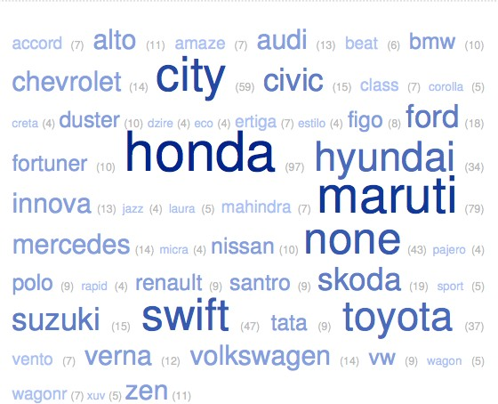

Figure 7 : Word Cloud - Family Car models owned

FREQUENCY OF INTERNATIONAL TRAVEL
Respondents were asked how many international trips they had made in the last 2 years. Almost 40% had not travelled overseas, 20% had made a single trip, 16% went overseas twice, about 11% thrice and almost 14% had gone 4 or more times. Hence the total majority of 60% had travelled overseas at some time in the past 2 years.

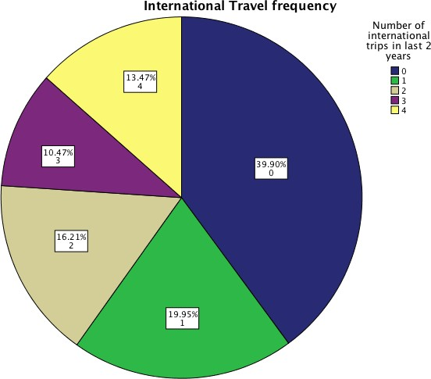

Figure 8: Frequency of International Travel in past 2 year

INTERPRETATIONS OF ‘LUXURY’

Respondents were asked what first came to mind when they heard the word ‘luxury’. The answers were many and varied but the most frequent terms for interpretations of “Luxury” were “expensive”, followed by “comfort” and “money”. Other popular words were: ‘Indulgence, premium, classy, high class, enhanced lifestyle, branded, money, top quality, grandiose, exclusive, handcrafted, designer, trendy, wealth, extravagance, rich, stylish, opulent, bliss, class, high standard, panache, earned, style, high end, royal, sophisticated, fat pay cheque, Louis Vuitton, Jaguar, Apple, Rolls Royce,

Audi, limited choice, swag, rich, suave, couture clothing, elegance, greed, bespoke, pampering, grand, glamorous, sophisticated, status, boutique, classic, feel-good, aesthetics”. Using TagCrowd, software that generates word cloud from text provided, which gives greater prominence to words that appear more frequently, the following visual indicated the more popular associations with the word ‘luxury’:
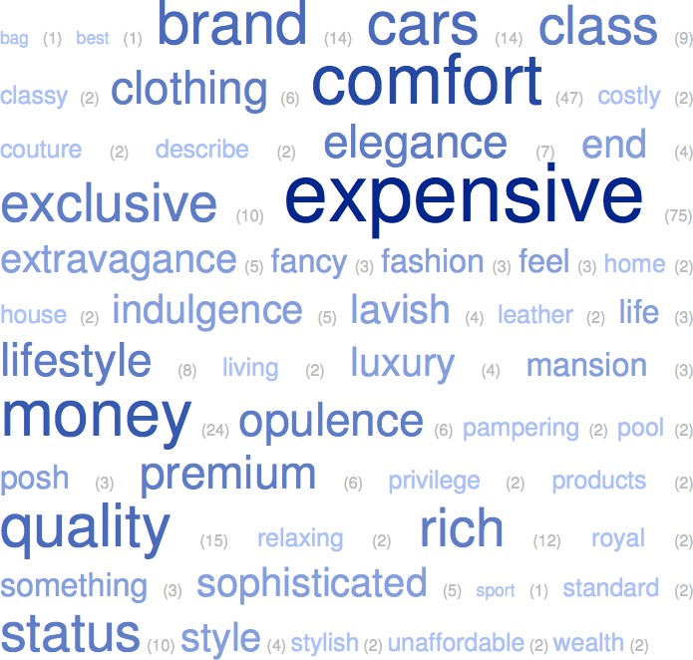

Figure 9: Word Cloud: The first WORD that comes to mind for ‘luxury’

The questionnaire listed many popular lifestyle and luxury brands of apparels and accessories. When asked whether the questionnaire included all their favourite brands, the brand names that appeared most often as missed were ‘Jimmy Choo’, ‘Mont Blanc’,‘Christian Louboutain’, ‘Salvatore Ferragamo’ ‘Rolex’, ‘Givenchy’ ‘Tiffany’, ‘Prada’ ‘Bvalgari’and ‘Calvin Klein’. One respondent even added an Indian designer ‘Masaba Gupta’.

A few added Marks & Spencers, H& M, Charles & Keith, Louis Phillipe, Arrow and other inexpensive but fashionable Indian brands like Fusion beats, Global Desi and 109F. This age group considered these brands as lifestyle.
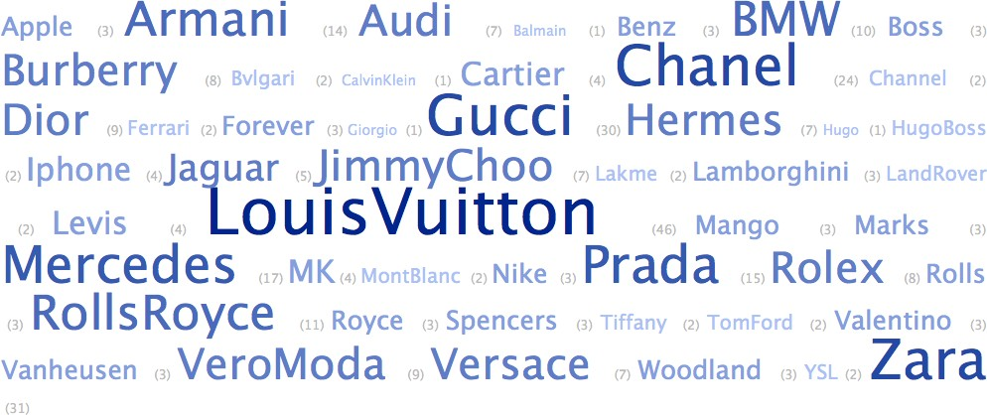

Figure 10 :Word Cloud: The first BRAND that comes to mind for ‘luxury’

PURCHASE BEHAVIOUR:
FREQUENCY OF PURCHASE AND AMOUNT SPENT IN LAST PURCHASE

Purchase behaviour that was the Independent Variable being studied, was measured by the frequency of spending in the last 2 years, as well as the amount spent in the last purchase.

FREQUENCY OF PURCHASE:
The respondents were asked how frequently they made purchases of fashionwear premium apparels and accessories in the last two years. The following graph indicates the spending of the respondents.

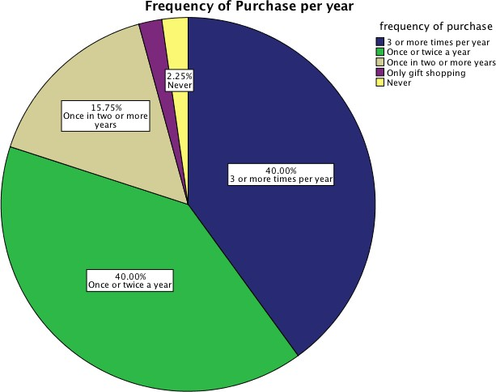

Figure 11 :Frequency of Purchase per year

Of a total 400 respondents, 40% were regular buyers, making purchases at 3 or more times a year. 40% shopped for fashionwear and accessories once or twice a year. Around 16% were infrequent shoppers at once in 2 years or more and only about 2% “never shopped”.

AMOUNT SPENT ON LAST PURCHASE:
Respondents purchase behaviour was also assessed on the amount spent on the last purchase of such merchandise. This question was added to get a rough idea of their spending power and would be a more realistic figure, being their most recent purchase.

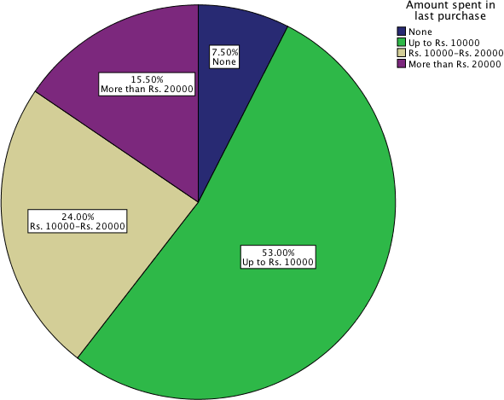

Figure 12: Amount spent on last purchase

The vast majority of 53% in this age group spent under Rs.10,000/- on their last purchase. 24% spent between Rs10,000/- to Rs .20,000/- , while a
minority of 15.5% spent over Rs.20,000/- on their last purchase.

HYPOTHESES TESTING-CROSSTABULATION AND CHI-SQUARE TESTS

To examine the affect and relationship if any, on socioeconomic factors on purchase behaviour, non-parametric Pearson’s Chi Square test and Crosstabulation was conducted for testing the hypothesis. The Pearson’s Chi Squared test is also known as the chi-squared goodness-of-fit or chi-squared test for independence. With Chi Square, a value is calculated from the data using Chi Square procedures on SPSS and then compared to a critical value

from a Chi Square table with degrees of freedom corresponding to that of the data. Chi Squared tests can be used to attempt rejection of the null hypothesis. Since the sample size was sufficiently large and the respondents were randomly collected, the results are more reliable. Given below, is the tests first done on each of the socio-economic Independent Variables listed earlier, with regard to Purchase Behavior (Dependent Variable) interpreted through a)Frequency of Purchase and b) Amount spent in last purchase. The following socioeconomic factors corelated to buying behaviour.
The results are interpreted by comparing the P-Value to the ‘significance level’and the null hypothesis is rejected when the P-Value is less than the significance level. For this analysis, the significance level is 0.05
The results indicated a correlation between the following variables where the significance level was below .05.

A: EDUCATION AND AMOUNT SPENT IN LAST PURCHASE

The Chi Square Test presented below indicates there was a significant difference in amounts spent based on the consumers education level and a rejection of the null hypothesis. The Asymptomatic Significance level of .014 is lower than 0.05 and hence the hypothesis, rejected, X²(12,N=400)=25.14,p=.01.

Chi-Square Tests
 | Value | df | Asymptotic Significance (2-  sided)
Pearson Chi-Square | 25.137ª | 12 | .014
Likelihood Ratio | 26.346 | 12 | .010
Linear-by-Linear Association | 14.105 | 1 | .000
N of Valid Cases | 292
  - 5 cells (25.0%) have expected count less than 5. The minimum expected count is
.16.

Table A: Chi Square Test Table:
Education / Amount spent on last Purchase

OCCUPATION AND AMOUNT SPENT ON LAST PURCHASE

The chi square test of independence was performed to examine the

relationship between occupation of the buyer and the amount he or she spent on these brands. The relationship was significant, X²(18,N=400)=39.24,p=.00. The null hypothesis was not accepted since the amount spent by a consumer on lifestyle fashion wear and accessories was dependent on his occupation. The two variables were very strongly related.

Chi-Square Tests
 | Value | df | Asymp. Sig. (2- sided)
Pearson Chi-Square | 39.248ª | 18 | .003
Likelihood Ratio | 40.575 | 18 | .002
Linear-by-Linear Association | 17.131 | 1 | .000
N of Valid Cases | 400
  - 13 cells (46.4%) have expected count less than 5. The minimum expected count is .08.

Table B: Chi Square Test Table:
Occupation / Amount spent on last Purchase

While the respondents’ occupation had no bearing on their frequency of purchase of apparels and accessories, it did impact the amounts last spent on these purchases. While in all cases, the average spend was Rs.10,000/- and under, entrepreneurs and professionals had higher value purchases where and average of 34% of both these categories spent over Rs 20,000/- in their last purchase. 0% to 3% of this category had never bought these brands, implying the awareness level of entrepreneurs and professionals was much more. This was a far higher figure than those who were employed or in service where just 14% made these high-value purchases. Surprisingly there was a higher percentage of non-working students (13%) compared to working students (5%) spending in this category, probably due to parents or others spending on them.

INCOME AND AMOUNT SPENT IN LAST PURCHASE
The Chi Square Test presented below indicate there was a relationship between amount spent on the last purchase and the consumers’ income level and hence the null hypothesis was rejected, X²(9,N=400)=54.61,p=.00.The Asymptomatic Significance level of .000 indicates a strong relationship

between the two.

Pearson Chi-Square | 54.616ª | 9 | .000
Likelihood Ratio | 53.866 | 9 | .000
Linear-by-Linear Association | 32.607 | 1 | .000
N of Valid Cases | 400
  - 0 cells (0.0%) have expected count less than 5. The minimum expected count is 5.70.

Table C: Chi Square Test Table:
Monthly Income / Amount spent in last Purchase

FAMILY CARS OWNED AND AMOUNT SPENT IN LAST PURCHASE
The chi square testing was done to establish whether there was a statistical significance between the value of the cars owned and the amounts spent on lifestyle fashion wear apparels and accessories. A strong association was established between the two, signifying the greater the value of cars owned by the family, the higher the purchase value of the apparel and accessories brands that were purchased by the respondent, X²(12,N=400)=59.60,p=.00. The null hypothesis was not accepted.

Chi-Square Tests
 | Value | df | Asymp. Sig. (2- sided)
Pearson Chi-Square | 59.596ª | 12 | .000
Likelihood Ratio | 50.146 | 12 | .000
Linear-by-Linear  Association | 33.098 | 1 | .000
N of Valid Cases | 400
  - 7 cells (35.0%) have expected count less than 5. The minimum expected count is .45.

Table D: Chi Square Test Table:
Cars owned / Amount spent in last purchase

INTERNATIONAL TRAVEL AND AMOUNT SPENT IN LAST PURCHASE

There was a statistical significance between the number of international trips made by the consumer and the amount spent in his last purchase X²(12,N=400)=64.63,p=.00. It appeared to be a strong relevant factor in assessing the impact on the independent variable or amount spent on lifestyle fashion wear and accessories. The more well travelled the consumer, the higher was the amount spent on these brands. Hence the null hypothesis is rejected.

Chi-Square Tests
 | Value | df | Asymp. Sig. (2- sided)
Pearson Chi-Square | 64.631ª | 12 | .000
Likelihood Ratio | 62.929 | 12 | .000
Linear-by-Linear  Association | 54.980 | 1 | .000
N of Valid Cases | 400
  - 3 cells (15.0%) have expected count less than 5. The minimum expected count is 3.15.

Table E: Chi Square Test Table:
International travel / Amount spent in last purchase

  - CONCLUSION AND SUGGESTIONS

The research objective was to arrive at conclusions and better understanding of the impact of socioeconomic influences on the buying behaviour of this target audience of 18 to 30 year-olds. Does the buyers’ socioeconomic background indicate his spending habit in lifestyle and luxury apparels and accessories? The study concludes specific buying behaviour of an educated class of millennials from Mumbai. Fashion apparels and accessories are a rapidly

growing market popular with under-grads, graduates and qualified youth in Mumbai and offer tremendous potential to marketers of these brands.

- The most popular association to the workd “luxury” was ‘expensive’, followed by ‘money’. Buyers in this group looked at lifestyle and luxury shopping as a pricey proposition. Apart from that, the other associations were that they were buying quality and comfort and a brand.
The brand that came first to mind with the words luxury was Louis Vuitton, followed by Chanel, Gucci and Zara.
- This age group of young Mumbai respondents are regular shoppers of apparels and accessories. A great majority or 80% said that they shopped at least once or twice a year or more, with 50% of them stating that it was 3 or more times per year that they went shopping for fashion wear and accessories.
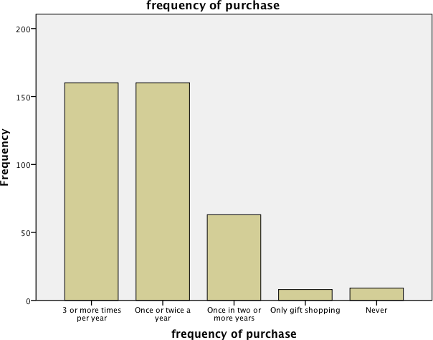

Figure 13: Frequency of Purchase

- The amount spent by the majority was under Rs.10,000/-, followed by the Rs.10,000/- to Rs.20,000/- range. Few had never bought these brands or done so only for gifting purposes.
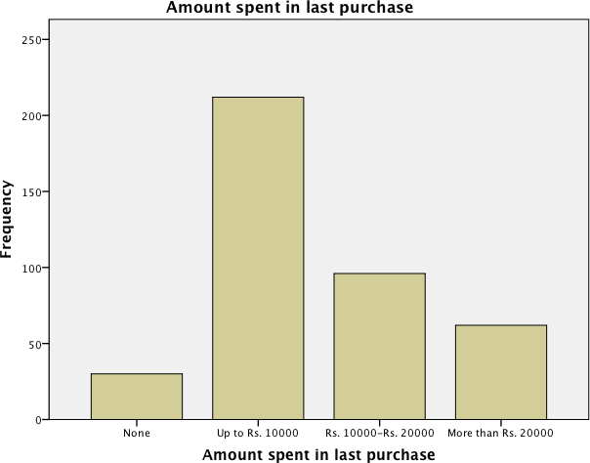
Figure 14:Amount Spent

- While 17% of undergrads had never bought these brands, 8% of graduates hadn’t and just 1% of those with a master’s degree had never bought these brands. This indicated that higher the educational qualification, more likely were the respondents, buyers of these brands. The value of purchases also differed where fewer undergrads as well as graduates bought a range of over Rs.20,000/- compared to more than a quarter of those with a Masters degree that purchased in this range. There was a definite correlation between educational qualification and amount spent on apparels and accessories but not the frequency of purchase.
- While the respondents’ occupation had no bearing on their frequency of purchase of apparels and accessories, it did impact the amounts last spent on these purchases. While in all cases, the average spend was Rs.10,000/- and

under, entrepreneurs and professionals were much more aware and most had bought this category of lifestyle fashion wear and accessories. Entrepreneurs, businessmen and professionals were the biggest buyer of these brands in terms of value. Those who were employed or in service spent lower amounts on these products. Comparatively, working students too, spent less, value wise, than non-working students. This could possibly be attributed to parents or others gifting them these purchases, as non-earners.
- The monthly income of respondents was a clear indicator of the amount they spent on fashion apparels and accessories, but not the frequency of their spending. Very few of those that earned over Rs.50,000/- per month had never bought these products compared to those not yet earning, or earning less than Rs.25,000/- per month. The majority of those that purchased higher values came from the category of high earners. It can be concluded that higher the income, higher was the spending power on these brands.
- Ownership of cars was a good indicator to reveal the value of spending on these lifestyle fashion wear and accessory brands, but not the frequency of shopping. Higher value car owners spent a lot more on these brands in comparison to those that owned lower end cars or did not own cars. All high end car owners with car values of over Rs.50 lakhs, had bought these brands and the majority of these categories claimed that their last purchase of lifestyle apparels and accessories, was over Rs.10,000/- Almost 32% of those that did not own cars or had a lower range of family cars owned had not bought these brands.
- The number of international trips done in the previous 2 years correlated to amounts being spent by the respondents. Though there was no correlation between the respondents’ international travel and frequency of purchase of these brands, their overseas travel did relate to the amount spent on this lifestyle and luxury segment. Most frequent flyers overseas had bought these brands, compared to those that hadn’t travelled and their value of purchase too was a much higher range. A maximum number of these regular travellers had made purchases of over Rs.20,000/- in their last purchase of fashion and accessories. The research did not qualify whether the purchasing was done overseas or locally.

Socio-economic factors and marketing:

Based on socio-economic background, the monthly income, occupation, foreign travel and value of cars owned could co-relate to the individuals spending power on these brands.
The qualifications of the buyer indicated his buying habits of fashion brands. Targeting a qualified audience for these brands would push for even more frequent and higher spending on it. For bridge-to-luxury and luxury brands the qualification and income levels were a true indicator and using media that goes exclusively to working professionals would pay. The occupation of the buyer was extremely relevant. Entrepreneurs and professionals spent more on bridge-to-luxury and upward, indicated by the higher amounts spent in the last purchase. The frequency of international trips indicated higher spending in bridge-to-luxury and luxury.
Car ownership was a relevant indicator of high-end purchases of bridge-to- luxury and luxury brands could incorporate the fact in their marketing plans.
Brand associations and tie-ups between these brands and automobile brands, travel companies and clubs could help reach out to a large number of potential buyers.
Professional magazines, airline magazines and developing advertising content relevant to this affluent class could help boost sales. Using the celebrity as an influencer could boost sales and stylists could be urged to get celebrities to wear the brand.
LIMITATIONS
Indigenous studies on the home market are rather limited and secondary data referred to in this area, is predominantly available from international research organisations. The study focused on a specific city, Greater Suburban Mumbai, the financial capital with a high level of awareness and global exposure. The age group was young educated millennials. There is limited city-centric, age and product specific research available. The area of research can be expanded to other metro cities like Bengaluru and Kolkata. Research could also investigate new growing markets in India that include Tier 2 and Tier 3 cities like Pune and Hyderabad and smaller towns that are witnessing new-found wealth. The age group was also restricted to a bracket of 18 to 30 year olds

and hence older and younger age groups could be studied to understand the buying behaviour of these prospects. Given time and cost limitations, a sample size of 400 using non-probability sampling was also used and this method does not ensure that each unit of the population will have an equal chance of being selected as in the case of probability sampling. There is further scope to examine other products or segments, like jewellery and automobiles that are popular symbols of luxury in India.

REFERENCES

Works Cited
Walker, R. (2016). 25 Predictions for the Luxury Goods Industry in 2016. Euromonitor International. Euromonitor International.
US National Library of Medicine. (n.d.). definitions.net. Retrieved November 15, 2017, from http://www.definitions.net/defintion/socioeconomic%20factors.
Business Dictionary. (n.d.). Retrieved November 15, 2017, from http://www.businessdictionalry.com/defintion/Generation-­‐Y.htmal Sinha, R. Mumbai is at the pinacle of the luxury market. Luxury Expo2013. www.economictimes.com.
Boston Consulting Group. (2012, April). The Millennial Consumer: Debunking Stereotypes. Retrieved November 16, 2017, from www.bcg.com: http://www.bcg.com/documents.file103894.pdf
Ordun, G. (2015). Millenial (Gen Y) Consumer Behaviour, Their Shopping Prefernces and Perceptual Maps associated with Brand Loyalty. Canadian Social Science , II (4), 40-­‐55.
Goldman Sachs. (2016, June 1). Indian Consumer Close-­‐Up: Tapping the spending power of a young, connected Urban Mass. Retrieved November 16, 2017, from www.goldmansachs.com: hettp://www.goldmansachs.com/our-­‐ thinking/pages/macroeconomic-­‐insights-­‐folder/rise-­‐of-­‐the-­‐india-­‐consumer
Dauriz, L., & Tochtermann, T. (2013). Luxury Lifestyle:Beyond the buzzwords. McKinsey & Company, Munich.
Hindustan Times. (2017, May 29). World luxury goods sales growth seen up 2-­‐4% in 2017: Bain. Hindustan Times .
Bendell, J., & Kleanthous, A. (2008). Deeper Luxury :Quality and Style when the world matters. WWF.
Moneycontrol. (2017, August 17). DATA STORY: How India has turned into the world's second largest online market. Retrieved November 20, 2017, from moneycontrol.com: http://www.moneycontro.com/news/technology/data-­‐story
Oakes, Michael. (n.d.). Measuring Socioeconomic status. Retrieved November 26, 1917, from wwwesourceresearch.org: http://ww.esourcesresearch.org/Porta;s/0/Uploads/Documents/Public/Oakes_FullCha ter.pdf
Administrative divisions of Mumbai. (2017, September 10). Retrieved December 1, 2017, from wikipedia.org: http://en.wikiedia.org/wiki/Administrative_divisions_of_Mumbai

firstpost.com. (2016, January 13). Latest Census data shows youth surge:Nearly 41% of India's population is below the age of 20. Retrieved December 1, 2017, from www.firstpost.com: http://www.firstpost.com/india/latest-­‐census-­‐data-­‐show-­‐youth-­‐ nearly-­‐41-­‐of-­‐indias-­‐population-­‐is-­‐below-­‐the-­‐age-­‐of 20
Krejcie, R., & Morgan, D. (1970, September 1). Education and Psychological Measurement. Retrieved December 1, 1917, from journnals.sagepub.com: www.journals.sagepub.com/doi/abs/10.1177
ASA & Associates LLP. (2015, Febryary). A brief Report on Lifestyle Products in India. Retrieved December 2, 2017, from www.asa.in: http://www,asa.in/insights/survey-­‐and-­‐ reports/lifestyle-­‐products-­‐in-­‐India
Times News Network. (2017, March 2). Mumbai pips Washington, Toronto in city wealth index. The Times of India .

