Andrean Counselling Unit Report
Academic Year 2010 - 2016

Andrean Counselling Unit Report – Academic Year 15 - 16
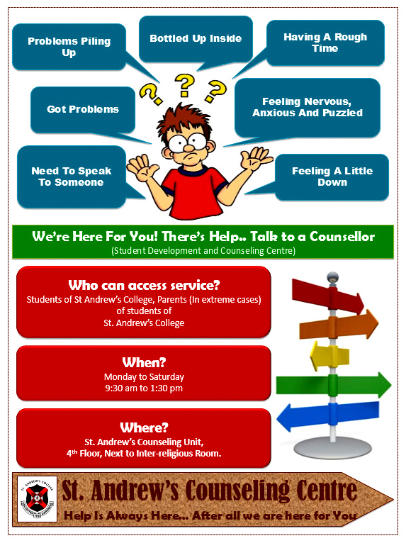
The Counseling Unit began the academic year 2015 - 16, with a regular orientation session that helped students in ‘Understanding What is Counseling?’ and the various aspects that the St Andrew’s Counseling Unit could help them out in. Over and above, each of the floors had a poster put-up to spread awareness about the existence of a Counselling Unit and the various issues that are dealt by the Counselling Unit.
The college counsellor was available for all six days of the week; from Monday to Saturday from 9:30am to 1:30pm.

Counseling Unit Services Offered (2015 - 16)
Service | Figure
Individuals (students and adults) availed of Counseling services | 302
Individuals availed of testing services | 253
Follow-up sessions taken | 300+
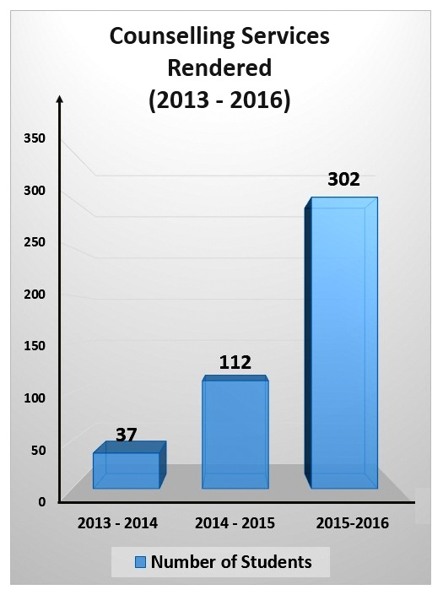
This unit has offered its services to about 302 individuals (students and adults) who have availed of counseling services and with more than 300+ follow-up session collectively. There has been a significant growth in the number of counselling services rendered in the last 3 years; from 37 individuals (in the year 2013-14) to 112 individuals (in the year 2014-15) to 302+ individuals (in the year 2015-16).
The various issues experienced by students and adolescents were – low self-esteem and confidence, academic issues, self-pity, behavioural issues, body image issues, domestic violence, bullying, discord in interpersonal relationship, incompetence, self destruction, depression, fear, unable to manage time, career confusion, negative thoughts, relationship issues, aggression and impulsive behaviour, inability to handle difficult emotions, substance abuse, and so on.
These issues were dealt using counseling techniques like anger management, reality therapy, test administration, cognitive behaviour therapy, client-centered therapy, Gestalt’s empty chair technique, challenging thoughts, assertiveness training, organizational skills – Time management, positive thinking, solution focused brief therapy, relaxation techniques and in group conflict situations, group counseling.
St Andrew’s College Counseling Unit has been reaching out to students in need of any help, be it academics, developmental or social; which means, providing assistance in area of need by “enriching life and making a difference” and in order to assist them to achieve personal and social growth and development.

Faculty/ Person In-charge were:
- Prof Shubda Malhotra
- Ms Melanie Mathias
Activities Done by Andrean Counselling Unit over and above the regular Counselling Services during the Academic Year 15-16

- Guiding students / student groups for projects related to the field of psychology
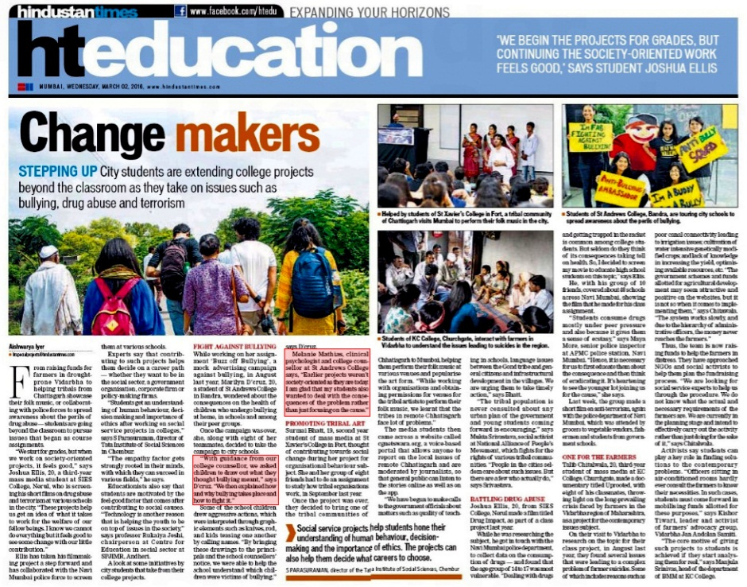
The College Counsellor has been guiding students from various sections for their projects related to the field of psychology. Some of the project topics directed under the guidance of the College Counsellor are – anger, bullying, relationships, stress, etc. The focus of the guidance has always been to offer a bridge to independent learning for students.
By suggesting students to take their project to the next level, it develops their skills in critical thinking and they are able to express their own ideas. Students are then encouraged to shape these ideas into reality by transforming the project into something that is more society oriented.
One of the BMM group of students who covered the topic of bullying, got media coverage by Hindustan Times, 2nd March 2016 (HT Education Section).
- YOUR VOICE – Staff Enrichment Initiative (360 Degree Feedback)

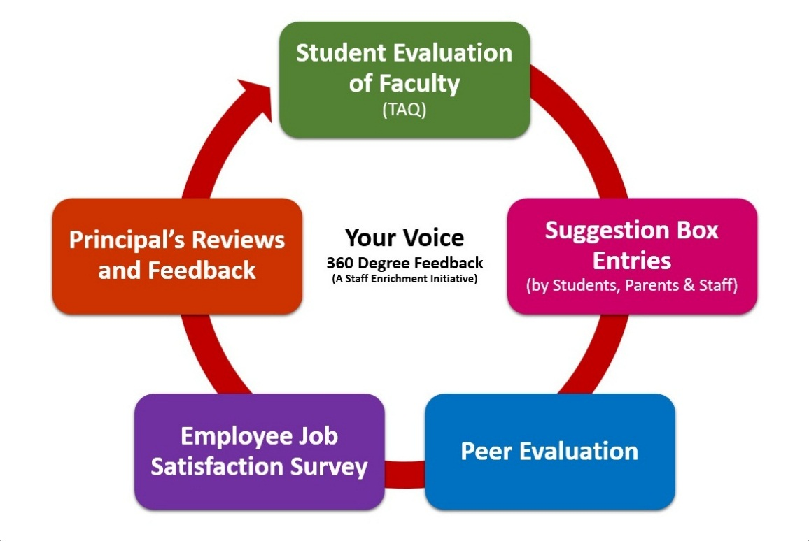

The initiative ‘YOUR VOICE’ was assigned to the Counselling Unit and was successfully handled by the College Counsellor. This new initiative as part of the Staff Performance Assessment began by introducing the 360 DEGREE FEEDBACK system. This system included the process of staff members receiving confidential, anonymous feedback from the people who work around them. This typically includes the staff member's heads, peers, and students. An online portal was devised exclusively for this initiative that looked at the following aspects:-

- Students Feedback of Faculty (TAQ)
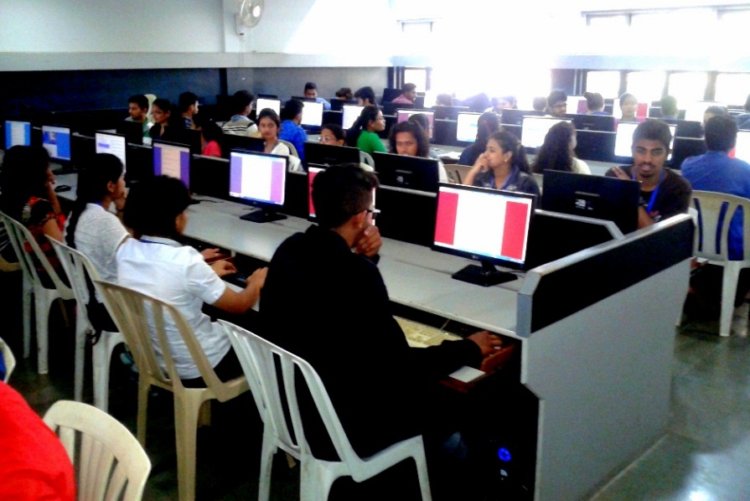
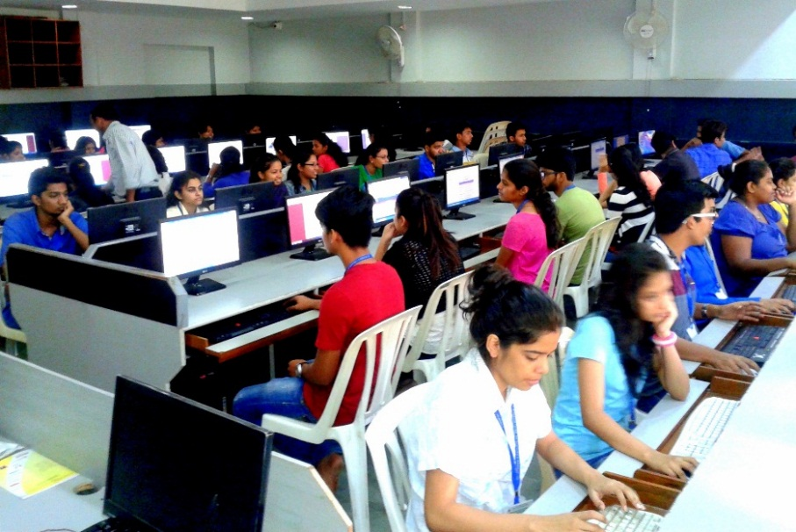
Students from each of the sections were brought to the computer lab where they answered questions to each of their professors in ‘yes’ or ‘no’ and filled in suggestions for each of their professors. The results of each of the staff members were then shared by the Principal in a confidential environment, together where certain goals were defined in order to cultivate the practice of progress in the next assessment, conducted in the following year.

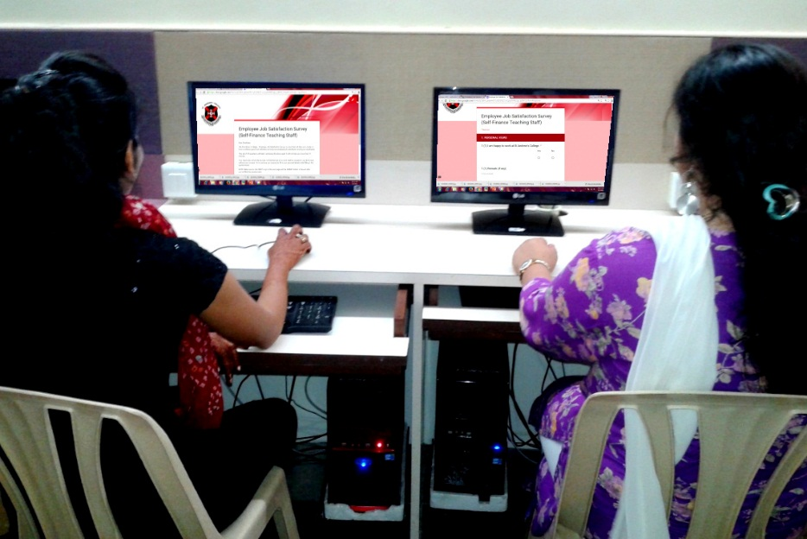
- Employee Job Satisfaction Survey
It is very important to understand the satisfaction levels of the staff working at St Andrew’s in order to influence positive work attitudes and work on building a positive work environment. Staff members were invited to fill an online assessment form about various aspects of the college which were then collected, compiled and reviewed:
- Personal Views
- Pay Received
- Staff Advancement
- Co-Workers and Team Building
- HOD / Coordinator / Superintendent
- Principal
- College
- Feedback Involving Students
- Overall Feedback

- Peer Evaluation
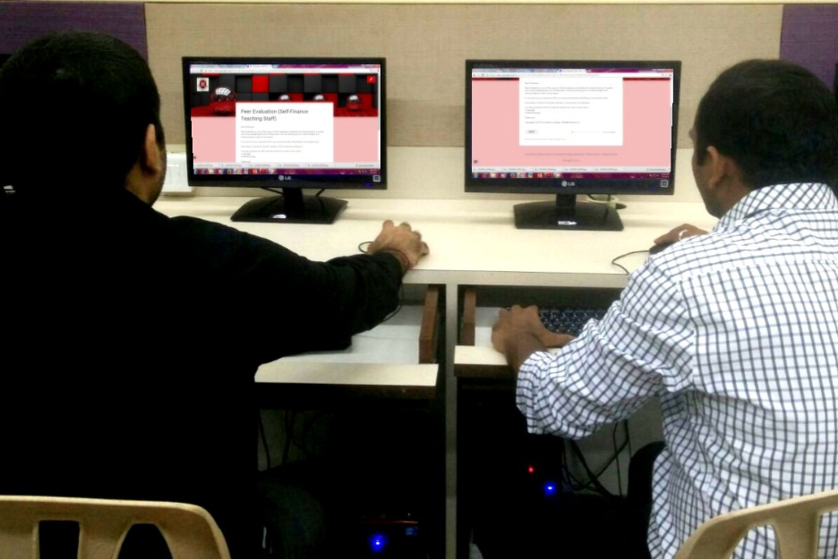
The Peer Evaluation was conducted on staff members who gave an evaluation about each of their colleagues in terms of their ‘STRENGHTS’ and ‘WEAKNESS’. The Principal then discussed each of their compiled responses report respectively, in a confidential environment and helped the staff to use their strengths to overcome their weakness.

Faculty/ Person In-charge were:
- Ms Melanie Mathias

----*****----

Andrean Counselling Unit Report – Academic Year 14 - 15
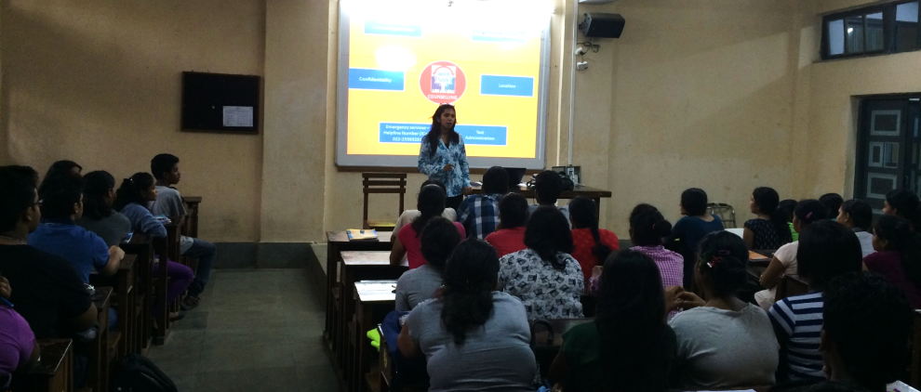
The Counseling Unit began the academic year 2014 - 15, by first sensitizing students to ‘Understanding What is Counseling?’ This was done through an orientation session from class-to-class, to help students understand the various aspects that the St Andrew’s Counseling Unit could help them out in.
The college counsellor was available for all six days of the week; from Monday to Saturday from 9:30am to 1:30pm.

Counseling Unit Services Offered (2014-2015)
Service | Figure
Individuals (students and adults) availed of Counseling services | 112
Individuals availed of testing services | 38
Follow-up sessions taken | 204
This unit has offered its services to about 112 individuals (students and adults); 38 individuals availed of counseling services and with more than 200+ follow-up session collectively.
The various issues experienced by students and adolescents were – low self-esteem and confidence, academic issues, self-pity, behavioural issues, body image issues, domestic violence, bullying, discord in interpersonal relationship, incompetence, self destruction, depression, fear, unable to manage time, career confusion, negative thoughts, relationship issues, aggression and impulsive behaviour, inability to handle difficult emotions, substance abuse, and so on.
These issues were dealt using counseling techniques like anger management, reality therapy, test administration, cognitive behaviour therapy, client-centered therapy, Gestalt’s empty chair technique, challenging thoughts, assertiveness training, organizational skills – Time management, positive thinking, solution focused brief therapy, relaxation techniques and in group conflict situations, group counseling.
St Andrew’s College Counseling Unit has been reaching out to students in need of any help, be it academics, developmental or social; which means, providing assistance in area of need by “enriching life and making a difference” and in order to assist them to achieve personal and social growth and development.

Counseling Unit Activities Report 14-15

The Green Ribbon Week
St. Andrew’s College of Arts, Science and Commerce (Accredited with “A” Grade by NAAC) has always worked as per its crest and motto – Enlighten the Darkness.
Against the scenario of darkness that has engulfed the human horizon due to ignorance, oppression, corruption, denial of justice and human rights, inhuman treatment of women, drugs, alcoholism, depicted by the dark background on the crest, there is light which dispels the gloominess of our world and herald’s joys and peace.
Through our initiative this year (2014-15) ‘The Green Ribbon Week’, we made efforts to dispel darkness and brighten the lives of students around us through this ‘Addiction Awareness Program’.
The Counselling Unit under Psychology Association planned a week long program called ‘The Green Ribbon Week’. Green symbolizes new life - growth, harmony, freshness, and fertility and a ribbon symbolizes support and awareness.As we are all aware that ADDICTION is not a brain disease, it’s a choice that an individual makes and our goal was to help students make the right and healthy choice.
Under the guidance of Principal Dr Marie Fernandes and Prof Shubda Malhotra, Vice-Principal, who themed this year’s concept as ADDICTION, we have all activities revolving around addiction and prevention of addiction for this academic year (2014-15).
Coincidently, we had our Prime Minister MrNarendraModi, who urged the netizens to begin the topic of ‘Drug Free India’ and make India a drug free nation on All India Radio, has been concerned about our younger generation, as he quoted in his recent speech this month.
Drugs brings 3 things he said, he calls them the 3Ds - Darkness, Destruction and Devastation. He also underlined the need to fight against the habit. He added, “People need to have the courage to say no (to drugs) and reject drugs. Tell your friends the same too.”

- Aim:
The aim of this Event – The Green Ribbon Week, was to break the Addiction cycle.
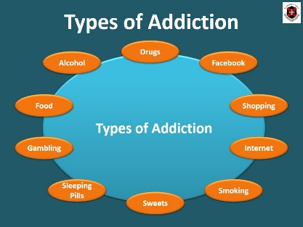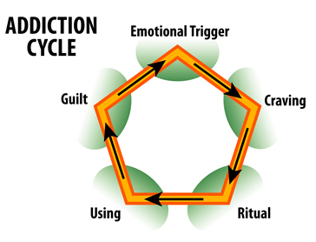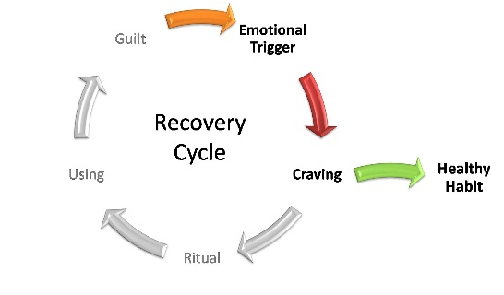
DE-ADDICTION
CYCLE
Students were exposed to information related to all types of addiction and what causes this addiction.
Day 1 – Screening and Presentations
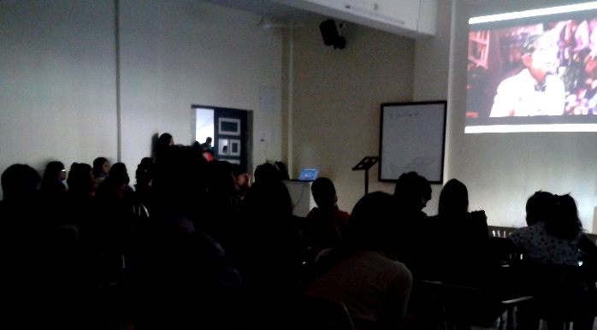
The first day of the Green Ribbon Week, began with exposing students to documentaries related to addiction and patterns of addiction. Dr. Gabor Maté talk helped them understand about the root causes of addiction and how to deal with them.
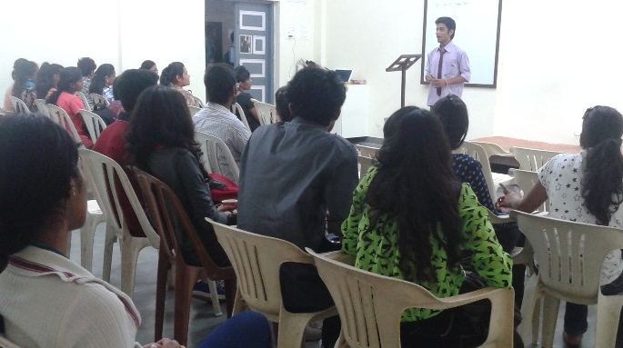
Along with screening of awareness and insightful talks, students also came forward and shared experiences around them about addiction and types of addiction.

Day 2 – Art Attack
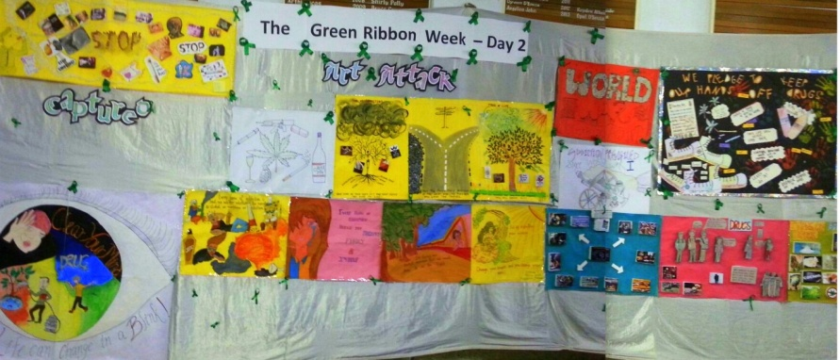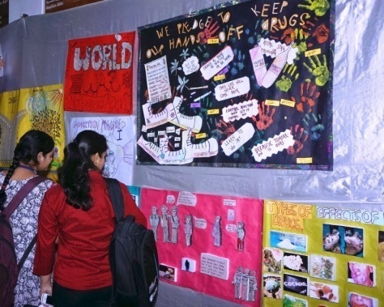
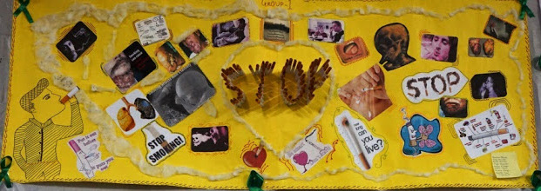
As 16th December 2014 marked the 100th Anniversary of the Heugh Battery Bomdardment - World War 1, St Andrew's College decided to have the Art Attack activity relating it to the War War I. Addiction is not an issue that prevails in the recent times, but has been taking place during and since the World War I.
Doctors and surgeons attached to both armies sought to ease the misery of sick and wounded soldiers by prescribing millions of doses of a recently-discovered wonder drug: morphine which eased the immediate suffering of sick and wounded Civil War soldiers. This created a generation of addicts among Civil War veterans. Accurate statistics for the period are hard to come by, but historians believe that many Civil War veterans suffered from morphine addiction.
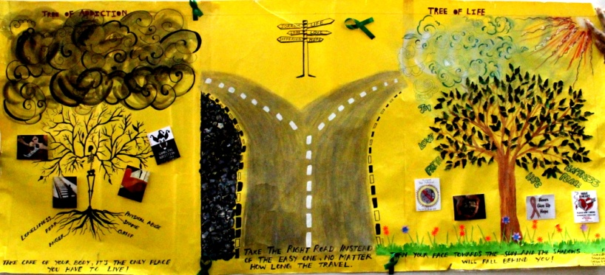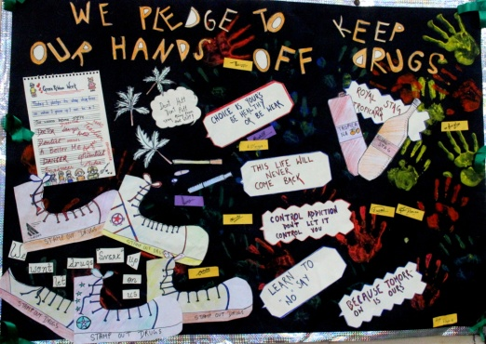
Today’s youth speak through art. Their posters, spoke volumes about history of addiction and present addiction along with prevention and de-addiction through ART!
This activity leads them to exploration of viewer’s learning and reactions towards the posters; it worked more as a projective process. Through the activity, students learnt and understood the personal meaning of each of the posters, which worked as an insight in itself.

Day 3 – Know Yourself Better
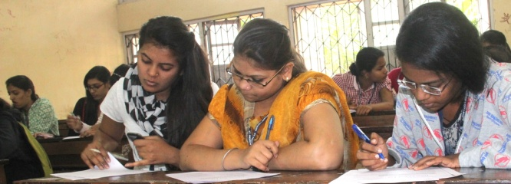
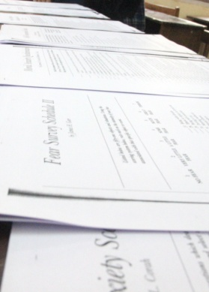
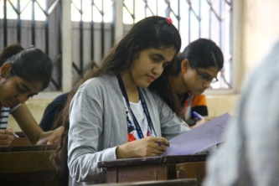
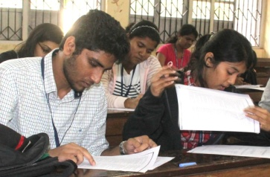
Students were exposed to a series of scales and tests – Personality Analysis, Stress, Anxiety, Fear, Vocation, Interpretation Relationships, etc,which were available to them to explore and administer. The interpretation of these tests will help them learn more about themselves and give them a deeper insight of how they function - their strengths & areas they need to work on.

Day 4 – Sing and Dance for a Cause
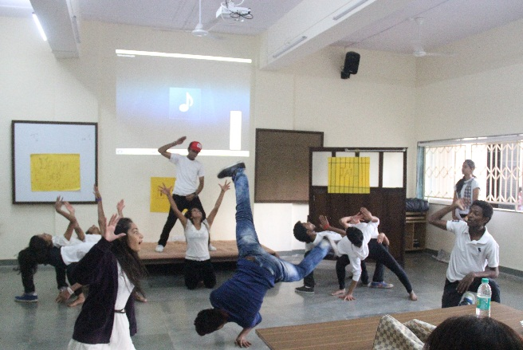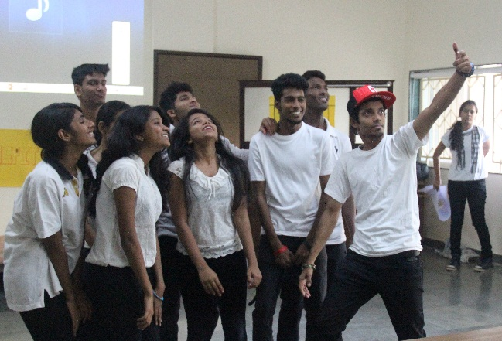
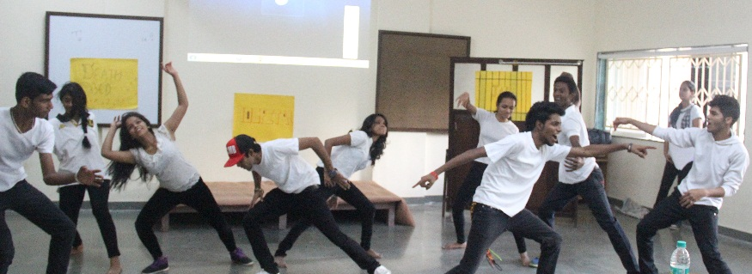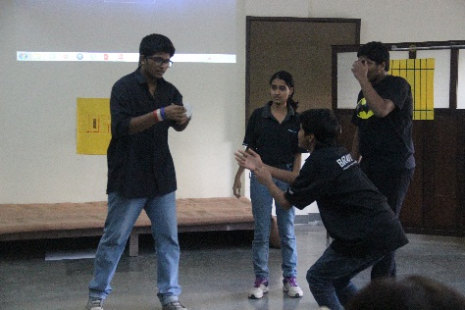
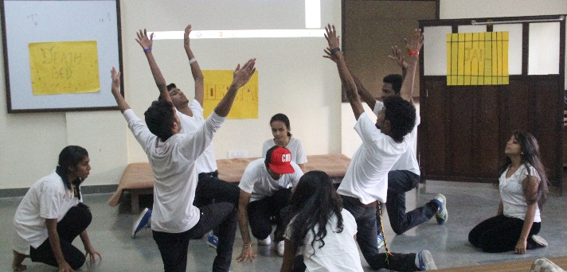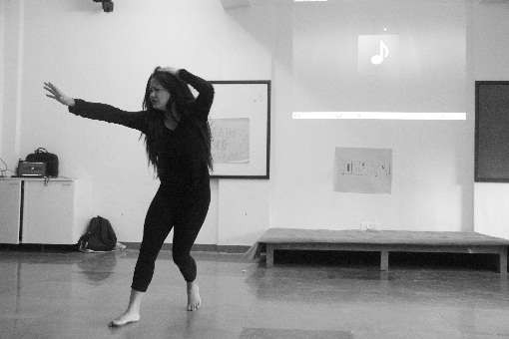
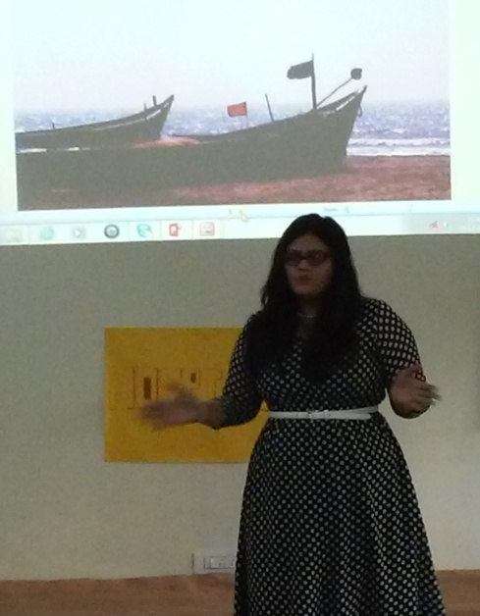
Singing and dancing keeps both body and brain active and is vital for people of all ages. Our students depicted the theme of addiction and prevention, through a creative outlet of singing and dancing in a safe environment for students, so that they can relate and it will open-up possibilities to spread awareness and towards insightful intervention.
This activity helped students’ channelize their creativity for a noble cause to spread awareness about the consequences of substance abuse.
We also had a Guest Lecture by Internationally Acclaimed Artist Ms Sonia Bendre on ‘Psychological Interpretations of Art & Photography’
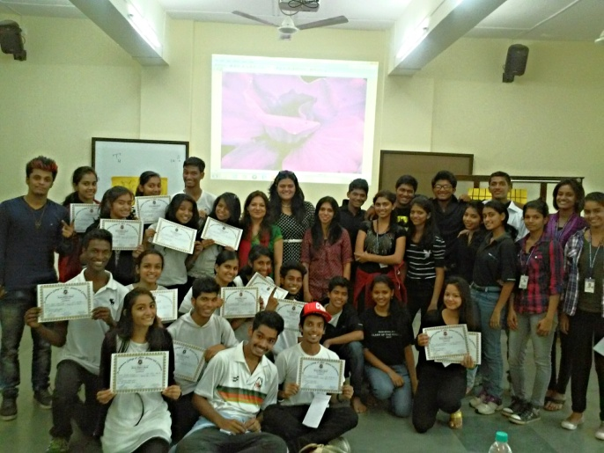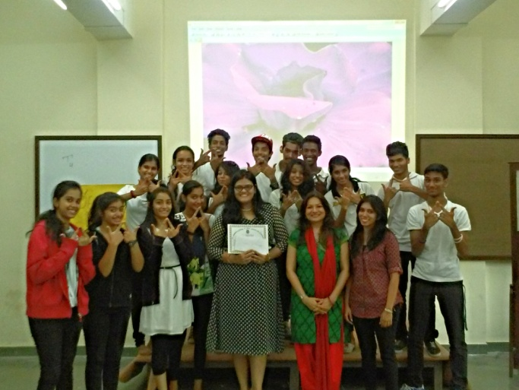
Participants and Winners of the ‘Sing and Dance for a Cause’ Activity with Judge – Sonia Bendre, Vice Pricipal – Ms Shubda Malhotra and College Counsellor – Ms Melanie Mathias

The sing and dance for a cause was judged by Ms Sonia Bendre who belongs to a family of renowned Indian artists. She appreciates art and is a very good singer and dancer herself. Her late grandfather-in-law is a celebrated Indian artist and has won padmashri and padmabhushan award for his outstanding paintings.

Faculty/ Person In-charge were:
- Prof Shubda Malhotra
- Ms Melanie Mathias

----*****----

Andrean Counselling Unit Report – Academic Year 13 - 14
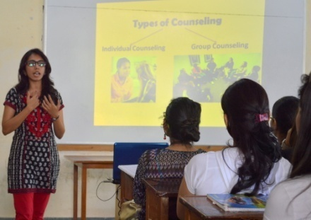
The Counseling Unit began in the academic year 2013-2014. A college counselor Ms Melanie Mathias was appointed, who was available for all six days of the week; from Monday to Saturday from 9:30am to 12:30pm.
The Counseling Unit began the academic year, by first sensitizing students to ‘Understanding What is Counseling?’ This was done through an orientation session from class-to-class, to help students understand the various aspects that the St Andrew’s Counseling Unit could help them out in.
Counseling Unit Services Offered (2013-2014)
Service | Figure |  | Service | Figure
Individuals (students and adults) availed of Counseling services | 37 |  | Follow-up sessions taken | 110
Individuals availed of testing services | 24 |  | Tests administered | 63
Total | 61 |  | Total | 173
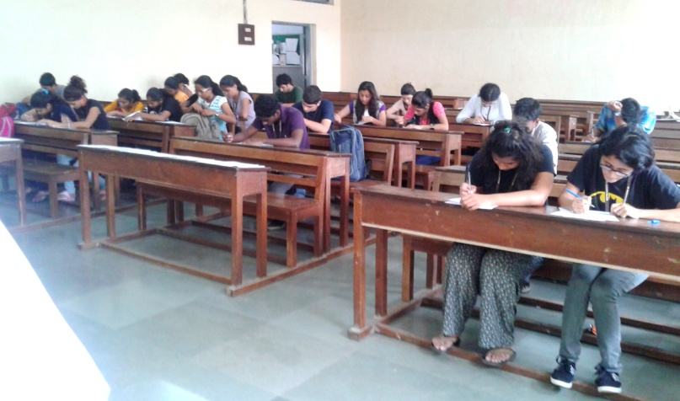
This unit has offered its services to about 61 individuals (students and adults); 37 individuals availed of counseling services and with more than 110+ follow-up session collectively and 24 students availed of testing services with about 60+ tests administered.
The various issues experienced by students and adolescents were – low self-esteem and confidence, academic issues, self-pity, behavioural issues, body image issues, domestic violence, bullying, discord in interpersonal relationship, incompetence, self destruction, depression, fear, unable to manage time, career confusion, negative thoughts, relationship issues, aggression and impulsive behaviour, inability to handle difficult emotions, substance abuse, and so on.
These issues were dealt using counseling techniques like anger management, reality therapy, test administration, cognitive behaviour therapy, client-centered therapy, Gestalt’s empty chair technique, challenging thoughts, assertiveness training, organizational skills – Time management, positive thinking, solution focused brief therapy, relaxation techniques and in group conflict situations, group counseling.
St Andrew’s College Counseling Unit has been reaching out to students in need of any help, be it academics, developmental or social; which means, providing assistance in area of need by “enriching life and making a difference” and in order to assist them to achieve personal and social growth and development.

Faculty/ Person In-charge were:
- Prof Shubda Malhotra
- Ms Melanie Mathias

----*****----
Andrean Counselling Unit Report – Academic Year 12 - 13
Interest in the well being of our students constantly encourages us to initiate activities that would lead to their development. This academic year, we remodeled the counseling unit so that, over and above the regular counseling services provided to our students, we hosted a wide array of activities that would provide students an opportunity to show case their talents and optimize their potential.
The counseling unit organized a series of guest lectures by professionals from Study Overseas on education and career options available abroad. The session equipped the students to meet the challenges in their future and was much appreciated by them. Students interested in the field of computers and computer – related careers attended a presentation by professionals from computer education institutes, who provided an insight into contemporary job-oriented courses for students.
Dr. Anuj Jain from Edu groomers presented a talk on career guidance; he acquainted the students with upcoming career options in all disciplines to help them decide on their careers.
There was an overwhelming response to the Poster Competition on ‘Stress’. Students exhibited a combination of their creative and analytic skills to address the issue of stress affecting today’s youth, focusing on the cause, symptoms and techniques used by youth to cope with stress.
In addition to these events, the unit rendered regular counseling services to students in areas like relationship issues, self-esteem, time management, substance abuse, career counseling, adjustment problems, difficulties in handling peer pressures and phobias. While we were able to help most of the students at our unit itself, some had to be referred to external counselors.
Issues on which Counseling given | Number of students
Relationship issues | 10
Self-esteem | 12
Time management | 8
Substance abuse | 2
Career counseling | 15
Adjustment problems and difficulties in handling peer pressures | 10
Total | 57
Standard psychological scales were done with students from different streams:
Tests Administered | Number of students
Scales of Self-Esteem | 100 approx. on F.Y.B.A
Level of Hostility | 110 approx. on F.Y.B.A
Fear of Negative Evaluation | 90 approx. on F.Y.B.A
Level of Annoyance | 100 approx. on F.Y.B.A
Intrinsic and Extrinsic Motivation Scale | 80 approx. on T.Y.B.Com
Type A Personality | 100 approx. on S.Y.B.A
Total | 580
Faculty/ Person In-charge were:
- Prof Shubda Malhotra
- Dr Madhu Rai

----*****----

Andrean Counselling Unit Report – Academic Year 11 - 12

In this year the unit was operated by Fr Savio Desales. He supported students through the process in which he helped them solve their personal problem and helped them improve their personal attitude, behavior and character.
The unit rendered regular counseling services to students in areas like relationship issues, self-esteem, time management, substance abuse, career counseling, adjustment problems, difficulties in handling peer pressures and phobias.
Standard psychological scales were done with students from different streams on areas like Scales of Self-Esteem, Level of Hostility, Fear of Negative Evaluation, Level of Annoyance, Intrinsic and Extrinsic Motivation Scale and Type A Personality.

Faculty/ Person In-charge were:
- Fr Savio Desales

----*****----

Andrean Counselling Unit Report – Academic Year 10 - 11

The Counseling Unit had just emerged at St Andrews College, as the Principal was sensitive towards the issues of adolescents and aimed towards providing services that would help students in both their personal and academic areas. The Principal then called Dr Sister Nandita Pereira to help and assist the faculty Prof Shubda Malhotra and Dr Madhu Rai, who contributed to the works of the Counseling Unit.
The unit rendered regular counseling services to students in areas like relationship issues, self-esteem, time management, substance abuse, career counseling, adjustment problems, difficulties in handling peer pressures and phobias. While we were able to help most of the students at our unit itself, some had to be referred to external counselors.
Standard psychological scales were done with students from different streams on areas like Scales of Self-Esteem, Level of Hostility, Fear of Negative Evaluation, Level of Annoyance, Intrinsic and Extrinsic Motivation Scale and Type A Personality.

Faculty/ Person In-charge were:
- Dr Sister Nandita Pereira
- Prof Shubda Malhotra
- Dr Madhu Rai

----*****----

